Abstract

This documentation contains the project initiation, project planning, project executing, project monitoring and controlling and project closing phases of project management.

Team Portfolio  
CH Grocers

Project Management

Level: 5

Section: B

Team Name: Epsilon Web Developers

Table of Contents

1. Project Initiation 1

1.1 Team Contract 1

1.2 Project Charter 5

1.2.1 Project Charter Version 1 5

1.2.2 Project Charter Version 2 8

2. Project Planning 12

2.1 Belbin’s Analysis 12

2.1.1 Team Belbin’s Analysis 12

2.2 MS Project 16

2.2.1 Timeline 16

2.2.2 Task Sheet 17

2.2.3 Gantt Chart 18

2.2.4 Resource Sheet 19

2.2.5 Calender 20

2.3 Skill Audit 22

2.3.1 Team Skill Audit 23

3. Project Execution 23

3.1 Design 24

3.1.1 Entity Relationship Diagram 24

3.1.1.1 ERD 24

3.1.1.2 Extended Entity Relationship Diagram 25

3.1.1.3 Composite ERD 26

3.1.1.4 Logical Design 26

3.1.2 Requirement Catalogue 27

3.1.2.1 Functional Requirements 27

3.1.2.1 Non-Functional Requirements 32

3.1.3 Use Case Diagram 34

3.1.3.1 Overview Use Case Diagram 34

3.1.3.2 Customer Use Case Diagram 35

3.1.3.3 Trader Use Case Diagram 35

3.1.3.4 Management Use Case Diagram 36

3.1.3.5 User Use Case Diagram 38

3.2 Oracle Tables 38

3.2.1 Data for Tables 38

3.2.2 SQL Code For Table Generation 42

3.3 Pictorial 49

3.3.1 Customer Interface Web 49

3.3.2 Management Interface Apex 67

3.3.3 Trader Interface Apex 78

3.3.4 Trader Interface Web 81

3.4 Website Mockup 85

3.4.1 Mockup Design 85

3.4.2 Product Logo 93

3.4.3 Team Logo 93

4.Project Closing 94

4.1Testing and Evaluation 94

4.1.1 CH GROCERS Testing 94

4.2 User Guide 95

4.2.1 Administrator Apex Guide 95

Management Interface Login 96

Management Dashboard 97

Product Management 98

Edit Product 99

Category Management 100

Trader Management 101

Edit Trader 102

Customer Management 103

Edit Customer 104

Order Details 105

Slider Image 106

Timeslot Details 107

107

Administration 108

4.2.2 Customer Guide 108

User Registration 109

User Login 109

Adding Products to the Cart 118

Check Out 120

After login into pay pal you get this screen 121

View orders, invoice 123

Edit Profile 124

**Delete Account** 125

4.2.3 Trader Guide 126

Trader Registration 126

Trader Login 128

Trader Products Dashboard 129

Insert products 129

View products 130

Edit products 131

Delete products 132

Edit Trader Profile 133

4.2.4 Trader Apex Guide 133

Trader Interface Login 134

Trader Dashboard 135

Product Management 136

Report on Product Stock 137

Report on Product Quantity 138

Weekly Report 139

Monthly Report 140

5.Project Closing 141

5.1 User Guide 141

5.1.1 Installation Guide 141

# 1. Project Initiation

## 1.1 Team Contract

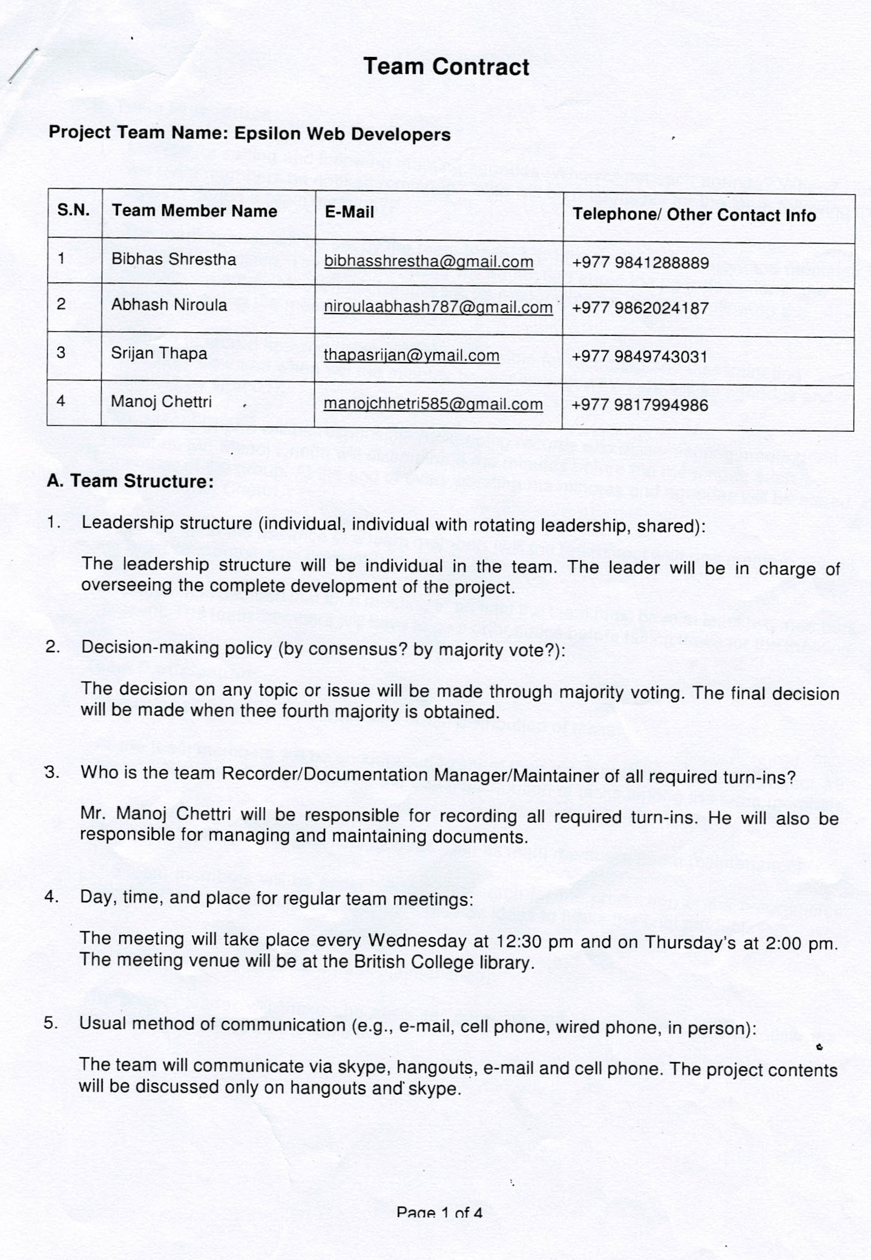

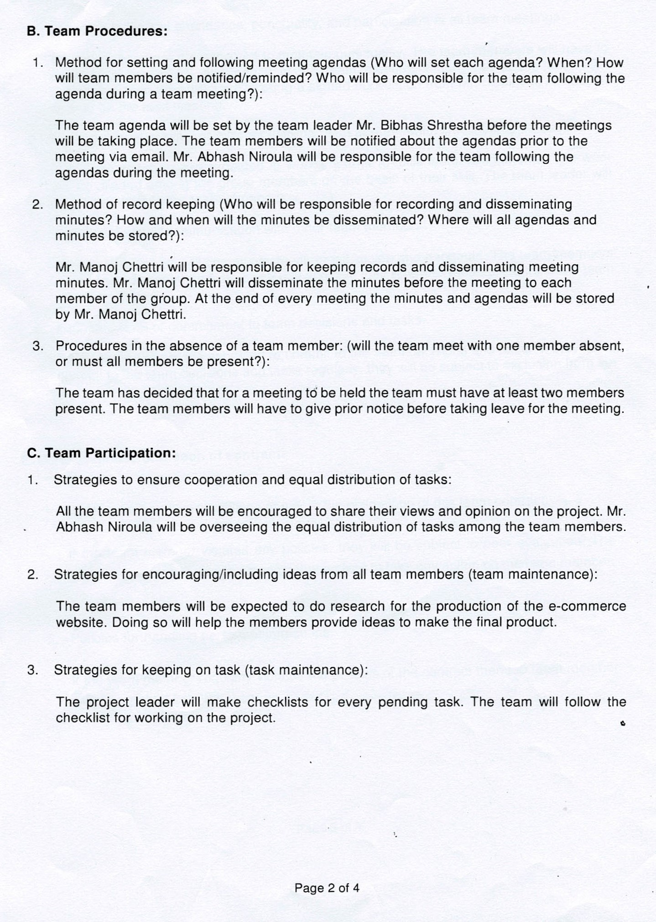

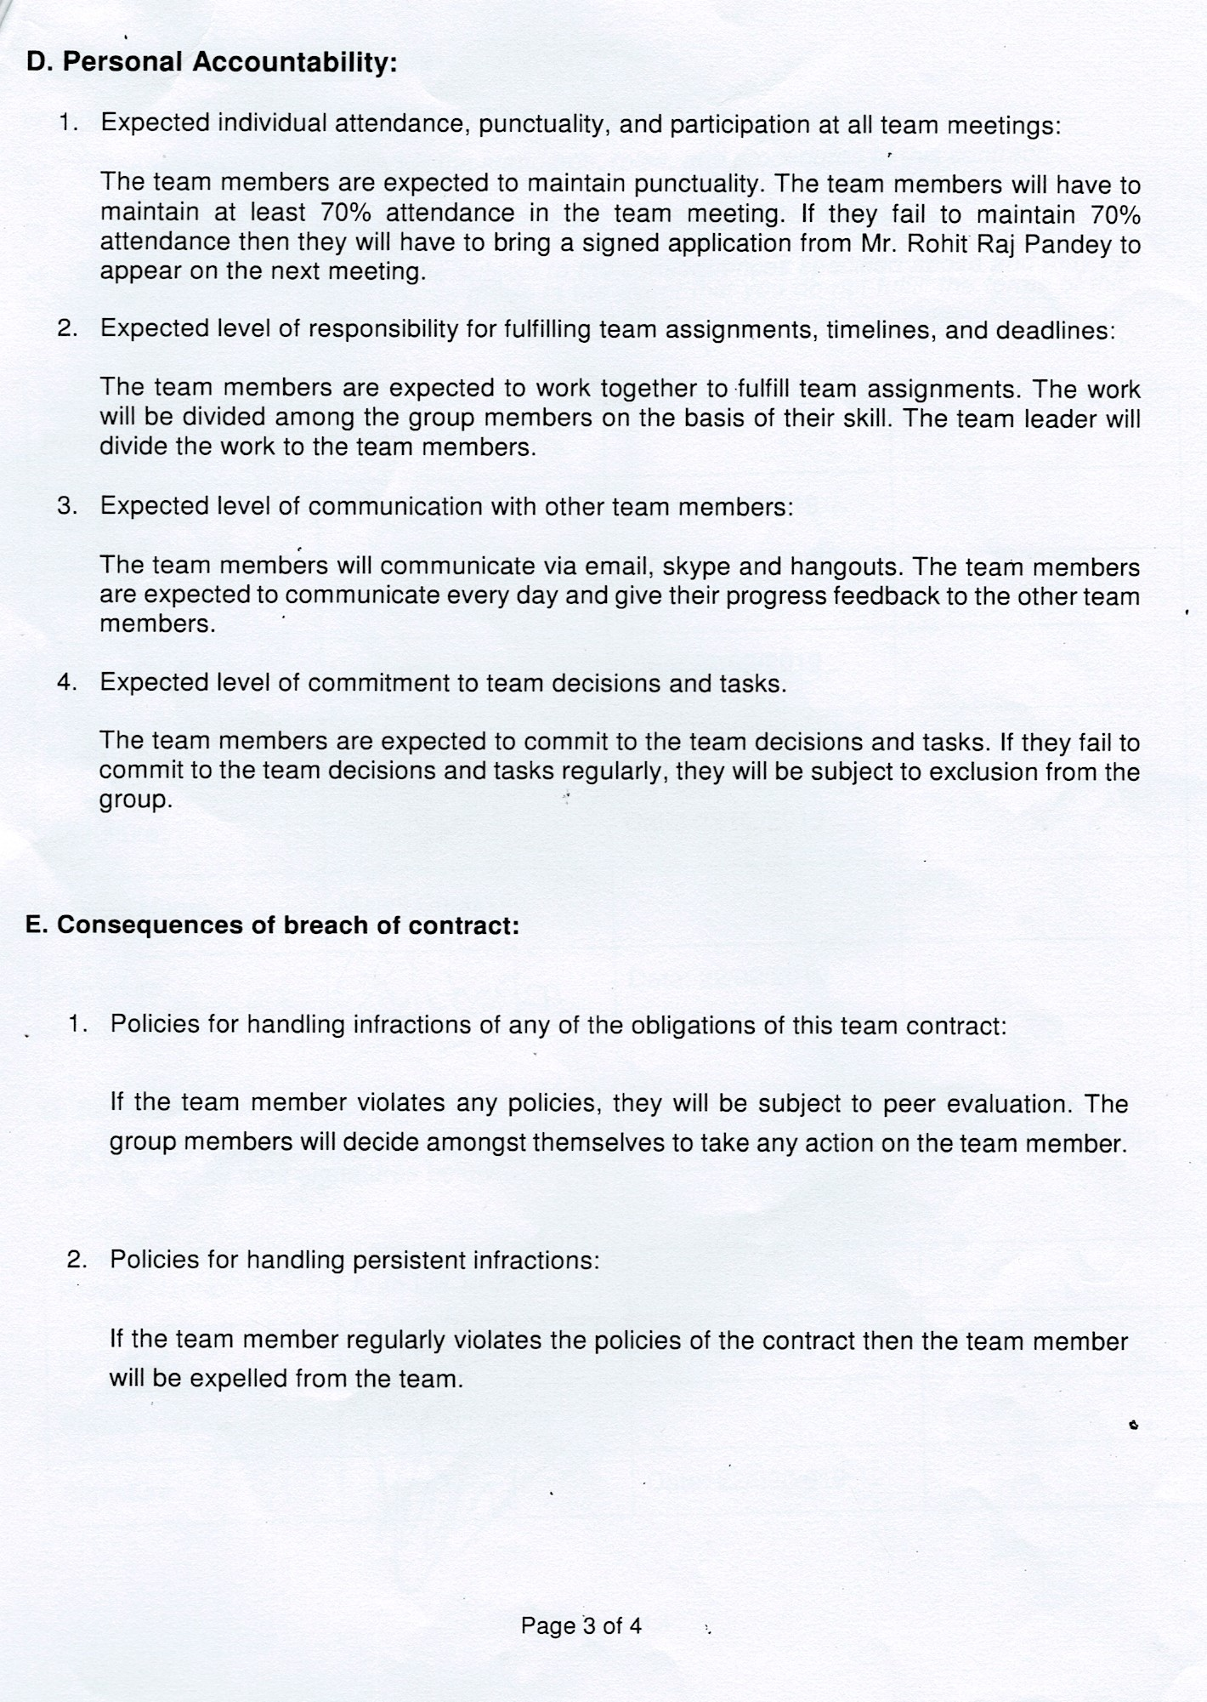

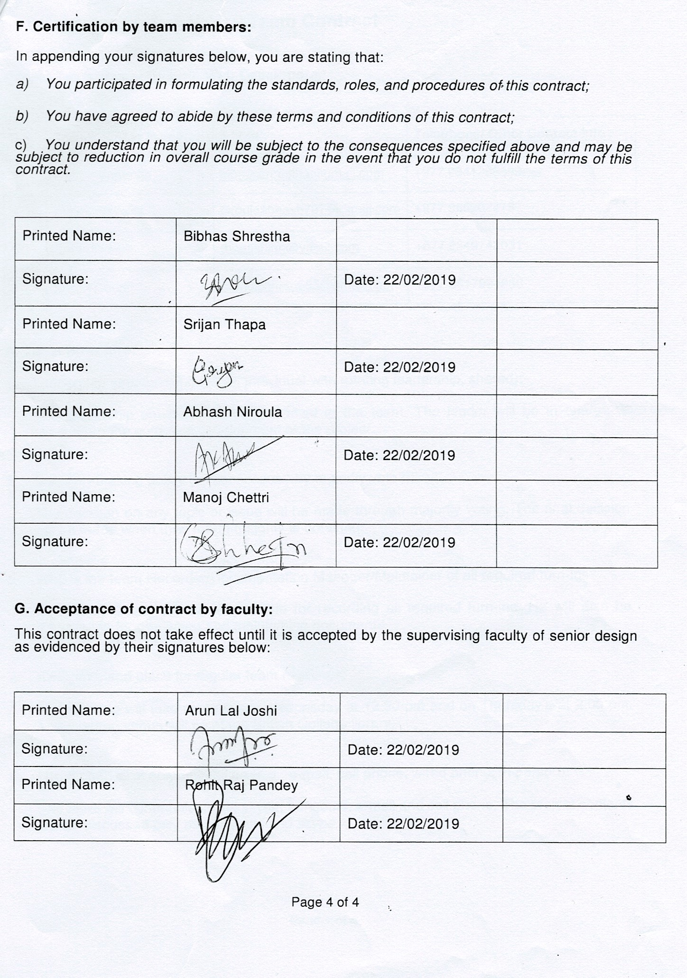

## 1.2 Project Charter

### 1.2.1 Project Charter Version 1

|  |
| --- |
| Project Title: Developing an e-commerce website for traders in Cleckhuddersfax. |

Version Control

|  |  |  |
| --- | --- | --- |
| Version | Date | Summary of changes |
| 1.0.0 | 22/02/2019 | No changes made. |
|  |  |  |
|  |  |  |

Project Justification

|  |
| --- |
| The project aims at creating an e-commerce website for the traders in Cleckhuddersfax. The traders in the area have jointly agreed to sell their products through the e-commerce website. Through the interface, the traders will be able to sell their products direct to consumers.    The system will allow local residents who cannot shop locally during normal opening hours to purchase goods from their local traders. The traders specialize in locally sourced high-quality goods, which are growing in popularity but cannot be purchased through local supermarkets. The development of the e-commerce website will help the traders to sell their products in the competitive retail market without losing out their revenue to the national chains.  The e-commerce platform will mainly focus on ease of access to the customers. The major target will be to provide a convenient user experience. |

Project Scope

|  |
| --- |
| **Objectives**   * Maintain or increase the shop turnover within 12 months of launching the website. * Attract new customers that would otherwise not be able to shop with the traders. * Be usable by traders within a normal and suitable working time. * Create a responsive interface so that it can be accessed across multiple devices. |
| **High level requirements:**  **Customer Interface**   1. Customers should be able to navigate to products by shop or by product type. 2. Customers should be provided with a single basket that holds goods that spans all traders and requires a single payment. 3. Customers should be required to register before they can place an order and be logged in to access the basket. 4. Customers should be able to review and update their account details.   **Trader Interface**   1. Traders should be able to manage their products and information on their shops via a web interface. 2. Traders should be able to add, delete and update their products. 3. Traders will login to the database on a daily basis to view reports on orders and stock levels. 4. Traders should have a trader login that allows them access to their details only.   **Management Interface**   1. A management dashboard to monitor trader and customer activity. 2. The management dashboard will give the traders access to a range of daily and periodic reports. 3. The management will provide traders with a weekly finance report which will identify payments to be made to them resulting from the previous 7 days orders. 4. The management will provide monthly report on product sales to the traders. |
| **Major deliverables**   1. E-Commerce website with customer and trader interface. 2. Database linked to e-commerce site with management interface. 3. Admin facility for traders to add, update and delete their products. 4. Add to cart functionality with billing system with PayPal Integration. |

Duration

|  |  |
| --- | --- |
| Name | Date |
| Project start date | 5/02/2019 |
| Work in Progress submission | 28/03/2019 |
| Final Project presentation | 06/05/2019 |
| Team Portfolio and Individual Report submission | 10/05/2019 |

Assumptions

|  |
| --- |
| * The platform would be developed using PHP and Laravel Framework. * The trader would be able to use the platform only after receiving verification from the management. * The management would be able to block the trader from using the platform if the trader violates the terms of agreement. * Customers would be required to login to the platform to purchase items. |

Roles and Responsibilities

|  |  |
| --- | --- |
| Name | Role |
| Bibhas Bahadur Shrestha | Resource Investigator, Co-ordinator, Completer Finisher |
| Abhash Niroula | Specialist, Shaper |
| Srijan Thapa | Monitor Evaluator, Team-worker |
| Manoj Chhetri | Implementer |

Communication and Collaboration Tools

|  |
| --- |
| **Hangouts:**  Hangouts will be used as the official source for communication. Team announcements and reminders will be given on Hangouts. It will also be used for conference calls and video chats.  **Trello:**  Trello will be used to plan the project, to prioritize important aspects of the project and to allocate tasks among the team members.  **Google Drive:**  Google Drive will be used to share the project files among the team members. The team members will upload their work on the shared google drive folder to keep the team members in sync with their progress. |

### 1.2.2 Project Charter Version 2

|  |
| --- |
| Project Title: Developing an e-commerce website for traders in Cleckhuddersfax. |

Version Control

|  |  |  |
| --- | --- | --- |
| Version | Date | Summary of changes |
| 2.0.0 | 22/02/2019 | Belbin’s Analysis, Skill Audit, EERD, Use Case Diagram and Wireframe Design were all completed. |
|  |  |  |
|  |  |  |

Project Justification

|  |
| --- |
| The project aims at creating an e-commerce website for the traders in Cleckhuddersfax. The traders in the area have jointly agreed to sell their products through the e-commerce website. Through the interface, the traders will be able to sell their products direct to consumers.    The system will allow local residents who cannot shop locally during normal opening hours to purchase goods from their local traders. The traders specialize in locally sourced high-quality goods, which are growing in popularity but cannot be purchased through local supermarkets. The development of the e-commerce website will help the traders to sell their products in the competitive retail market without losing out their revenue to the national chains.  The e-commerce platform will mainly focus on ease of access to the customers. The major target will be to provide a convenient user experience. |

Project Scope

|  |
| --- |
| **Objectives**   * Maintain or increase the shop turnover within 12 months of launching the website. * Attract new customers that would otherwise not be able to shop with the traders. * Be usable by traders within a normal and suitable working time. * Create a responsive interface so that it can be accessed across multiple devices. |
| **High level requirements:**  **Customer Interface**   1. Customers should be able to navigate to products by shop or by product type. 2. Customers should be provided with a single basket that holds goods that spans all traders and requires a single payment. 3. Customers should be required to register before they can place an order and be logged in to access the basket. 4. Customers should be able to review and update their account details.   **Trader Interface**   1. Traders should be able to manage their products and information on their shops via a web interface. 2. Traders should be able to add, delete and update their products. 3. Traders will login to the database on a daily basis to view reports on orders and stock levels. 4. Traders should have a trader login that allows them access to their details only.   **Management Interface**   1. A management dashboard to monitor trader and customer activity. 2. The management dashboard will give the traders access to a range of daily and periodic reports. 3. The management will provide traders with a weekly finance report which will identify payments to be made to them resulting from the previous 7 days orders. 4. The management will provide monthly report on product sales to the traders. |
| **Major deliverables**   1. E-Commerce website with customer and trader interface. 2. Database linked to e-commerce site with management interface. 3. Admin facility for traders to add, update and delete their products. 4. Add to cart functionality with billing system with PayPal Integration. |

Duration

|  |  |
| --- | --- |
| Name | Date |
| Project start date | 5/02/2019 |
| Work in Progress submission | 28/03/2019 |
| Final Project presentation | 06/05/2019 |
| Team Portfolio and Individual Report submission | 10/05/2019 |

Assumptions

|  |
| --- |
| * The platform would be developed using PHP and Laravel Framework. * The trader would be able to use the platform only after receiving verification from the management. * The management would be able to block the trader from using the platform if the trader violates the terms of agreement. * Customers would be required to login to the platform to purchase items. |

Roles and Responsibilities

|  |  |
| --- | --- |
| Name | Role |
| Bibhas Bahadur Shrestha | Resource Investigator, Co-ordinator, Completer Finisher |
| Abhash Niroula | Specialist, Shaper |
| Srijan Thapa | Monitor Evaluator, Team-worker |
| Manoj Chhetri | Implementer |

Communication and Collaboration Tools

|  |
| --- |
| **Hangouts:**  Hangouts will be used as the official source for communication. Team announcements and reminders will be given on Hangouts. It will also be used for conference calls and video chats.  **Trello:**  Trello will be used to plan the project, to prioritize important aspects of the project and to allocate tasks among the team members.  **Google Drive:**  Google Drive will be used to share the project files among the team members. The team members will upload their work on the shared google drive folder to keep the team members in sync with their progress. |

## 2. Project Planning

### 2.1 Belbin’s Analysis

### 2.1.1 Team Belbin’s Analysis

|  |  |  |
| --- | --- | --- |
| Version:1.1 **Belbin’s Analysis** Date reviewed: 2/3/2019 | | |
| Primary role | Bibhas Shrestha | Co-ordinator |
| Srijan Thapa | Specialist |
| Abhash Niroula | Team worker |
| Manoj Chhetri | Implementer |
|  |  |
| Secondary role | Bibhas Shrestha | Complete Finisher |
| Srijan Thapa | Shaper |
| Abhash Niroula | Monitor Evaluator |
| Manoj Chhetri | Plant |
|  |  |
| Least likely role | Bibhas Shrestha | Plant |
| Srijan Thapa | Co-ordinator |
| Abhash Niroula | Resource Investigator |
| Manoj Chhetri | Complete Finisher |
|  |  |
| Do you think the descriptions of these roles are an accurate description of your behaviour in teams? How do you see yourself differently? | Bibhas Shrestha | I think the description of these roles are accurate description of my behaviour. I think being the team leader gives me certain responsibilities and co-ordinator fits the role of a leader. |
| Srijan Thapa | Yes, the description of the role is an accurate description of my behaviour in the team because I can bring in-depth knowledge on key areas to the team. |
| Abhash Niroula | I think the descriptions of these roles are fairly accurate description of my behaviour. The description of the role Team worker suits my personality as I am more type of diplomatic person who believes in teamwork. |
| Manoj Chhetri | Yes, I think the description of the role is an accurate description of my behaviour in the team as I am proficient in planning a workable strategy and carrying it out as efficiently as possible. |
|  |  |
| Are there roles identified by Belbin that you might like to develop in yourself more? Which ones and why? | Bibhas Shrestha | Complete Finisher is the role I would like to develop in myself because the role would allow me to polish and scrutinise the team’s work for errors which would allow me to subject the work to the highest standard. |
| Srijan Thapa | Shaper is the role I would like to develop myself in because I would like to improve my ability to ensure that the team keeps moving and does not lose focus or momentum. |
| Abhash Niroula | Specialist is the role identified by Belbin that I would like to develop in myself. I think this is a challenging role and I want to be more dedicated towards particular topic to gain depth knowledge about it. |
| Manoj Chhetri | I would like to develop myself as the Plant because I would be able to generate creative ideas and solve difficult problems. |
|  |  |
| What possible situations in the coming months can you identify where you could work on developing these skills? | Bibhas Shrestha | In the coming months I would be able to develop my skill as co-ordinator. I will be responsible to delegate work appropriately in the team. |
| Srijan Thapa | In the upcoming months our team may struggle in key areas during the project and I think I will be able to help them during this situation to fulfil my role as the specialist. |
| Abhash Niroula | There may arise situation like communication issues between team members where I could really put my skills on test. As a team worker I would co-ordinate with my team members properly and understand their problems and try to resolve it in a way what’s good for the team. I will make sure of one thing in my mind that I must give adequate time and space for my team members. |
| Manoj Chhetri | In the upcoming months I think I could improve my creativity and problem-solving skills for the betterment of the project. |
|  |  |
| Considering your team working, how do you think you could improve your effectiveness in group work and in contributing to the success of teams that you work in? | Bibhas Shrestha | I think I could improve my punctuality to bring more effectiveness to the group work and contribute to the success of the team. |
| Srijan Thapa | I think I could improve my communication skills to contribute to the group. |
| Abhash Niroula | I think in order to improve effectiveness in group work I would have to be visionary about the consequences that might occur while doing the project. I should be able to judge what is wrong and what is right for the team. And to contribute for the team success I should be a factor for my team motivation by being strict about the goals, rules and regulations of our team. |
| Manoj Chhetri | I think I could improve my effectiveness in the group work and contribute to its success by managing my time properly. |
|  |  |
| Are the results of this inventory consistent with how you worked in the Foundation Project in your small groups for discussions and presentations? | Bibhas Shrestha | The result of this inventory is not consistent with the Foundation Project as earlier we did not divide the roles among ourselves and we did not plan the final outcome of our project. |
| Srijan Thapa | I think the results of this inventory is fairly consistent with the previous projects. |
| Abhash Niroula | The result of this inventory is not consistent with the foundation project we worked earlier. Previously, the process involved in achieving the result was not planned in an organized way but this time the process involved in achieving the results are different than the previous one as it is done in more organized way. This time we considered 5 main project management phases which was not done previously which made it easy to keep track of the project. |
| Manoj Chhetri | I think the results of this inventory is not consistent with the previous projects that I have been a part of. |
|  |  |
| How well did you contribute to group presentations? | Bibhas Shrestha | My contribution to group projects has always been more than my group members. I work extensively to ensure the group project is done perfectly. |
| Srijan Thapa | I contribute to the best of my ability in group projects. I always try to put maximum effort to the group presentations. |
| Abhash Niroula | Working with group was a challenging task to achieve. I was fairly good in contributing to the group presentations. I was positive about my role in the group. The task which was assigned to me by group leader was completed well on time. I think I was supportive enough to my group members for presentation. The most important part I think which really made to contribute to the group was learning from my mistakes and dealing with it. |
| Manoj Chhetri | I contribute moderately to the group presentations but I will gradually improve my contribution to the group. |
|  |  |
| What most contributed to the success of your group in that exercise | Bibhas Shrestha | The understanding between the group members was the key factor that contributed to the success of the group during the exercise. |
| Srijan Thapa | The proper management of time contributed to the success of the group in the exercise. |
| Abhash Niroula | Class time group discussions between group members, Supportive nature of group members, all team members understanding the goals of the group, Handling nerves during the exercise and Troubleshooting the problems in right way. |
| Manoj Chhetri | The creativity of the group members contributed to the success of the group in that exercise. |
|  |  |
| What prevented your group from doing better in the exercise? | Bibhas Shrestha | The lack of time management prevented the team from doing better. We felt that we could do the project better but were not able to because of the poor planning in finishing the task. |
| Srijan Thapa | The lack of communication between the group members prevented the group from doing better in the exercise. |
| Abhash Niroula | Poor preparation, Lack of time management, Team members not being serious about their respective roles, Absence of team members during meetings, Inadequate documentation and tracking and unequal distribution of workload within the group. |
| Manoj Chhetri | The irregularity of the group members prevented the group from doing better in the exercise. |
|  |  |

|  |  |  |
| --- | --- | --- |
|  | Srijan Thapa | The proper management of time contributed to the success of the group in the exercise. |
|  |  |
| What prevented your group from doing better in the exercise? |  |  |
| Srijan Thapa | The lack of communication between the group members prevented the group from doing better in the exercise. |
|  |  |

## 2.2 MS Project

For this, Microsoft Project is used as project management software. This product is developed and sold by Microsoft. The software is designed to assist a project manager in developing a plan, assigning resources to tasks, tracking progress, managing the budget, and analyzing workloads.

## 2.2.1 Timeline

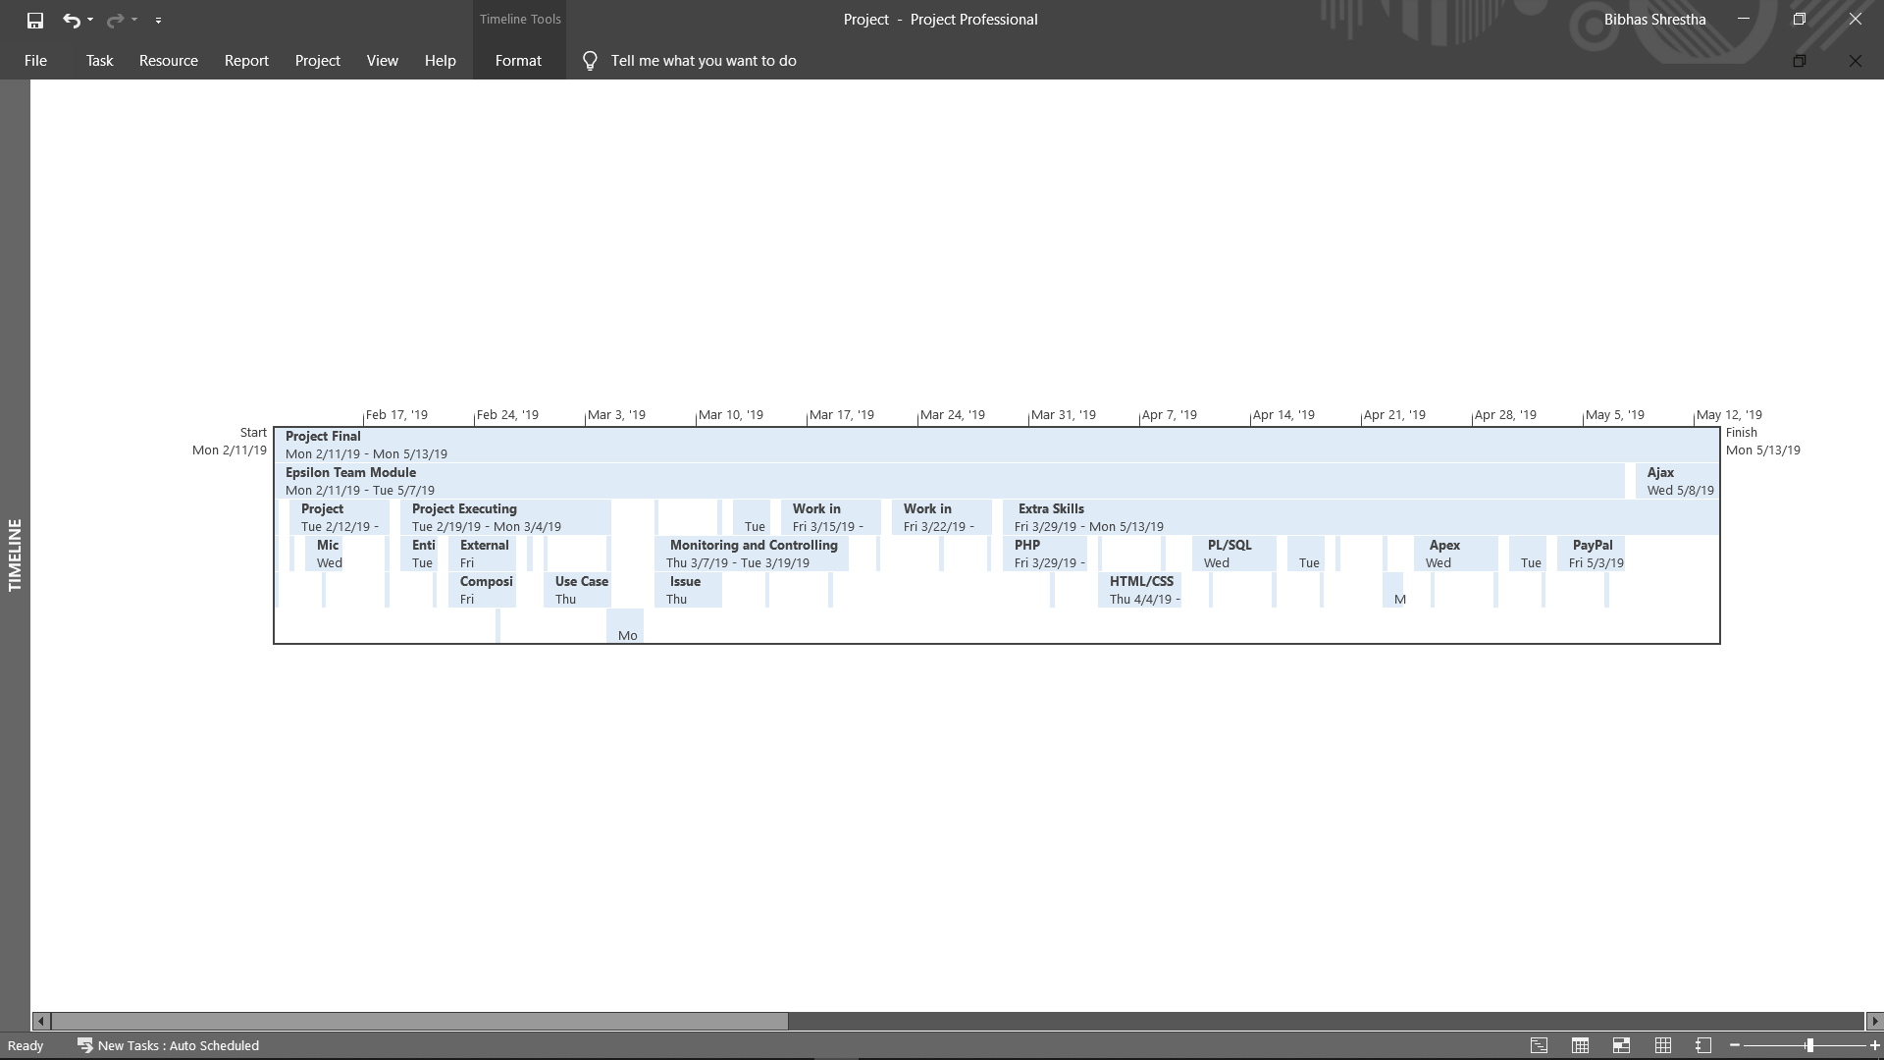

## 2.2.2 Task Sheet

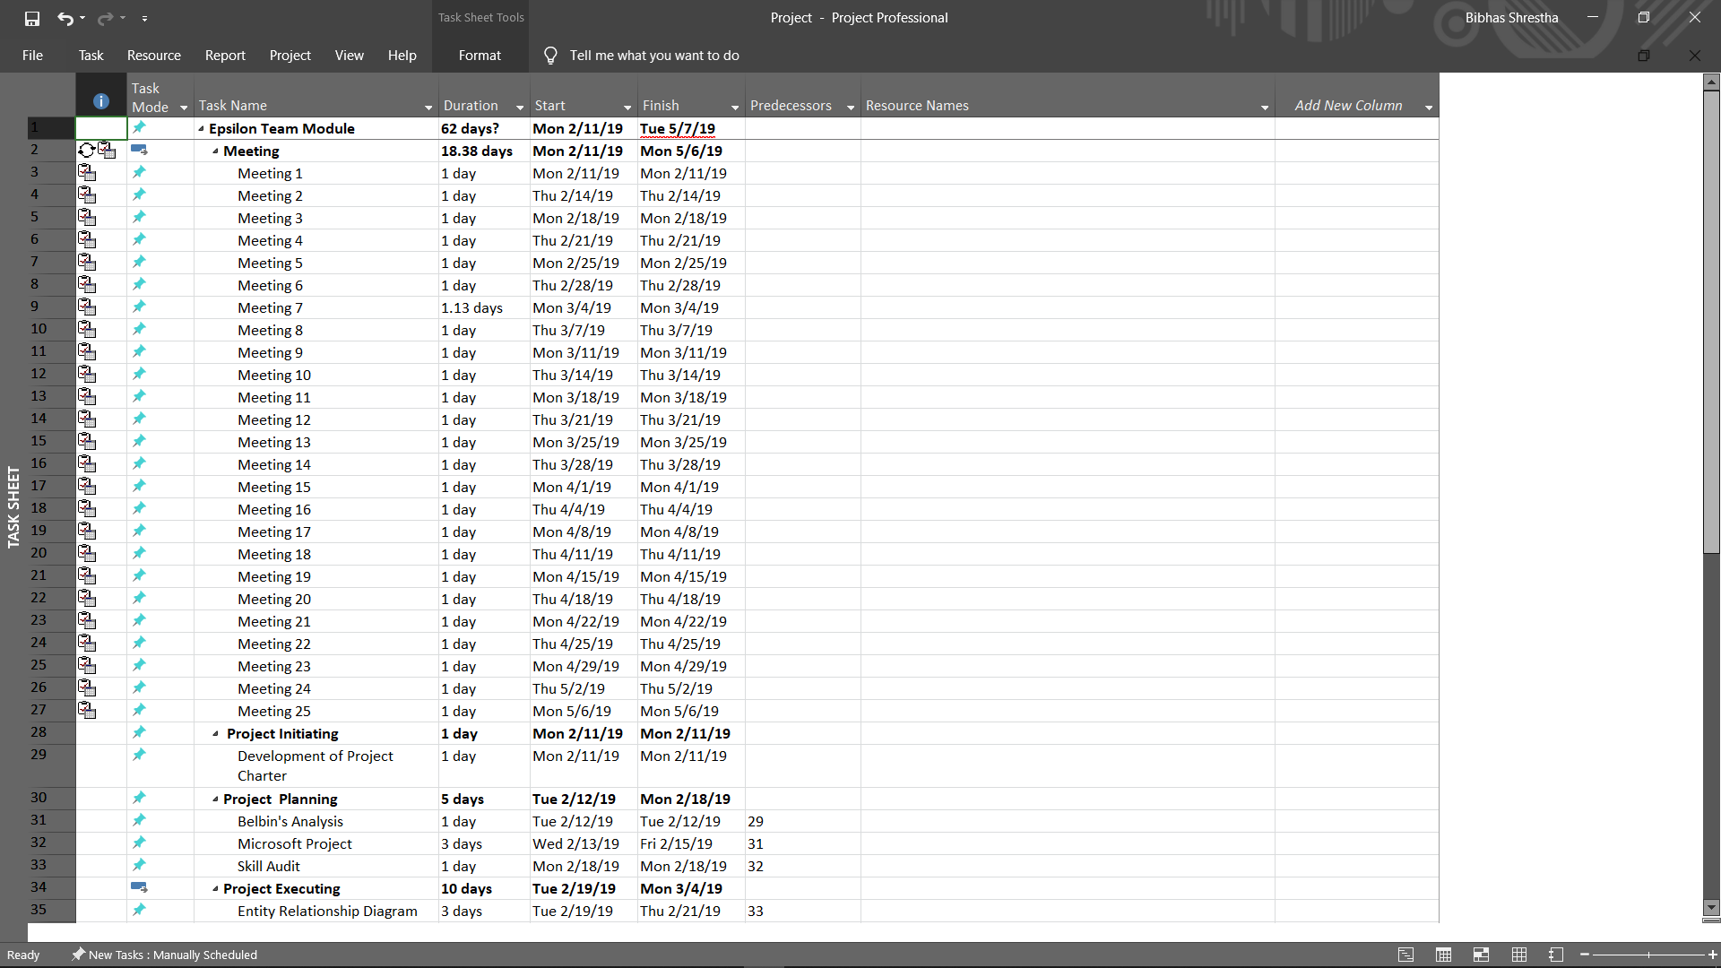

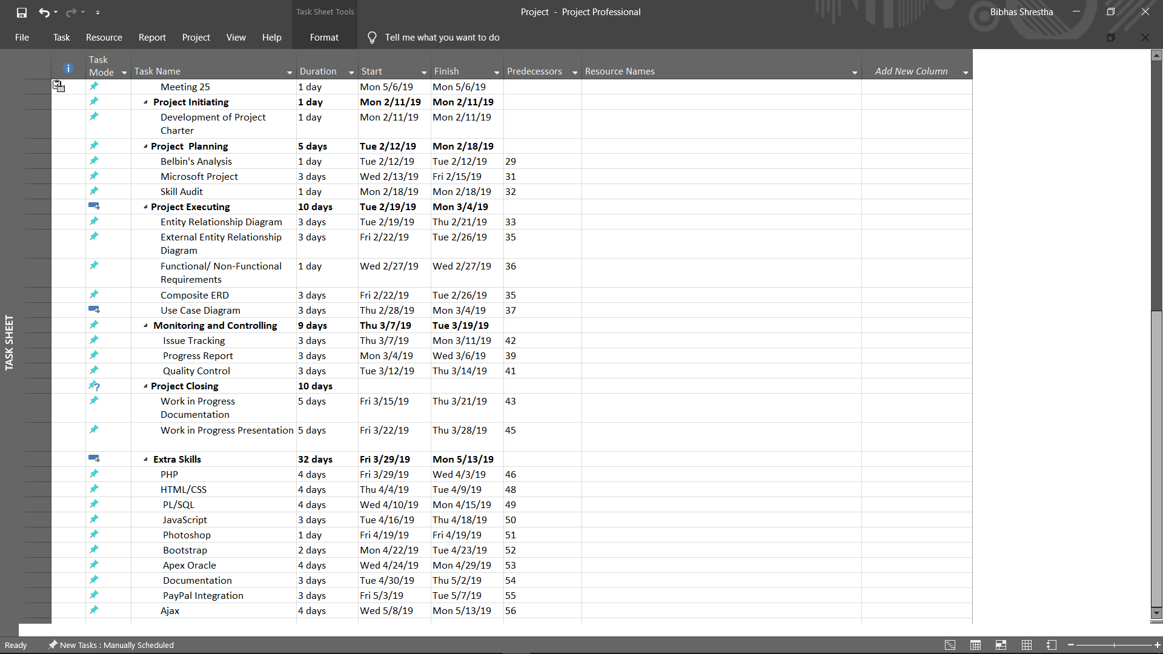

## 2.2.3 Gantt Chart

Gantt chart is a chart in which a series of horizontal lines shows the volume of work done or production completed in certain frame of time in relation to the amount planned for those periods.

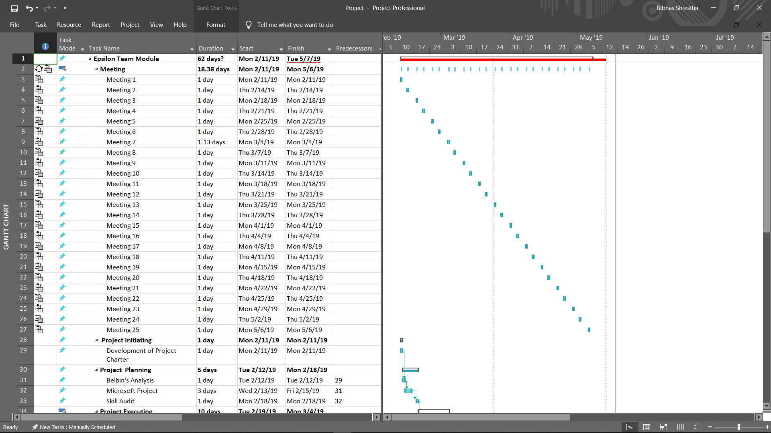

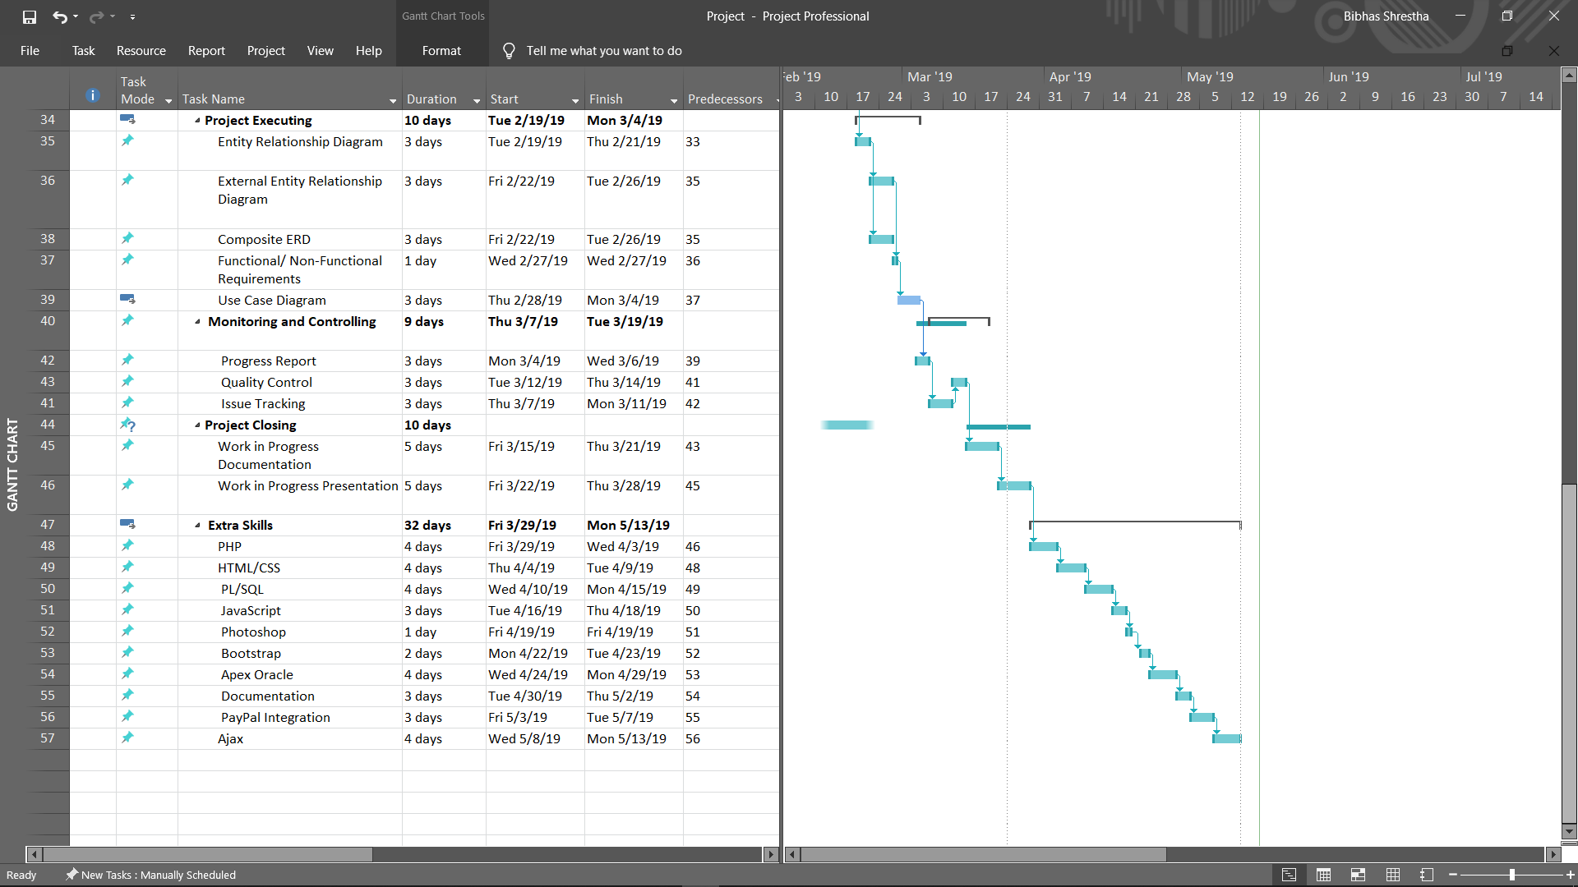

## 2.2.4 Resource Sheet

Resource Sheet is a view within MS Project that allows the user to view, create, and edit resources and resource information.

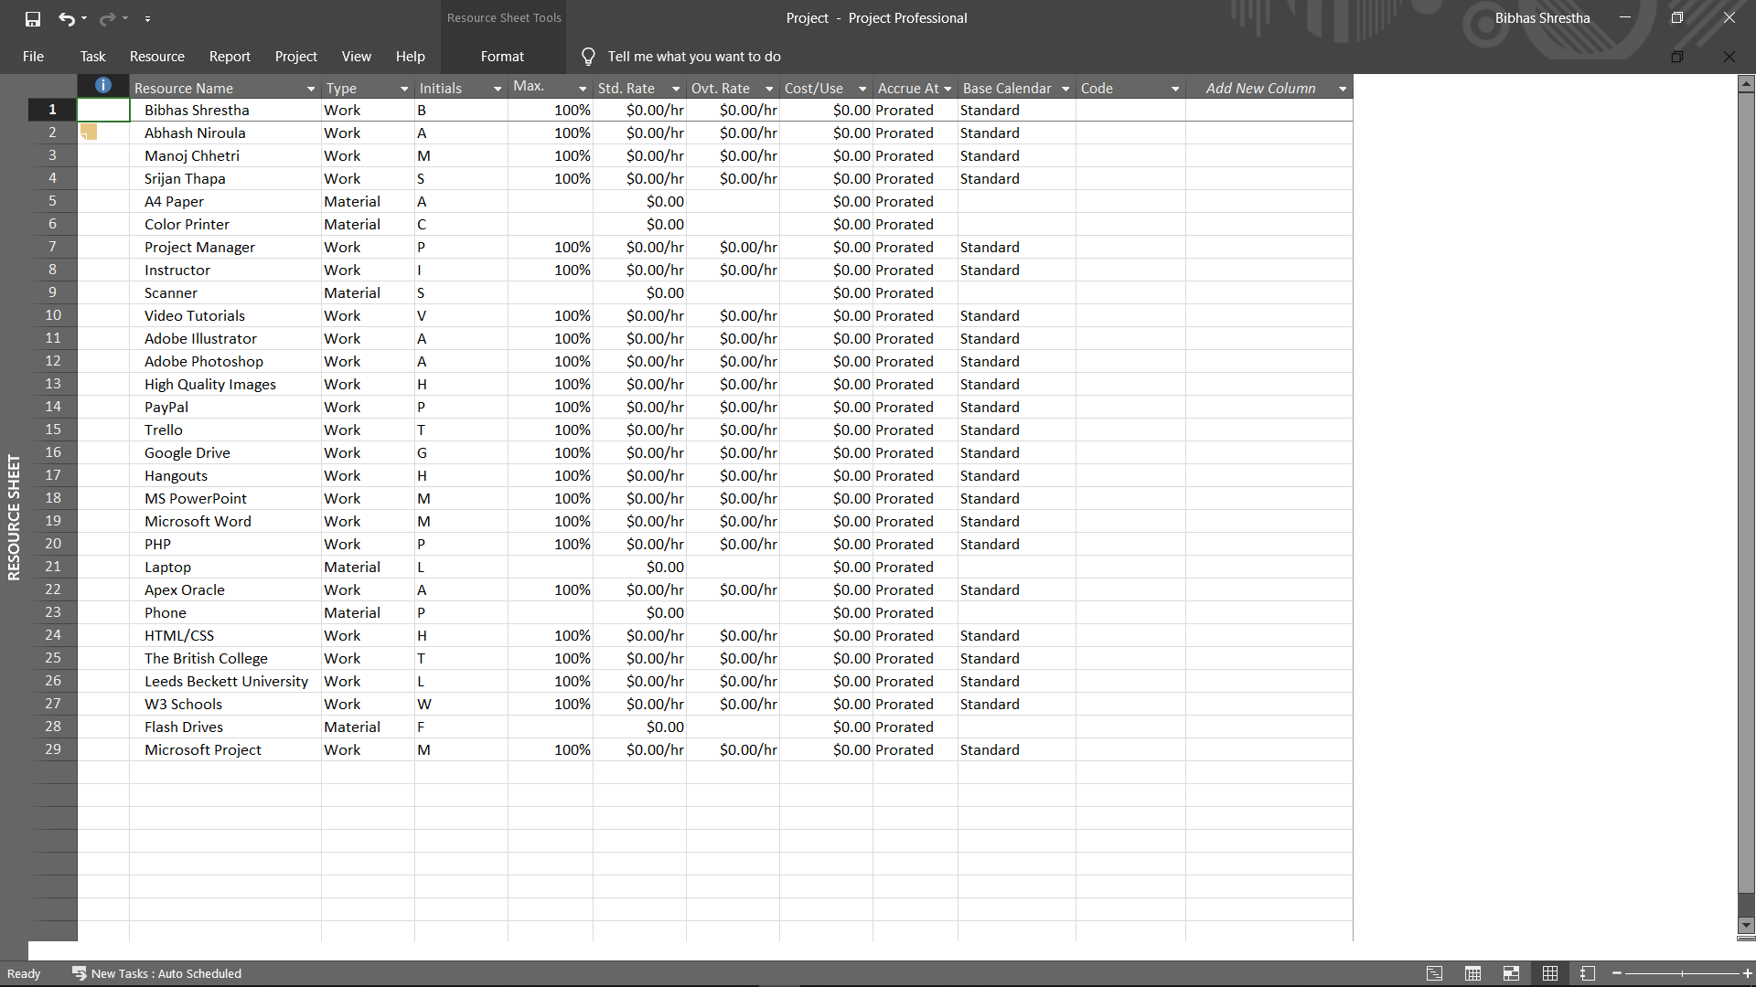

## 2.2.5 Calender

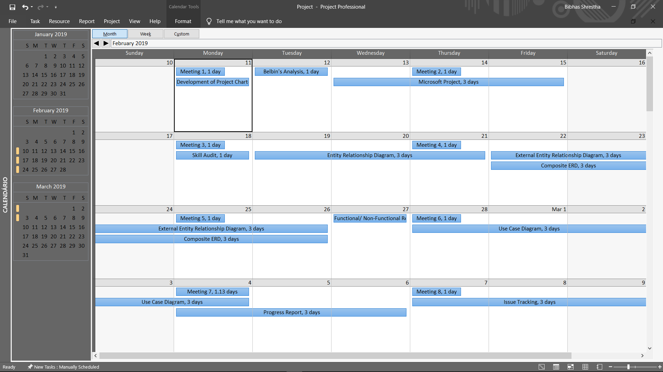

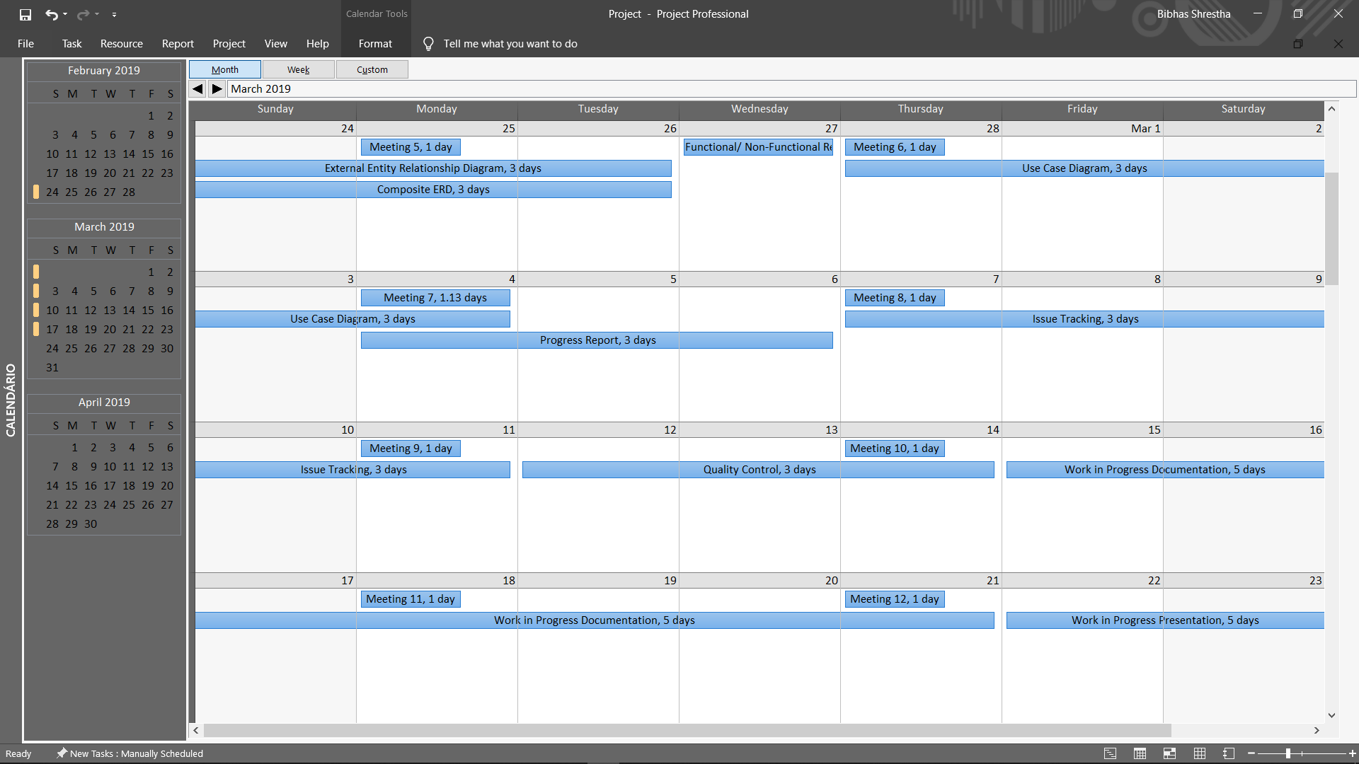

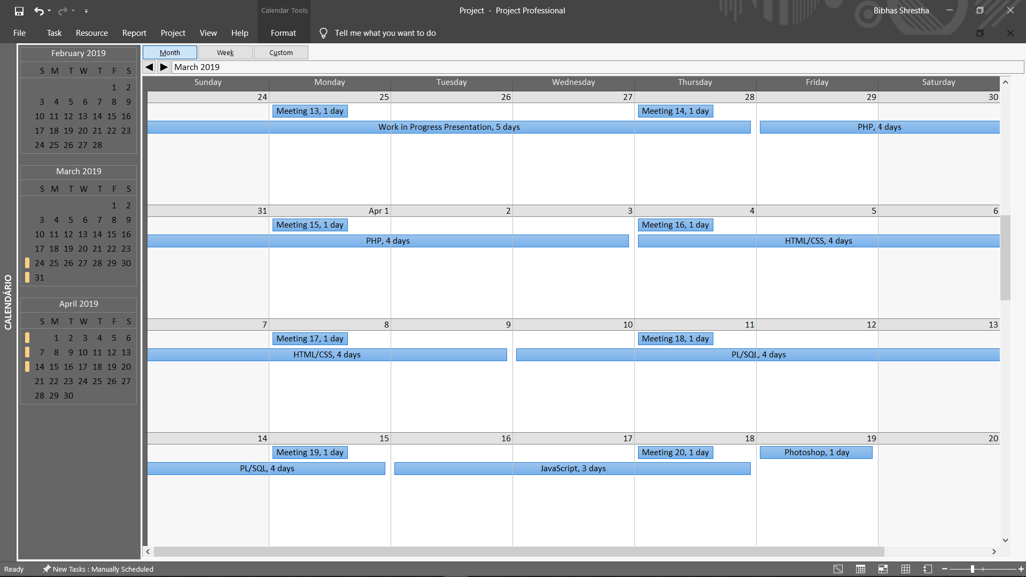

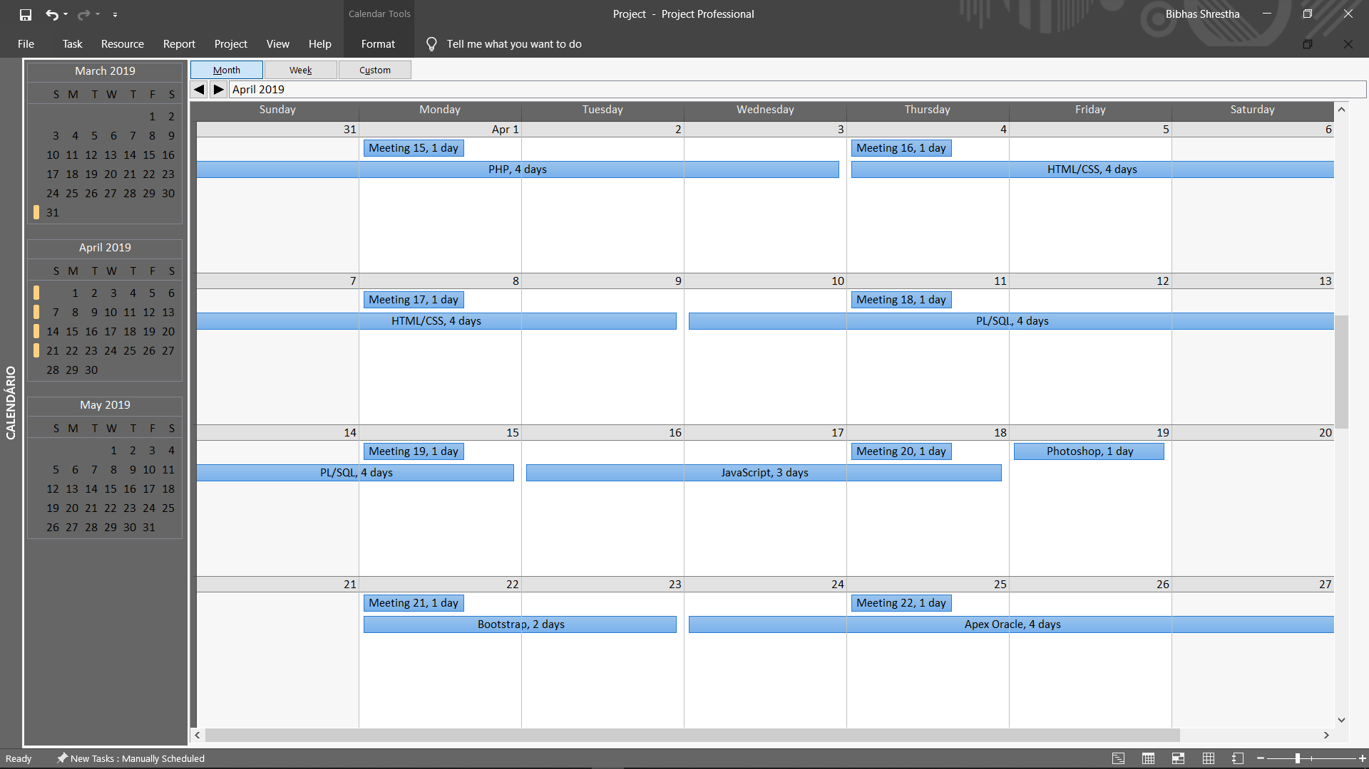

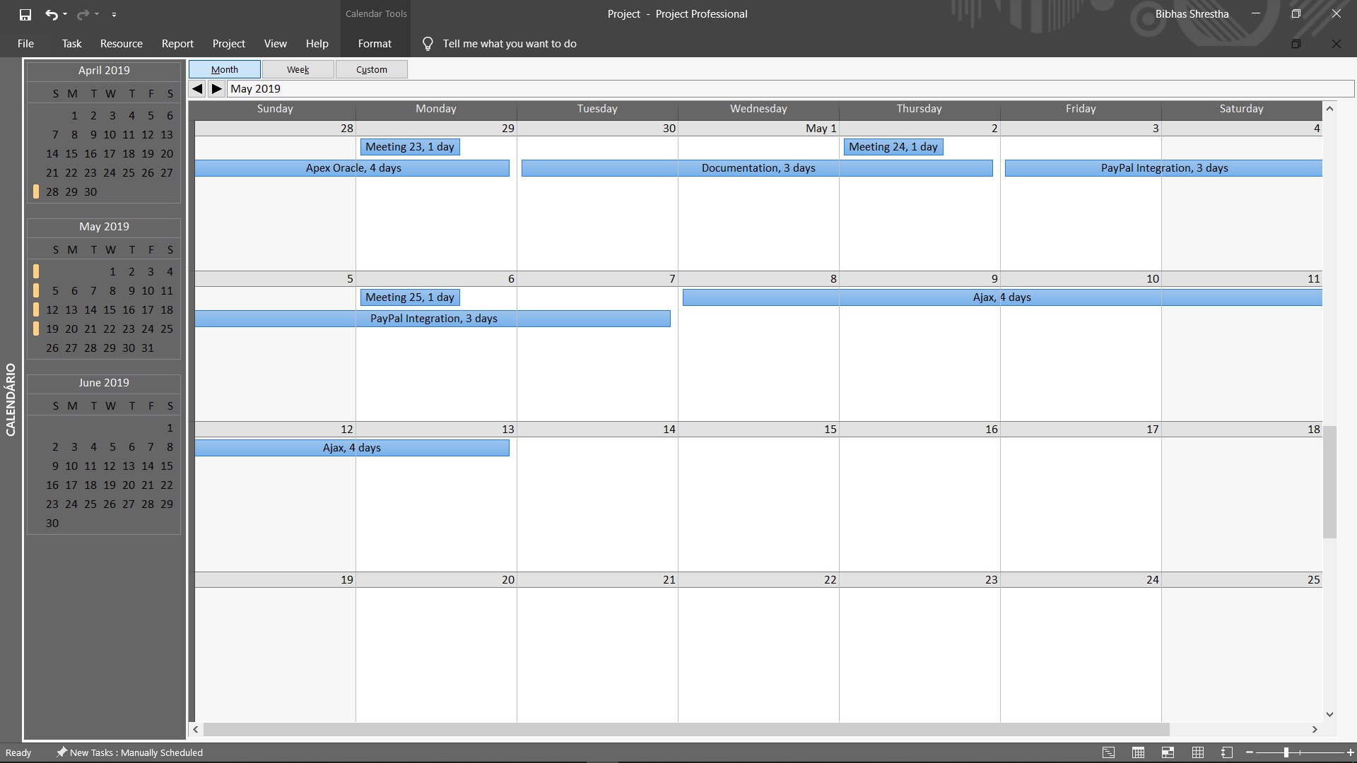

## 

## 2.3 Skill Audit

### 2.3.1 Team Skill Audit

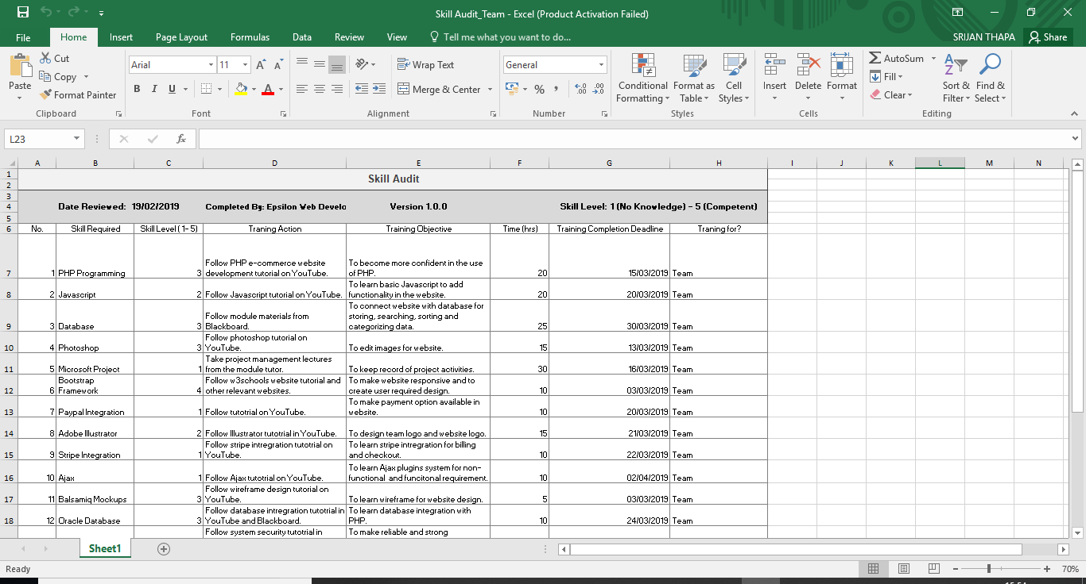

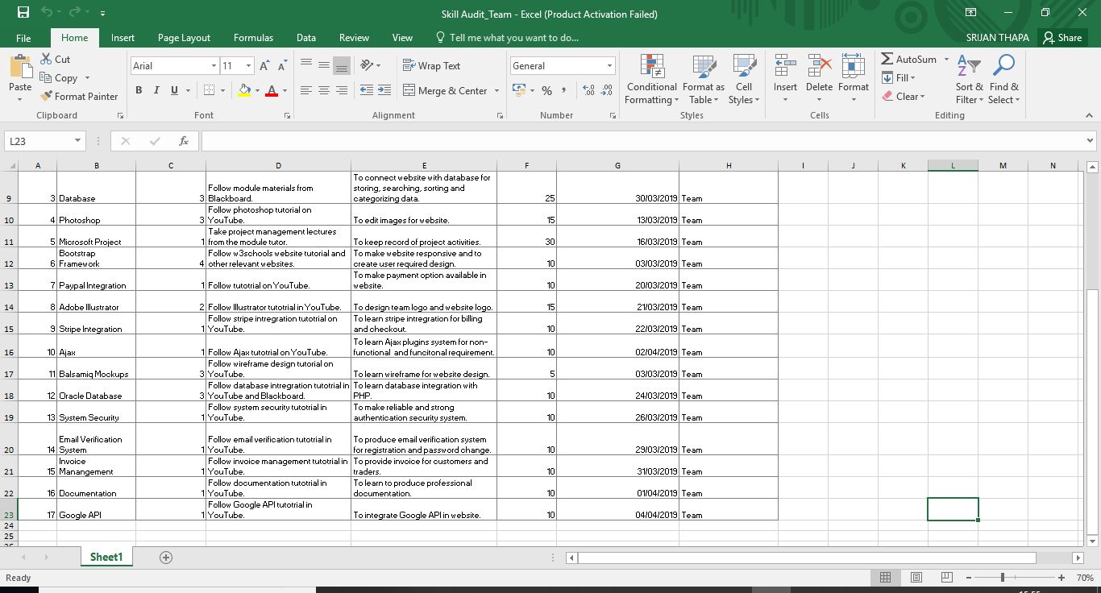

### 

# 3. Project Execution

## 3.1 Design

### 3.1.1 Entity Relationship Diagram

### 3.1.1.1 ERD



### 3.1.1.2 Extended Entity Relationship Diagram



### 3.1.1.3 Composite ERD



### 3.1.1.4 Logical Design

LOGICAL DESIGN

1. User (USER_ID, USER_NAME, USER_DOB)

2. Trader (USER_ID, TRADER_NAME, TRADER_ADDRESS, TRADER_PHONE,

TRADER_EMAIL)

3. Management (USER_ID, MANAGEMENT _NAME, MANAGEMENT _ADDRESS,

MANAGEMENT _PHONE, MANAGEMENT _EMAIL)

4. Customer (USER_ID, CUSTOMER_NAME, CUSTOMER _ADDRESS, CUSTOMER

_PHONE, CUSTOMER _EMAIL)

5. Shop (SHOP_ID, SHOP_NAME, SHOP _ADDRESS, SHOP _PHONE, SHOP _EMAIL,

USER_ID)

6. Product_Type (PRODUCT_TYPE_ID, PRODUCT_TYPE_NAME)

7. Product_Offer (PRODUCT_OFFER_ID, PRODUCT_OFFER_AMOUNT)

8. Product (PRODUCT_ID, PRODUCT_NAME, PRODUCT_PRICE, SHOP_ID,

PRODUCT_TYPE_ID, PRODUCT_OFFER_ID)

9. Cart (CART_ID, CART_NAME, PRODUCT_ID)

10. Order_Details (ORDER_ID, ORDER_DATE, ORDER_NAME, USER_ID)

11. Collection_Slot (COLLECTION_SLOT_ID, COLLECTION_SLOT_NAME, ORDER_ID)

12. Product_Order (PRODUCT_ORDER_ID, PRODUCT_ORDER_NAME)

13. Payment (PAYMENT_ID, PAYMENT_AMOUNT, CART_ID, ORDER_ID,

PRODUCT_ORDER_ID)

### 3.1.2 Requirement Catalogue

### 3.1.2.1 Functional Requirements

#### Part A: Customer

| Requirement ID | Description | MoSCoW |
| --- | --- | --- |
| A1 | **An interface to allow customers to view items** |  |
| A1-01 | Customers should be able to navigate to products by shop or by product type. | M |
| A1-02 | Customers will be able to display items by category. | M |
| A1-03 | Customers will be able to search for items by open text search. | M |
| A1-04 | Customers will be able to sort items displayed appropriately e.g. alphabetical, date, price etc. | S |
| A1-05 | Customers will be able to sort/search items based on multiple search criteria | S |
| A2 | **Cart functionality for Customers** |  |
| A2-01 | Customers should be provided with a single basket that holds goods that spans all traders and requires a single payment. | M |
| A2-02 | Customers should be required to register before they can place an order and be logged in to access the basket. | M |
| A2-03 | Customers will be able to update or delete products in their cart list. | M |
| A3 | **Login and Registration Facility** |  |
| A3-01 | Customers should be able to review and update their account details. | M |
| A3-02 | Registration and account updates should be confirmed through interaction from email. | M |
| A3-03 | Customers will be provided with a form to register to the website. | M |
| A3-04 | Customers will be able to deactivate or delete their account. | M |
| A4 | **Payment system for the Customer** |  |
| A4-01 | Customers will be provided with a bill of products in their cart before checking out. | M |
| A4-02 | Customers will be provided with an invoice after the checkout is complete. | M |
| A4-03 | Customers will be provided with timeslots for the collection of products. | M |
| A4-04 | Customers will be provided with an online payment option. | M |

#### Part B: Trader

| Requirement ID | Description | MoSCoW |
| --- | --- | --- |
| B1 | **An Interface for traders** |  |
| B1-01 | Traders should be able to manage their products and information on their shops via a web interface. | M |
| B2-02 | Traders should be able to view and update the details of their account. | M |
| B2-03 | Traders will be able to deactivate their account. | M |
| B2-04 | Traders will be provided with terms of agreement and verification to create their account | M |
| B2 | **An Interface for traders to use CRUD functionality** |  |
| B2-01 | Traders will be able to add product items. | M |
| B2-02 | Products added will have a unique id and be associated to the trader. | M |
| B2-03 | Traders will be able to edit their product details. | M |
| B2-04 | Traders will be able to delete their product | M |
| B2-05 | Traders will be given the option to provide discount on their products. | S |
| B3 | **Reports and Accessibility** |  |
| B3-01 | Traders will receive invoice for their sales on the website. | M |
| B3-02 | Traders will be able to view their product rating. | C |
| B3-03 | Traders will be provided with periodic reports on orders and stock levels in their account. | S |
| B3-04 | Traders will be provided with their financial report and statement on request. | C |
| B3-05 | Traders will be able to view comments on their products. | W |
| B3-06 | Traders will be able to change their collection slot details. | W |

#### Part C: Management

| Requirement ID | Description | MoSCoW |
| --- | --- | --- |
| C1 | **Login Privilege** |  |
| C1-01 | Login will be provided for the management which will direct the to the management dashboard. | M |
| C1-02 | Management will also be able to access the website. | M |
| C2 | **Management Dashboard** |  |
| C2-01 | An active management dashboard link will be provided once an admin user has logged in. | M |
| C2-02 | The management page will display all activities of traders. | M |
| C3-03 | The management will have the facility to monitor trader activity. | S |
| C4-04 | The management will be able to block trader if the trader violates the terms of agreement. | M |
| C1-05 | The management will be able to accept or decline new trader requests. | S |
| C1-06 | The management will get the daily financial turnover report in the dashboard. | C |
| C3 | **Management Accessibility** |  |
| C3-01 | The management will be able to delete inappropriate products in the website. | M |
| C3-02 | The management will be able to deactivate customer and trader account. | M |
| C3-03 | The management will be able to provide new login credentials. | M |
| C3-04 | The management will be able to send email verification to customers and traders. | M |

#### Part D: User

| Requirement ID | Description | MoSCoW |
| --- | --- | --- |
| D1 | **Registration** |  |
| D1-01 | Registration form will be provided to new users. | M |
| D1-02 | Users will be provided with email verification before signing in on the website. | M |
| D1-03 | The user will be provided with the option to change their password through email verification in the case they forget their password. | C |
| D2 | **View items on the interface** |  |
| D2-01 | The user will be able to view items on the e-commerce platform. | M |
| D2-02 | The user will be able to sort items on the website. | M |
| D2-03 | The user will be able to search for item on the website. | M |
| D2-04 | The user will be able to categorize items on the website. | M |

### 3.1.2.1 Non-Functional Requirements

| Requirement ID | Description | MoSCoW |
| --- | --- | --- |
| D1 | **The website will comply with the following non-functional requirements.** |  |
| D1-01 | HTML/CSS template will be used as suited to requirements. | M |
| D1-02 | The template will be applied consistently throughout the site. | S |
| D1-03 | Third party plugins will be used for extra functionality. | C |
| D1-04 | Laravel framework will be used to create the website. | S |
| D1-05 | JavaScript will be used for web functionality. | S |
| D1-06 | The customers will be able to view their purchase records. | W |
| D1-07 | The customers would be able to like or dislike comments on the products. | W |
| D1-08 | Product offers and advertisements would be provided to the customers via email. | W |
| D1-09 | Customers would be able to share products on their social media handles. | W |
| D1-10 | The web interface will be made responsive for use across multiple devices. | S |

### 3.1.3 Use Case Diagram

### 3.1.3.1 Overview Use Case Diagram



### 3.1.3.2 Customer Use Case Diagram



### 3.1.3.3 Trader Use Case Diagram



### 3.1.3.4 Management Use Case Diagram



### 3.1.3.5 User Use Case Diagram



### 3.2 Oracle Tables

### 3.2.1 Data for Tables

Categories

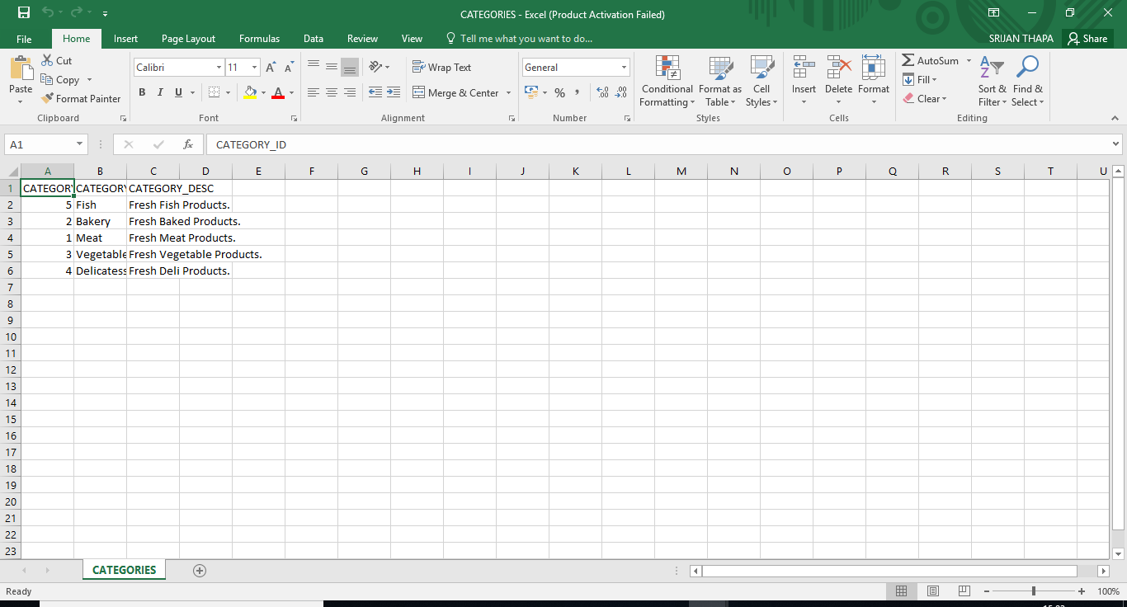

Customer_Order

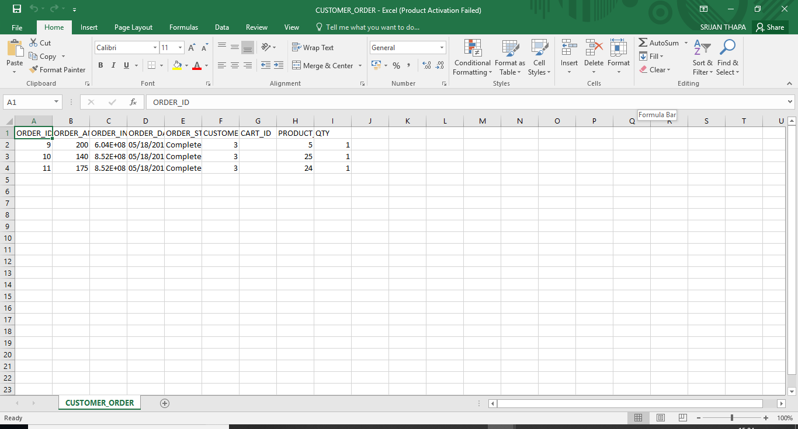

Customer

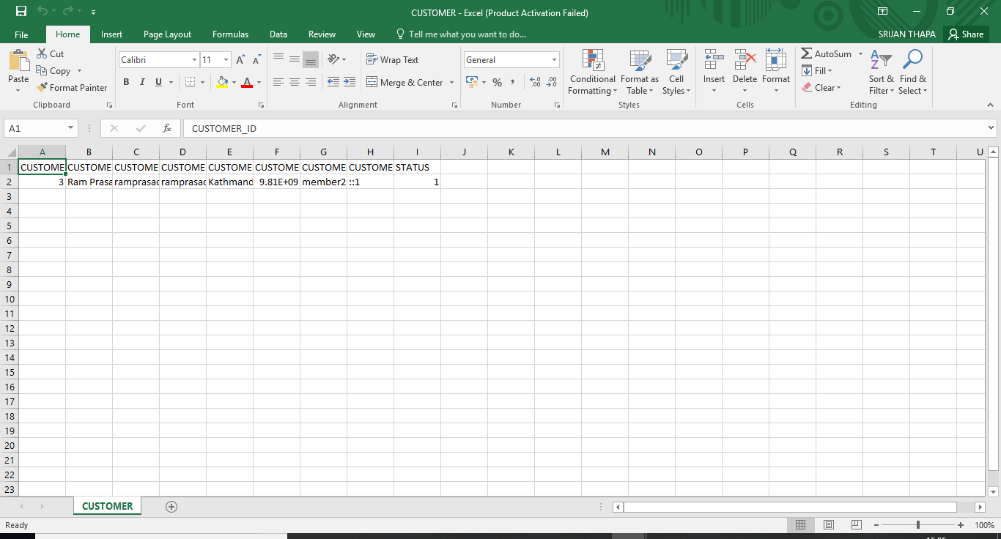

Product

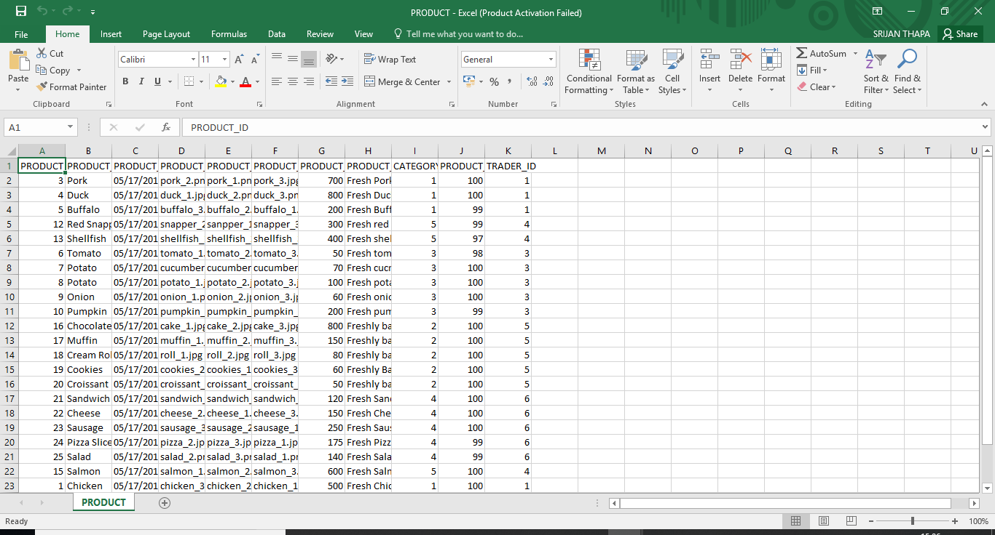

Slider

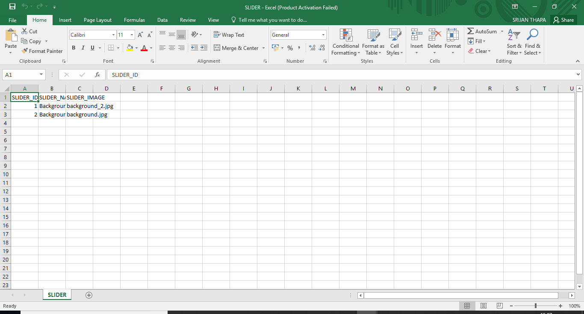

Timeslot

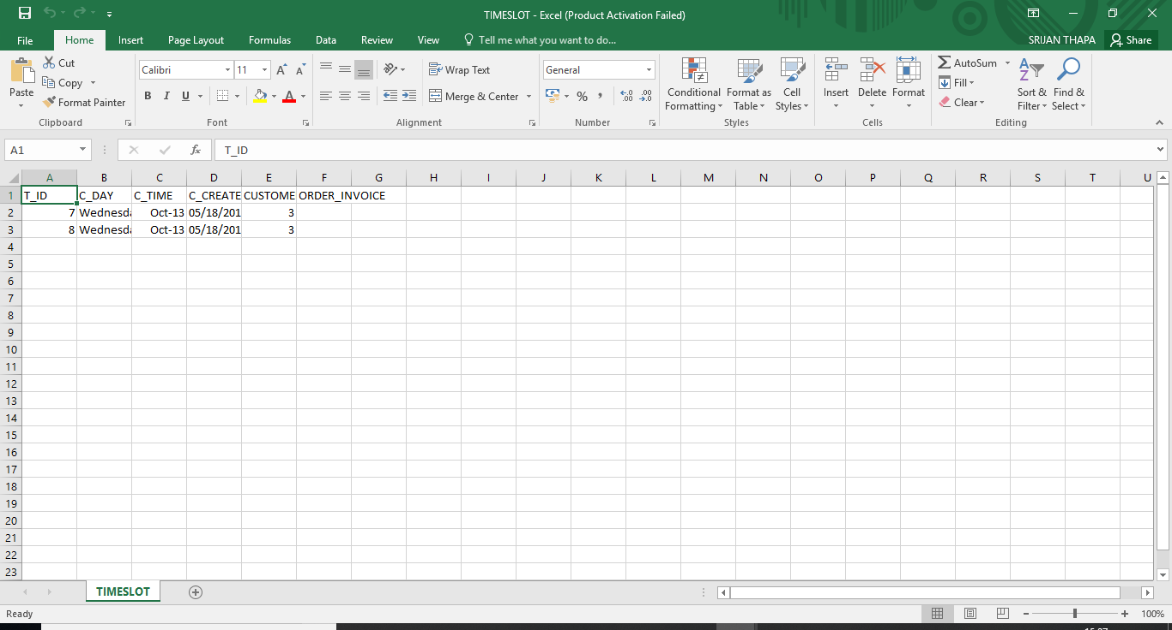

Trader

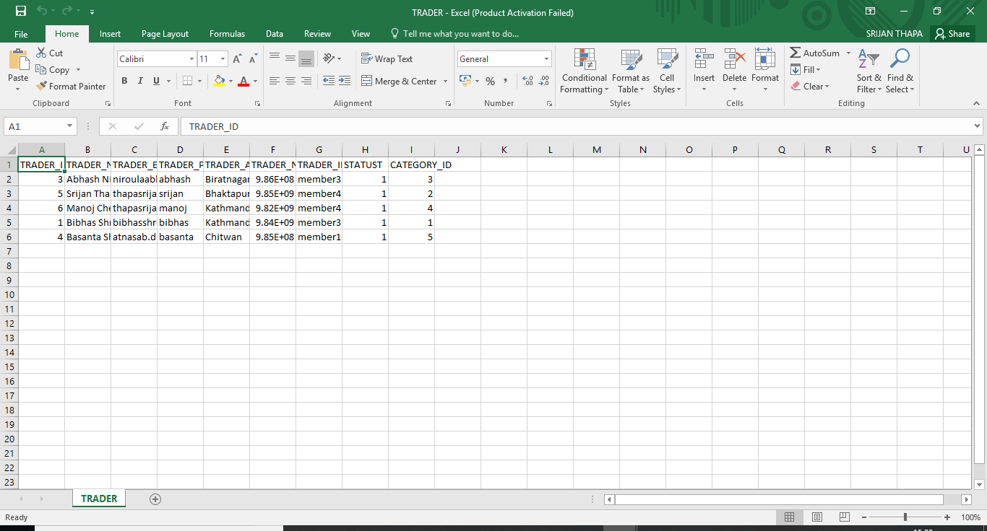

### 3.2.2 SQL Code For Table Generation

ch_grocers..sql

DROP TABLE CART CASCADE CONSTRAINTS;

CREATE TABLE CART(

CART_ID NUMBER(10) PRIMARY KEY,

CART_QUANTITY NUMBER(10),

IP_ADD VARCHAR2(255)

);

DROP SEQUENCE CART_SEQ;

CREATE SEQUENCE CART_SEQ START WITH 1;

DROP TABLE CATEGORIES CASCADE CONSTRAINTS;

CREATE TABLE CATEGORIES(

CATEGORY_ID NUMBER(10) PRIMARY KEY,

CATEGORY_NAME VARCHAR2(50) ,

CATEGORY_DESC VARCHAR2(300)

);

DROP SEQUENCE CATEGORY_SEQ;

CREATE SEQUENCE CATEGORY_SEQ START WITH 1;

DROP TABLE TRADER CASCADE CONSTRAINTS;

CREATE TABLE TRADER(

TRADER_ID NUMBER(10) PRIMARY KEY,

TRADER_NAME VARCHAR2(50) ,

TRADER_EMAIL VARCHAR2(50) ,

TRADER_PASSWORD VARCHAR2(50) ,

TRADER_ADDRESS VARCHAR2(100) ,

TRADER_NUMBER VARCHAR2(100) ,

TRADER_IMAGE VARCHAR2(100) ,

STATUST NUMBER(10),

CATEGORY_ID NUMBER(10) REFERENCES CATEGORIES(CATEGORY_ID) ON DELETE CASCADE

);

DROP SEQUENCE TRADER_SEQ;

CREATE SEQUENCE TRADER_SEQ START WITH 1;

DROP TABLE CUSTOMER CASCADE CONSTRAINTS;

CREATE TABLE CUSTOMER(

CUSTOMER_ID NUMBER(30) PRIMARY KEY,

CUSTOMER_NAME VARCHAR2(100) ,

CUSTOMER_EMAIL VARCHAR2(50) ,

CUSTOMER_PASSWORD VARCHAR2(50) ,

CUSTOMER_ADDRESS VARCHAR2(100) ,

CUSTOMER_NUMBER NUMBER(20) ,

CUSTOMER_IMAGE VARCHAR2(100),

CUSTOMER_IP VARCHAR2(255),

STATUS NUMBER(10)

);

DROP SEQUENCE CUSTOMER_SEQ;

CREATE SEQUENCE CUSTOMER_SEQ START WITH 1;

DROP TABLE CUSTOMER_ORDER CASCADE CONSTRAINTS;

CREATE TABLE CUSTOMER_ORDER(

ORDER_ID NUMBER(10) PRIMARY KEY,

ORDER_AMOUNT VARCHAR2(255) ,

ORDER_INVOICE VARCHAR2(255) ,

ORDER_DATE DATE ,

ORDER_STATUS VARCHAR2(255) ,

CUSTOMER_ID NUMBER(30) REFERENCES CUSTOMER(CUSTOMER_ID) ON DELETE CASCADE,

CART_ID NUMBER(10) REFERENCES CART(CART_ID) ON DELETE CASCADE,

PRODUCT_ID NUMBER(10) REFERENCES PRODUCT(PRODUCT_ID) ON DELETE CASCADE,

QTY NUMBER(10)

);

DROP SEQUENCE ORDER_SEQ;

CREATE SEQUENCE ORDER_SEQ START WITH 1;

DROP TABLE PAYMENT CASCADE CONSTRAINTS;

CREATE TABLE PAYMENT(

PAYMENT_ID NUMBER(10) PRIMARY KEY,

PAYMENT_DATE DATE ,

PAYMENT_MODE VARCHAR2(50) ,

PAYMENT_REF NUMBER(10) ,

PAYMENT_CODE NUMBER(10) ,

ORDER_ID NUMBER(10) REFERENCES CUSTOMER_ORDER(ORDER_ID) ON DELETE CASCADE

);

DROP SEQUENCE PAYMENT_SEQ;

CREATE SEQUENCE PAYMENT_SEQ START WITH 1;

DROP TABLE PRODUCT CASCADE CONSTRAINTS;

CREATE TABLE PRODUCT(

PRODUCT_ID NUMBER(10) PRIMARY KEY,

PRODUCT_TITLE VARCHAR2(50) ,

PRODUCT_DATE DATE ,

PRODUCT_IMG1 VARCHAR2(1000) ,

PRODUCT_IMG2 VARCHAR2(1000) ,

PRODUCT_IMG3 VARCHAR2(1000) ,

PRODUCT_PRICE NUMBER(10) ,

PRODUCT_DESC VARCHAR2(300),

CATEGORY_ID NUMBER(10) REFERENCES CATEGORIES(CATEGORY_ID) ON DELETE CASCADE,

PRODUCT_QUANTITY NUMBER(10),

TRADER_ID NUMBER(10) REFERENCES TRADER(TRADER_ID) ON DELETE CASCADE

);

DROP SEQUENCE PRODUCT_SEQ;

CREATE SEQUENCE PRODUCT_SEQ START WITH 1;

DROP TABLE SLIDER CASCADE CONSTRAINTS;

CREATE TABLE SLIDER(

SLIDER_ID NUMBER(10) PRIMARY KEY,

SLIDER_NAME VARCHAR2(100) ,

SLIDER_IMAGE VARCHAR2(100)

);

DROP SEQUENCE T_SEQ;

CREATE SEQUENCE T_SEQ START WITH 1;

DROP TABLE TIMESLOT CASCADE CONSTRAINTS;

CREATE TABLE TIMESLOT(

T_ID NUMBER(30) PRIMARY KEY,

C_DAY VARCHAR2(255),

C_TIME VARCHAR2(255),

C_CREATED DATE,

CUSTOMER_ID NUMBER(30) REFERENCES CUSTOMER(CUSTOMER_ID) ON DELETE CASCADE,

ORDER_INVOICE VARCHAR2(255)

);

CREATE OR REPLACE TRIGGER "CATEGORY_T"

before insert on "CATEGORIES"

for each row

begin

if :NEW."CATEGORY_ID" is null then

select "CATEGORY_SEQ".nextval into :NEW."CATEGORY_ID" from dual;

end if;

end;

/

ALTER TRIGGER "CATEGORY_T" ENABLE;

CREATE OR REPLACE TRIGGER "TIME_T"

before insert on "TIMESLOT"

for each row

begin

if :NEW."T_ID" is null then

select "T_SEQ".nextval into :NEW."T_ID" from dual;

end if;

end;

/

ALTER TRIGGER "TIME_T" ENABLE;

CREATE OR REPLACE TRIGGER "CART_T"

before insert on "CART"

for each row

begin

if :NEW."CART_ID" is null then

select "CART_SEQ".nextval into :NEW."CART_ID" from dual;

end if;

end;

/

ALTER TRIGGER "CART_T" ENABLE;

CREATE OR REPLACE TRIGGER "CUSTOMER_T"

before insert on "CUSTOMER"

for each row

begin

if :NEW."CUSTOMER_ID" is null then

select "CUSTOMER_SEQ".nextval into :NEW."CUSTOMER_ID" from dual;

end if;

end;

/

ALTER TRIGGER "CUSTOMER_T" ENABLE;

CREATE OR REPLACE TRIGGER "PRODUCT_T"

before insert on "PRODUCT"

for each row

begin

if :NEW."PRODUCT_ID" is null then

select "PRODUCT_SEQ".nextval into :NEW."PRODUCT_ID" from dual;

end if;

end;

/

ALTER TRIGGER "PRODUCT_T" ENABLE;

CREATE OR REPLACE TRIGGER "CUSTOMERO_T"

before insert on "CUSTOMER_ORDER"

for each row

begin

if :NEW."ORDER_ID" is null then

select "ORDER_SEQ".nextval into :NEW."ORDER_ID" from dual;

end if;

end;

/

ALTER TRIGGER "CUSTOMERO_T" ENABLE;

CREATE OR REPLACE TRIGGER "TRADER_T"

before insert on "TRADER"

for each row

begin

if :NEW."TRADER_ID" is null then

select "TRADER_SEQ".nextval into :NEW."TRADER_ID" from dual;

end if;

end;

/

ALTER TRIGGER "TRADER_T" ENABLE;

package_head.sql

create or replace package login_package is

function authenticate_user(p_email varchar2, p_password varchar2)

return boolean;

procedure process_login(p_email varchar2, p_password varchar2,p_app_id number);

end login_package;

/

login_package.sql

create or replace package body login_package is

function authenticate_user(p_email varchar2, p_password varchar2)

return boolean as

v_password TRADER.TRADER_PASSWORD%Type;

v_email TRADER.TRADER_PASSWORD%Type;

begin

if p_email is null or p_password is null then

Apex_Util.Set_Session_State('LOGIN_MESSAGE'

,'Please enter email and password.');

Return False;

End If;

Begin

Select u.TRADER_EMAIL,u.TRADER_PASSWORD into v_email,v_password

from TRADER u

where upper(u.TRADER_EMAIL)=upper(p_email) and u.TRADER_PASSWORD = p_password;

return true;

exception

When No_Data_Found Then

-- Write to Session, User not found.

Apex_Util.Set_Session_State('LOGIN_MESSAGE'

,'User not found');

Return False;

End;

if v_password<>p_password then

-- Write to Session, Password incorrect.

Apex_Util.Set_Session_State('LOGIN_MESSAGE'

,'Password incorrect');

Return False;

End If;

Apex_Util.Set_Session_State('SESSION_EMAIL'

,p_email);

Return True;

End;

Procedure process_login(p_email varchar2, p_password varchar2, p_app_id number)

as v_result boolean:=False;

Begin

v_result:=Authenticate_User(p_email,p_password);

if v_result=true then

Wwv_Flow_Custom_Auth_Std.Post_Login(p_email -- p_email

,p_password -- p_password

,v('APP_SESSION') -- p_session_dd

,p_app_id || ':1' -- p_Flow_page

);

Else

-- Login Failure, redirect to page 101 (Login Page).

Owa_Util.Redirect_Url('f?p=&APP_ID.:101:&SESSION.');

End If;

End;

End;

/

slider_trigger.sql

DROP SEQUENCE SLIDER_SEQ;

CREATE SEQUENCE SLIDER_SEQ START WITH 1;

DROP TABLE SLIDER;

CREATE TABLE SLIDER

( SLIDER_ID NUMBER(10) PRIMARY KEY,

SLIDER_NAME VARCHAR2(100),

SLIDER_IMAGE VARCHAR2(100)

);

CREATE OR REPLACE TRIGGER SLIDER_T

before insert on SLIDER

for each row

begin

if :NEW.SLIDER_ID is null then

select SLIDER_SEQ.nextval into :NEW.SLIDER_ID from dual;

end if;

end;

ALTER TRIGGER SLIDER_T ENABLE;

### 3.3 Pictorial

### 3.3.1 Customer Interface Web

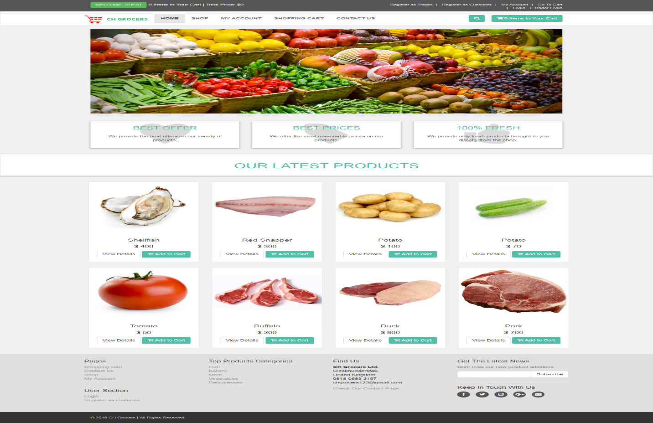

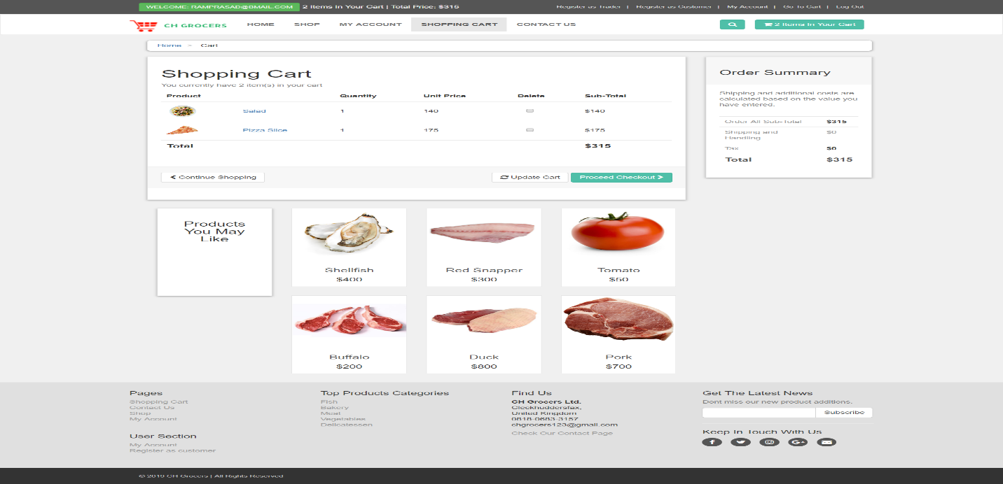

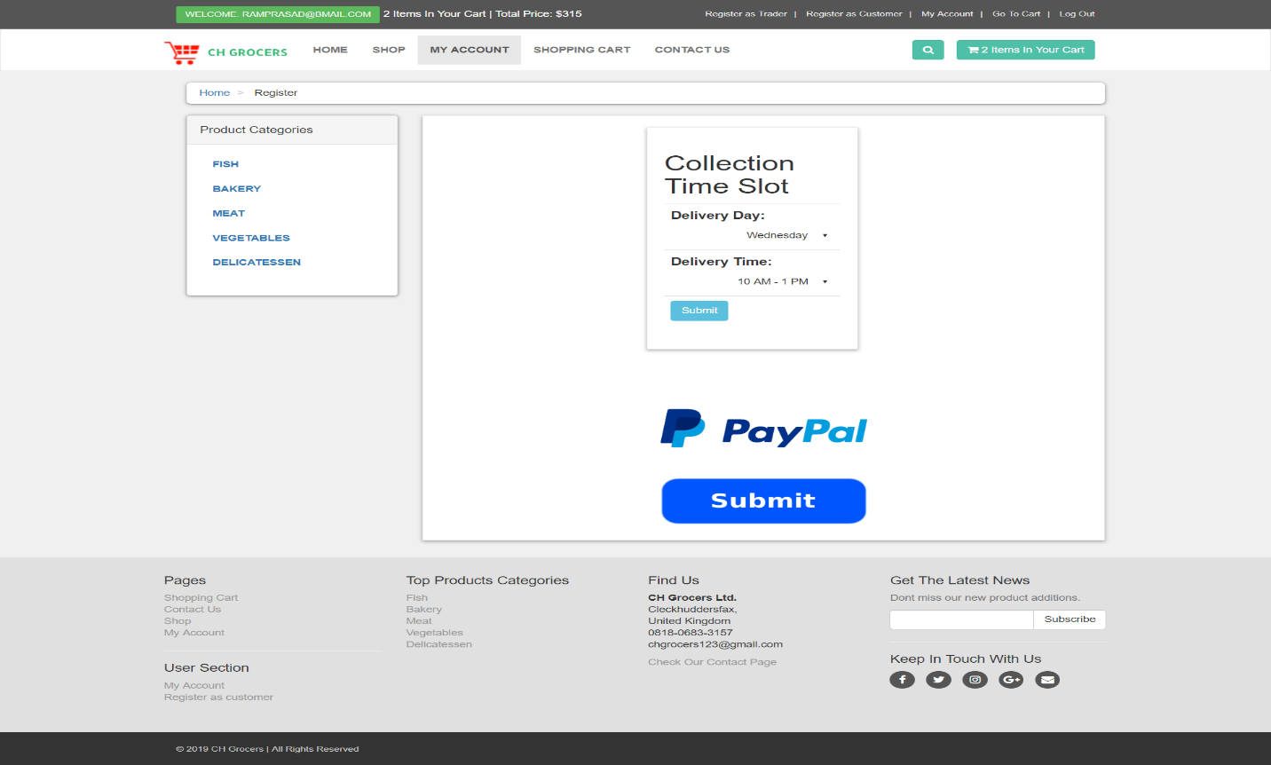

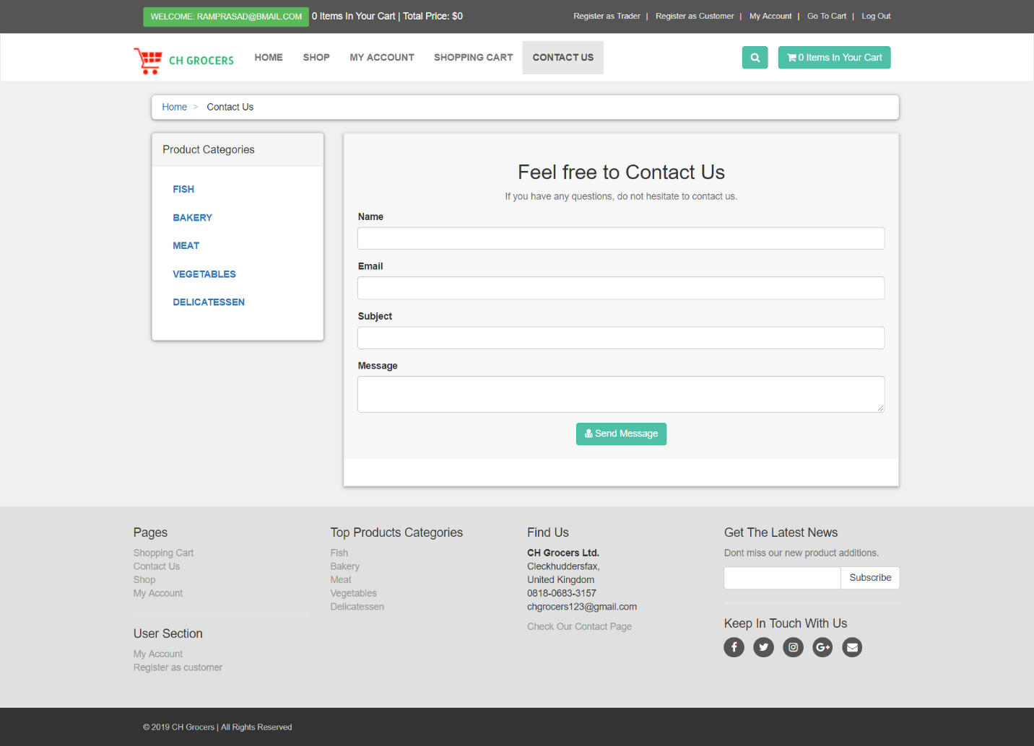

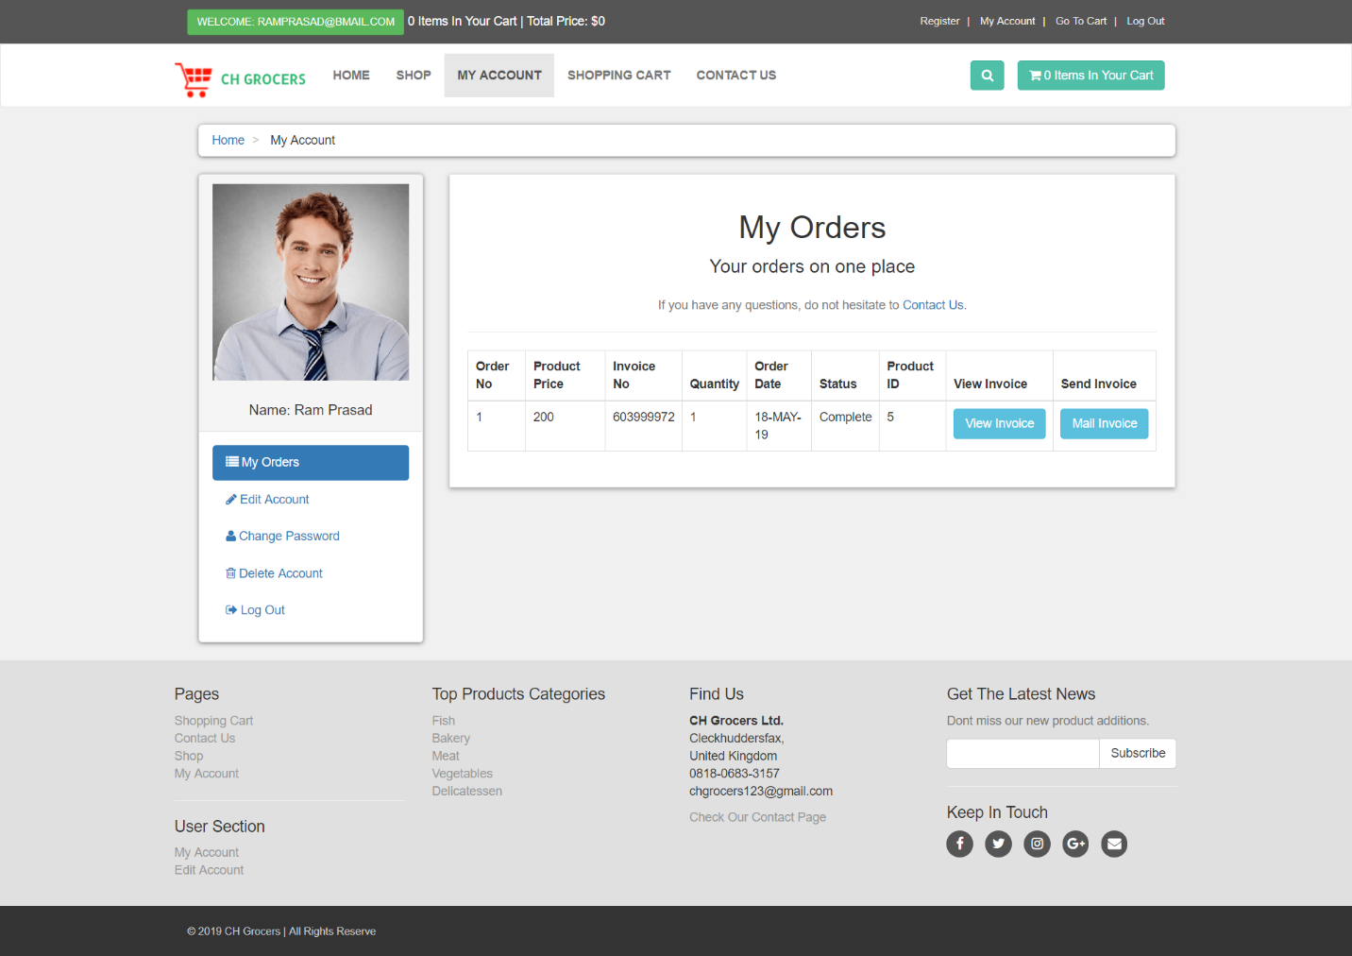

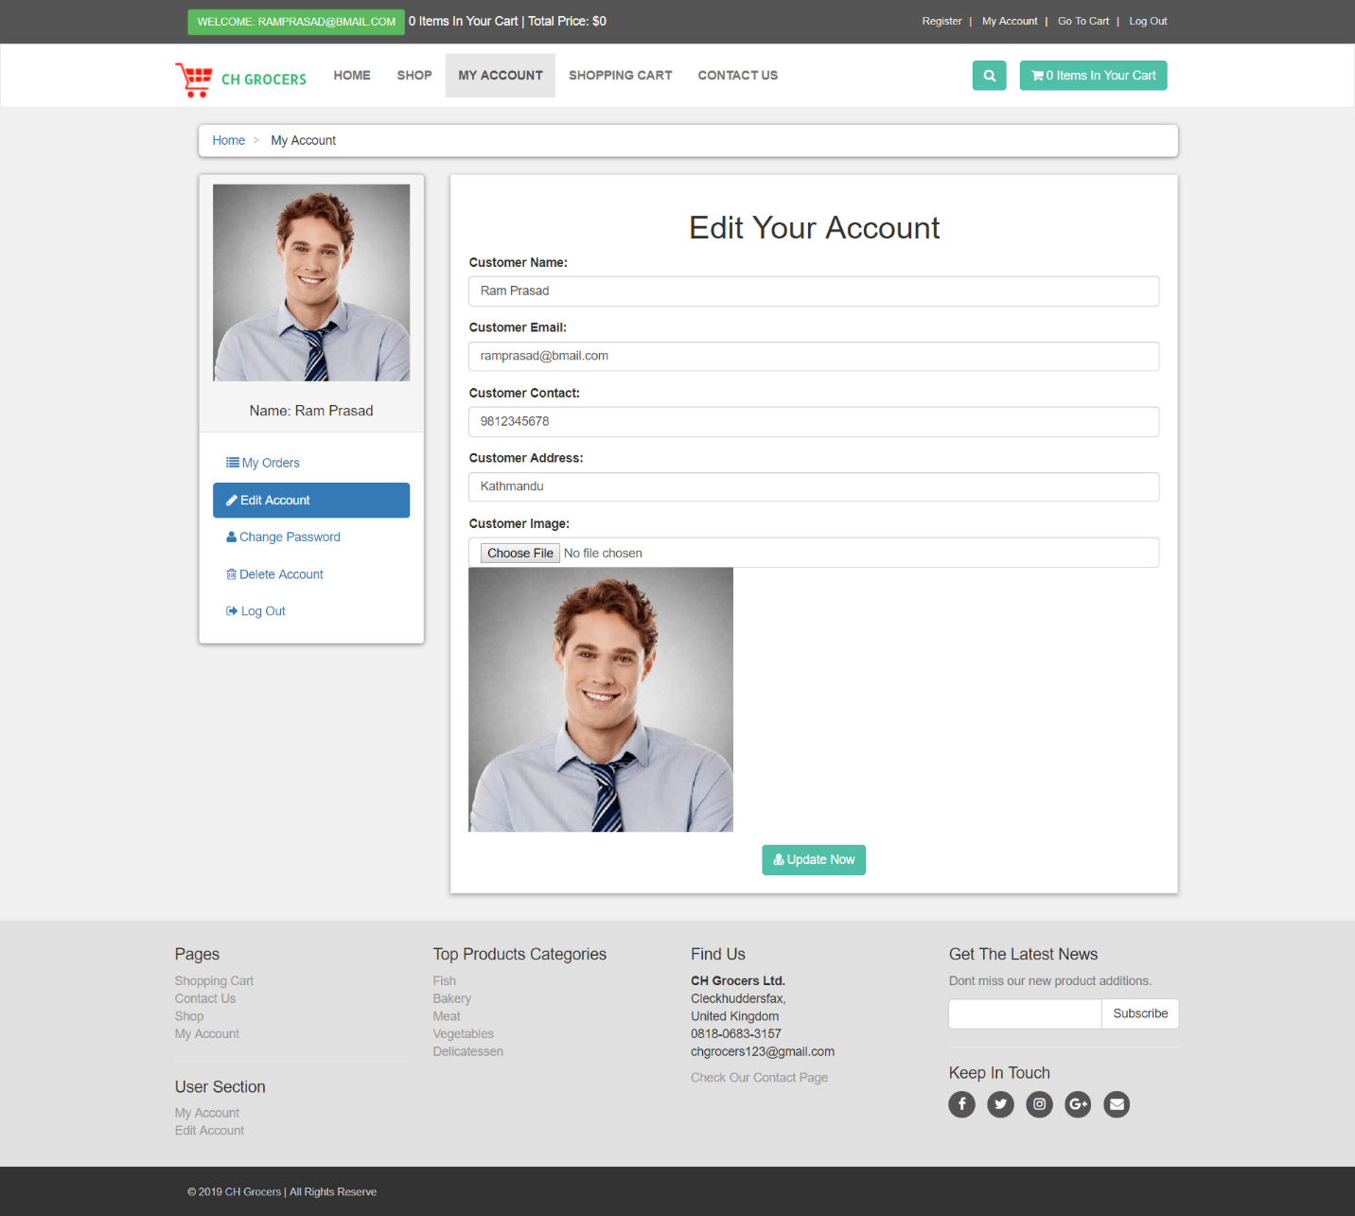

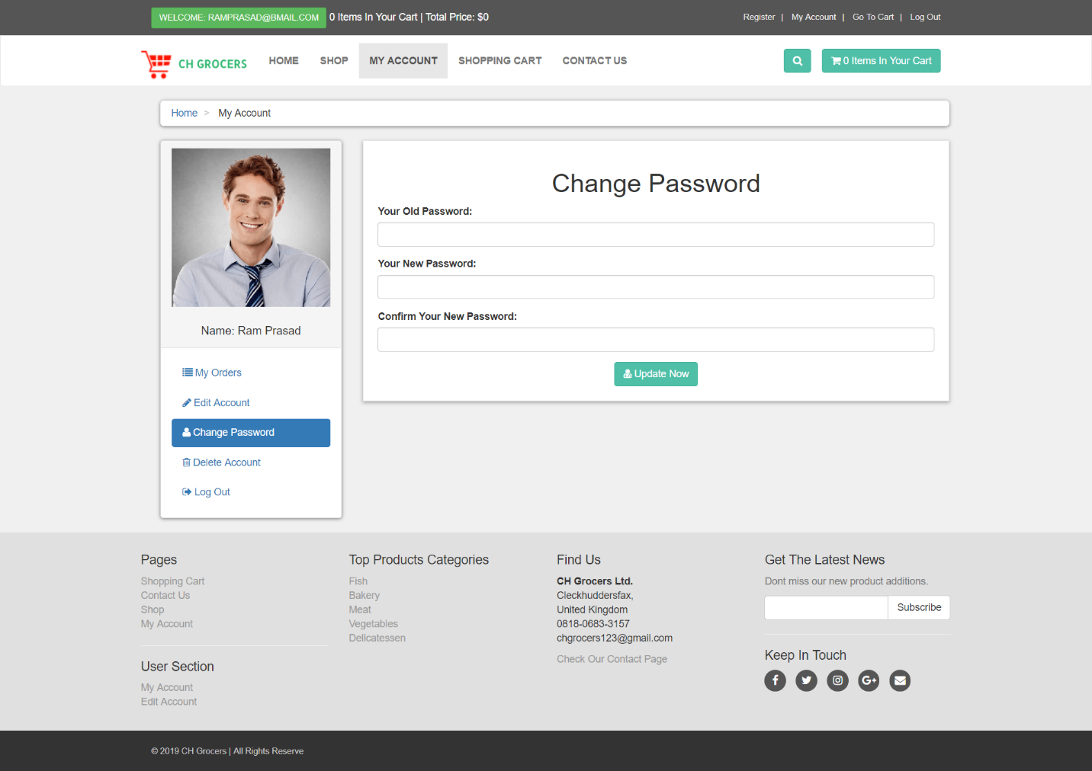

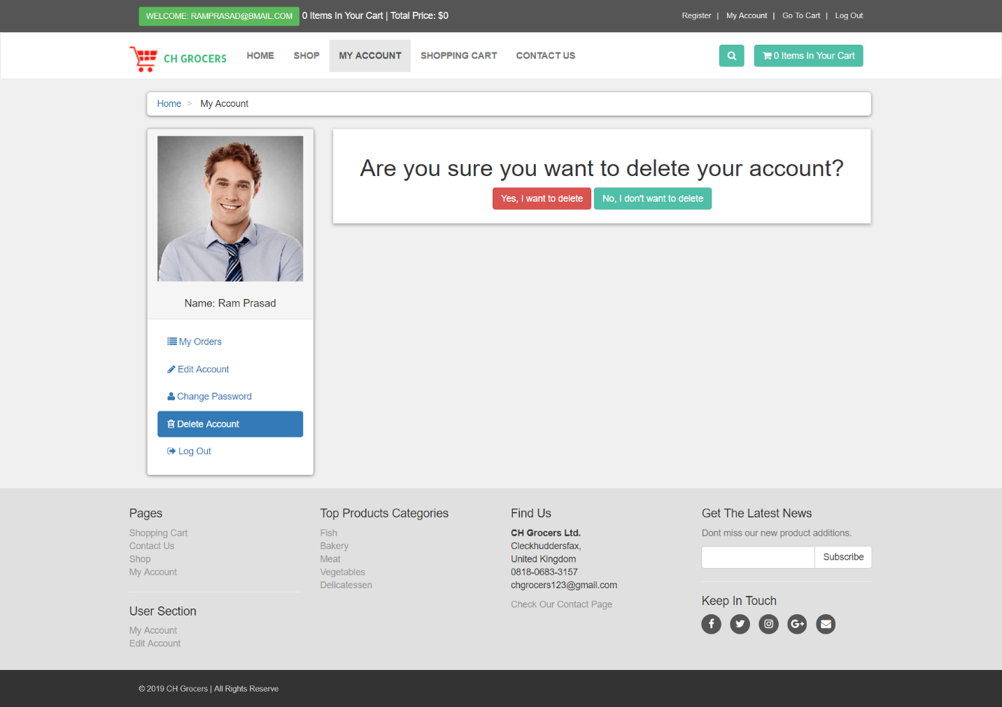

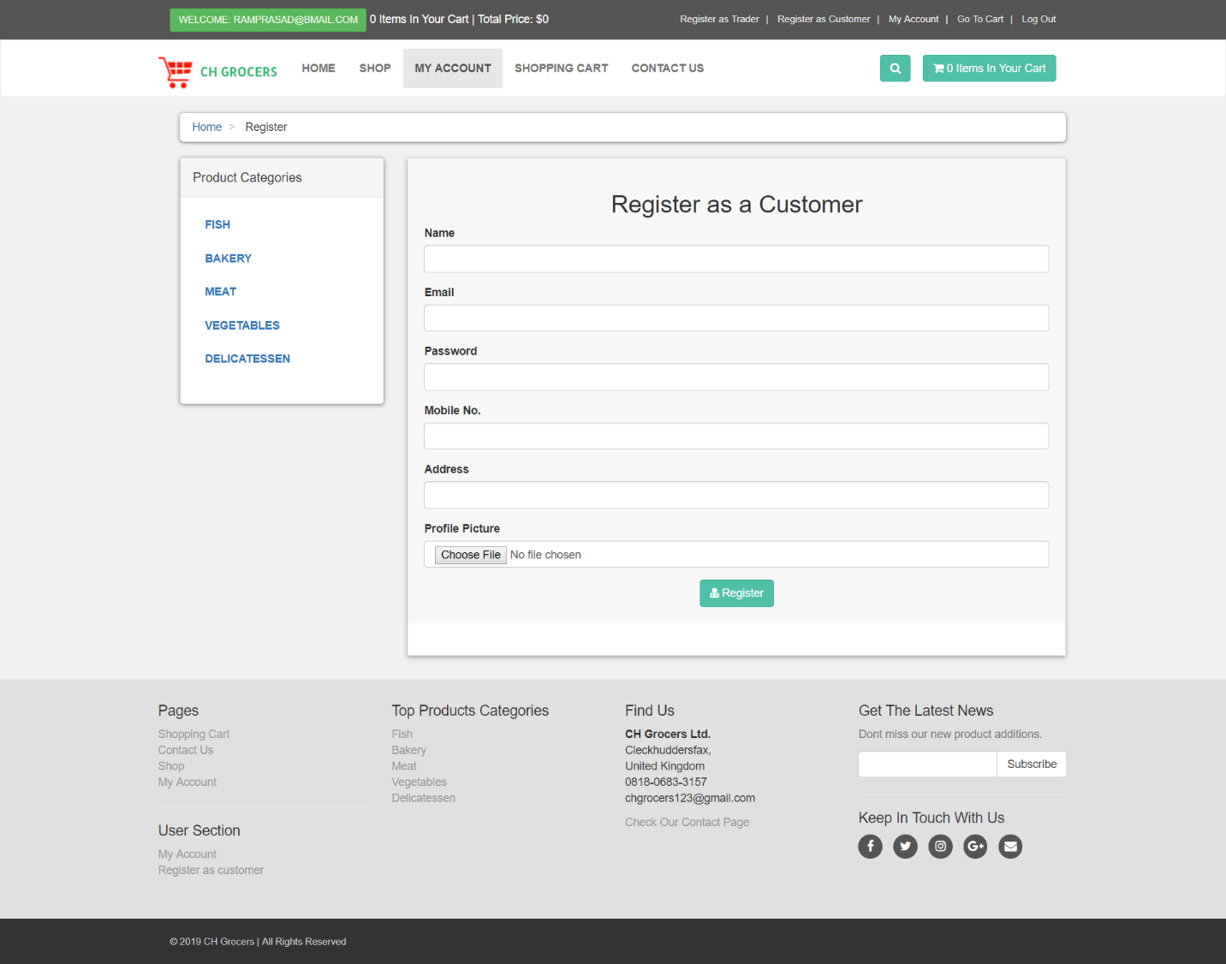

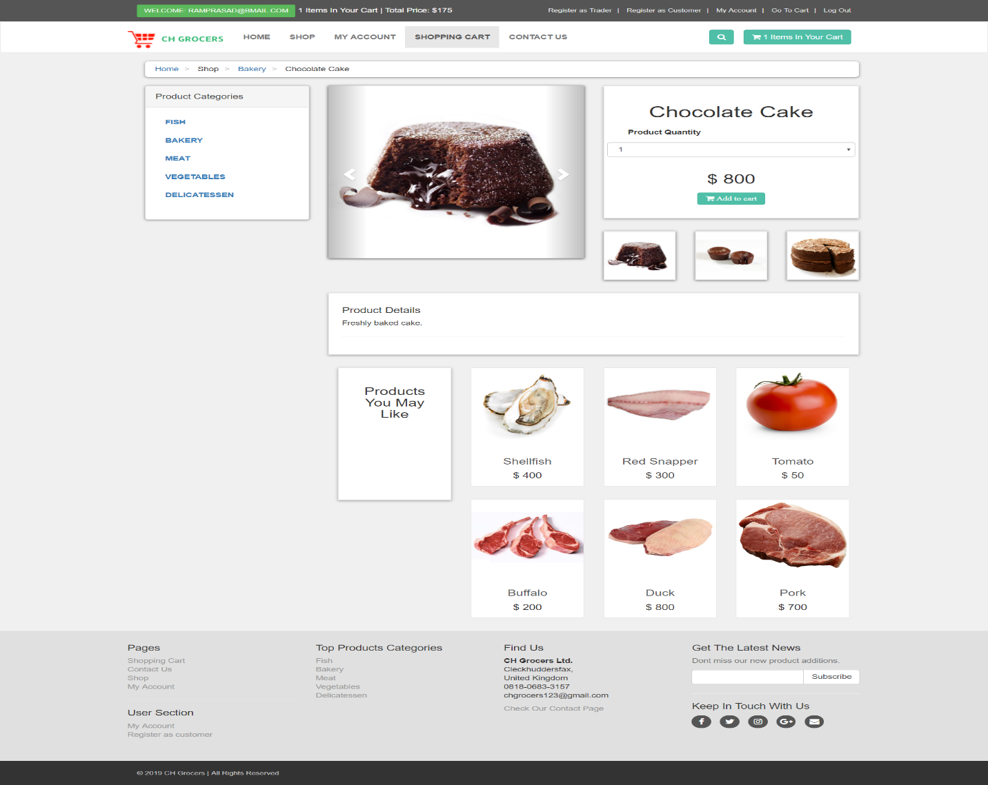

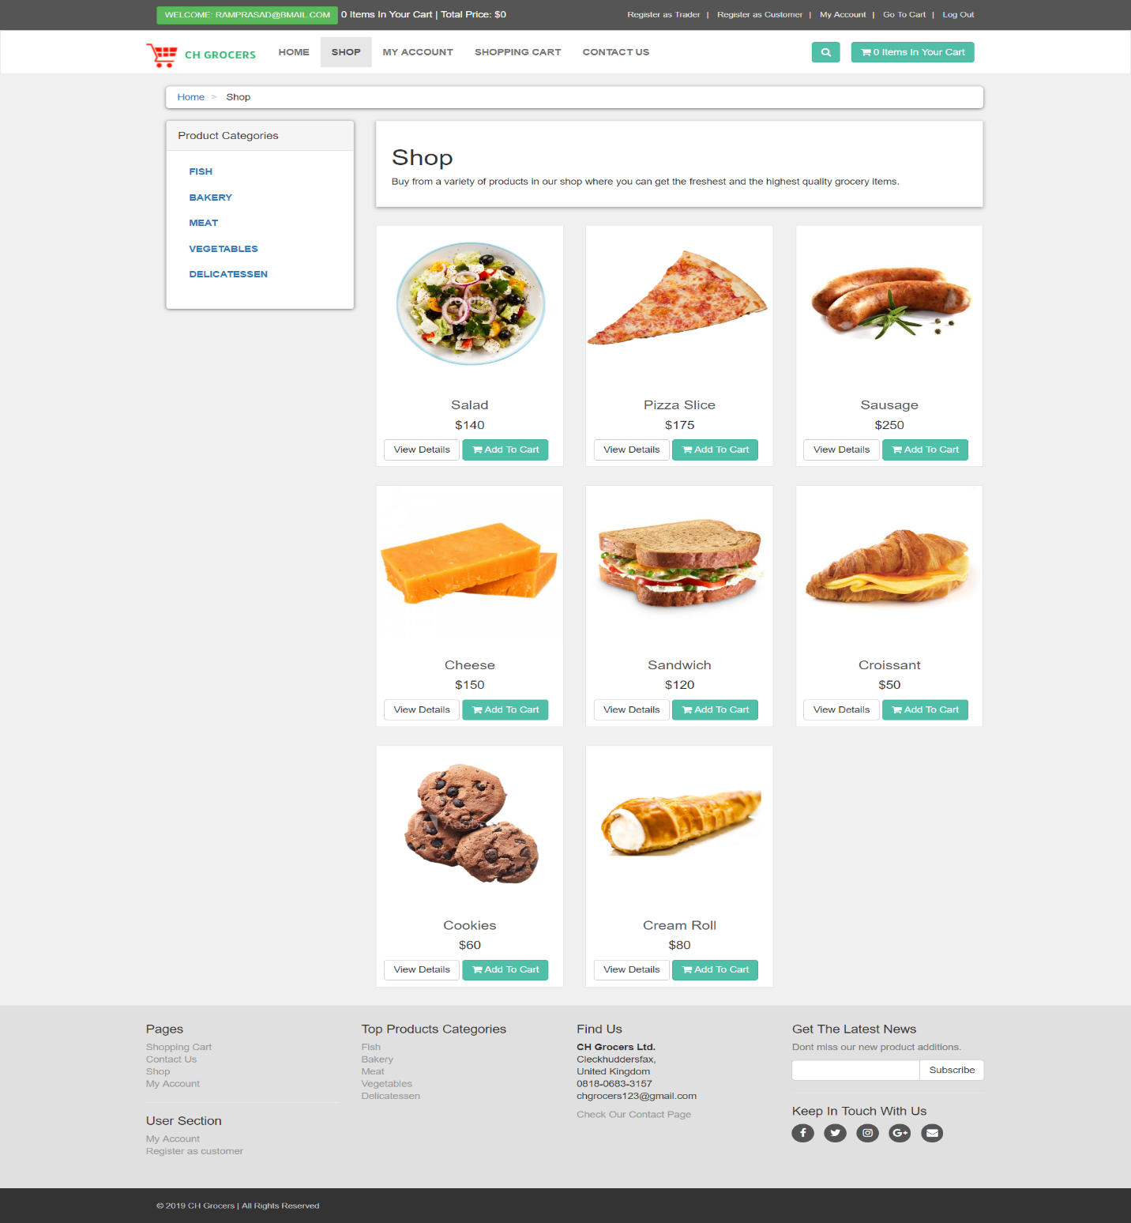

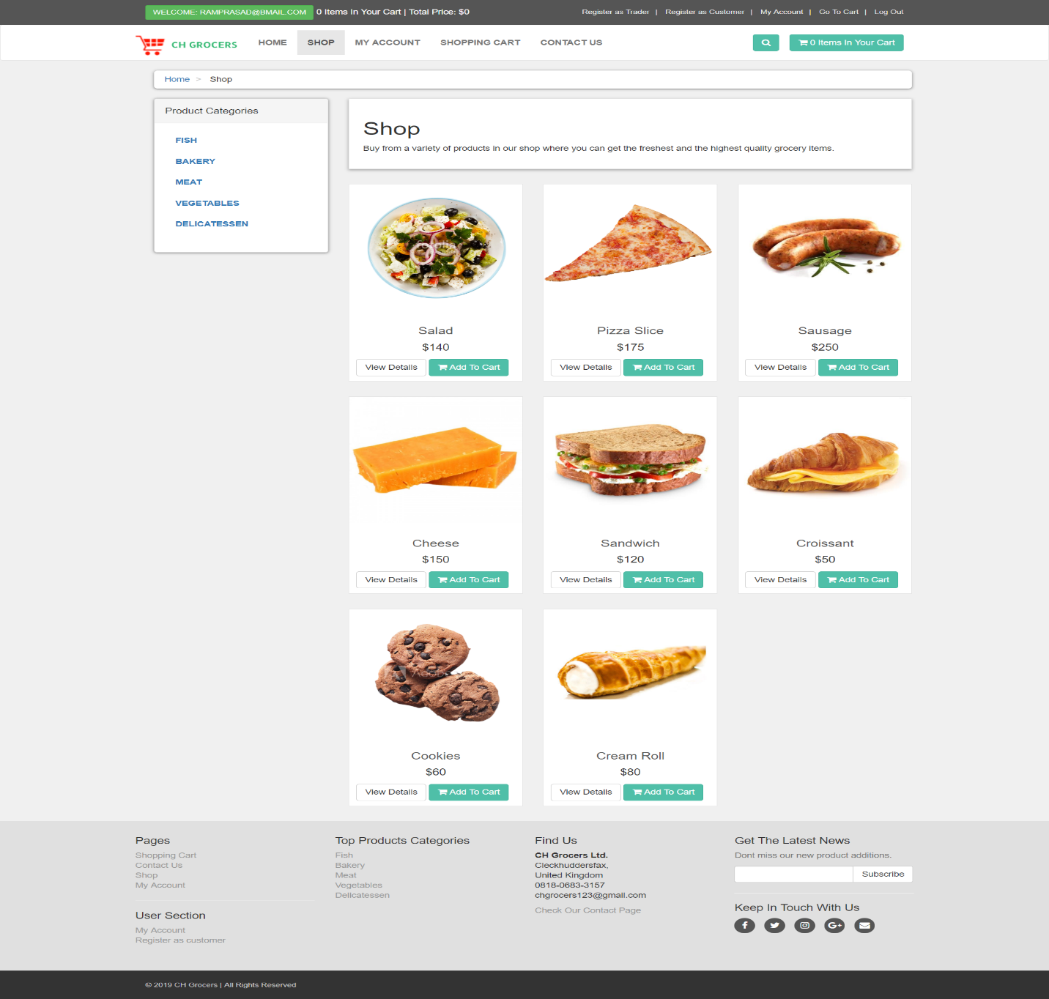

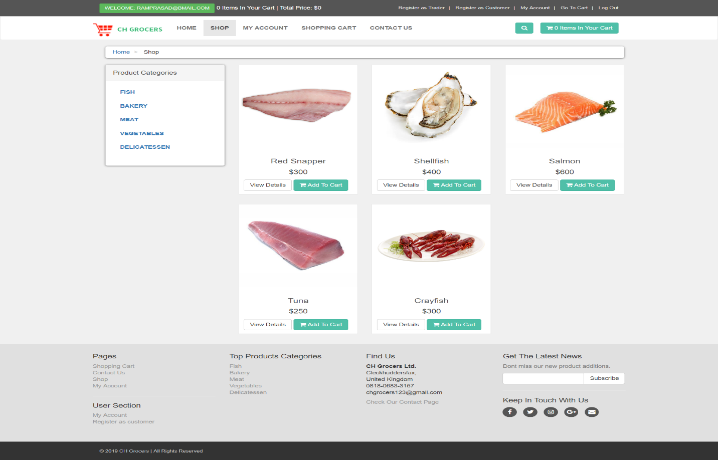

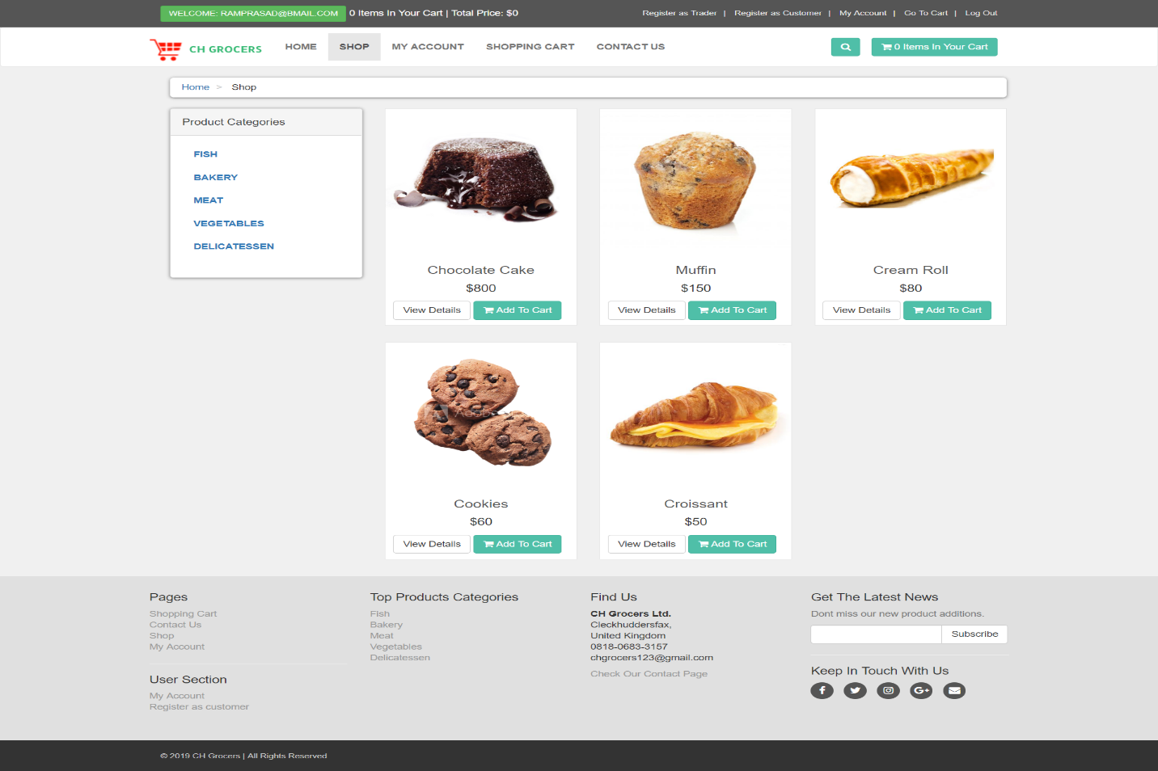

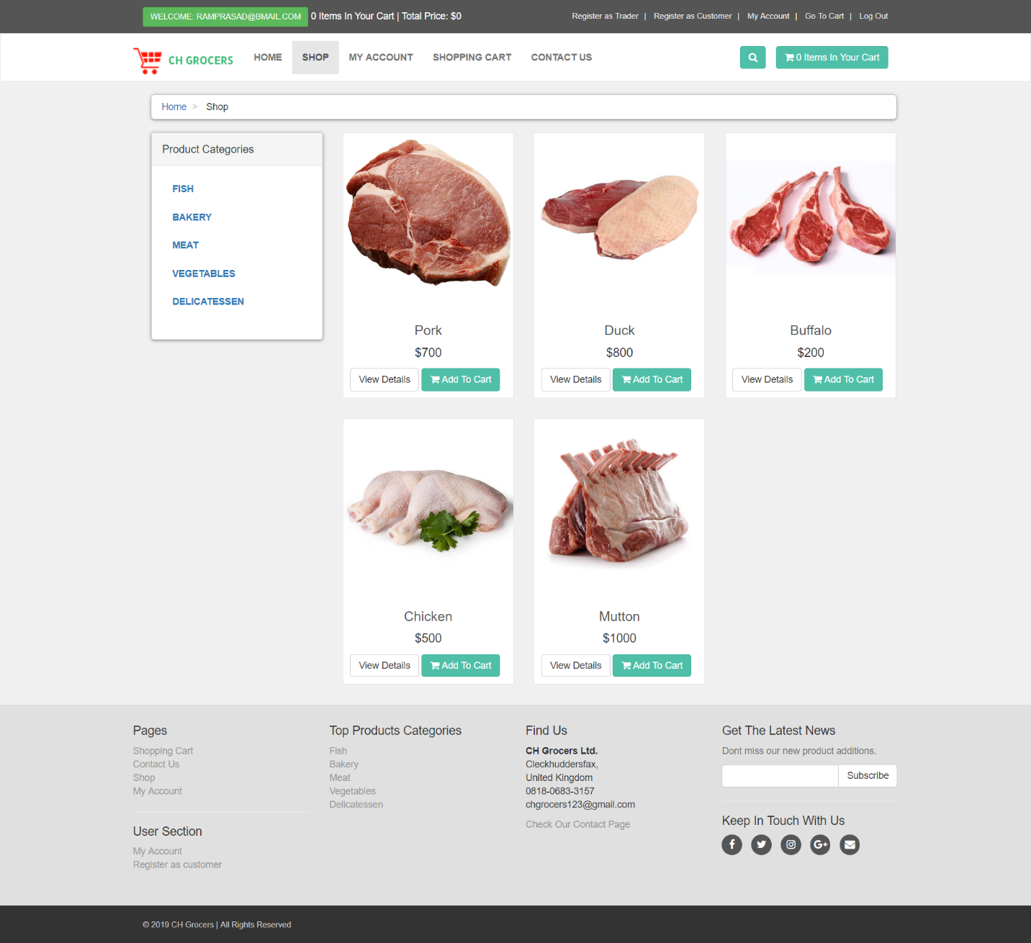

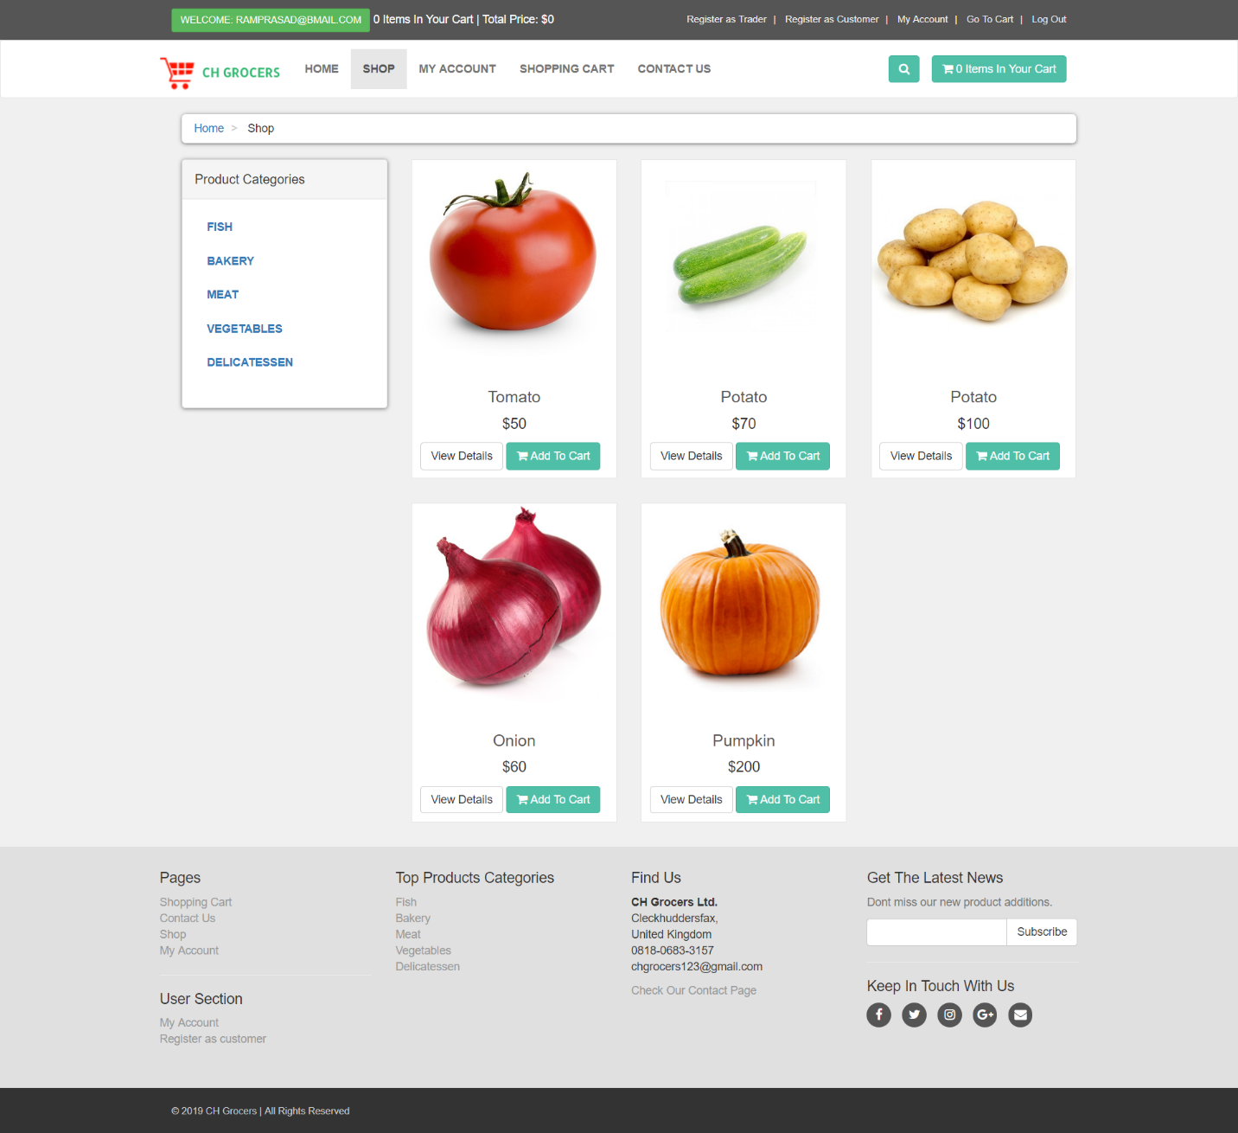

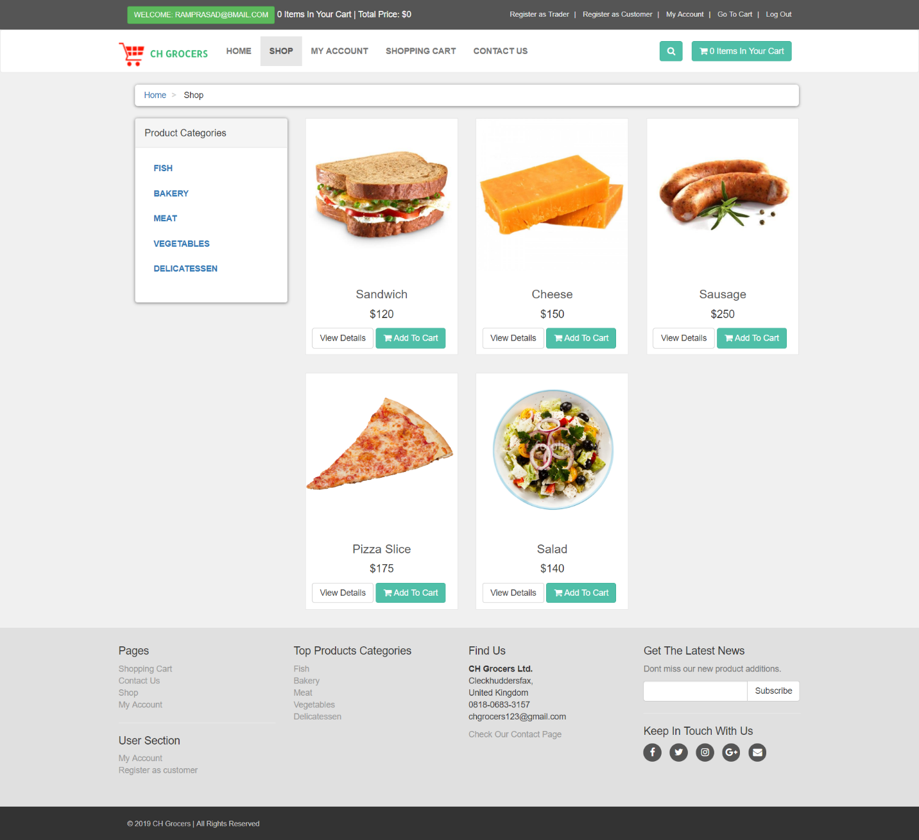

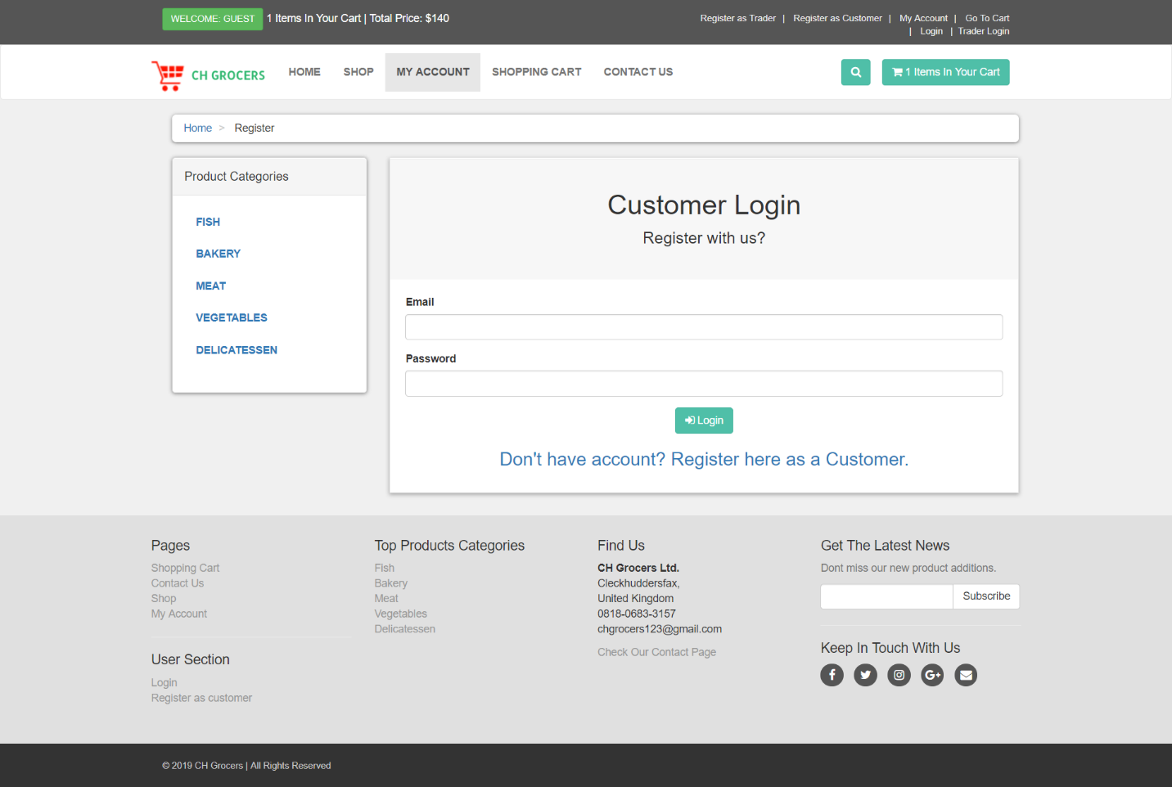

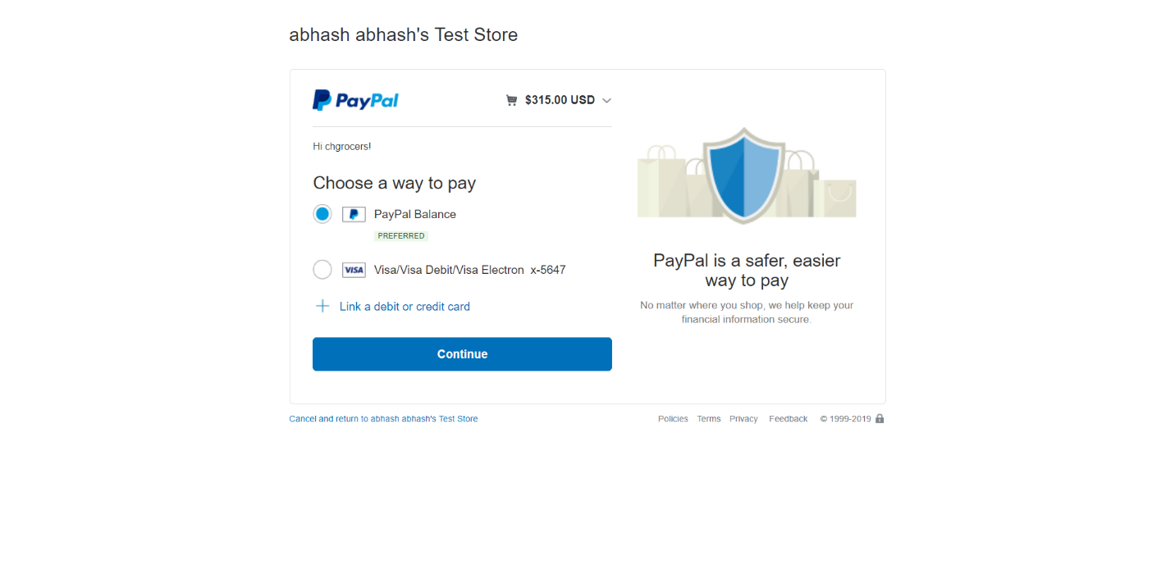

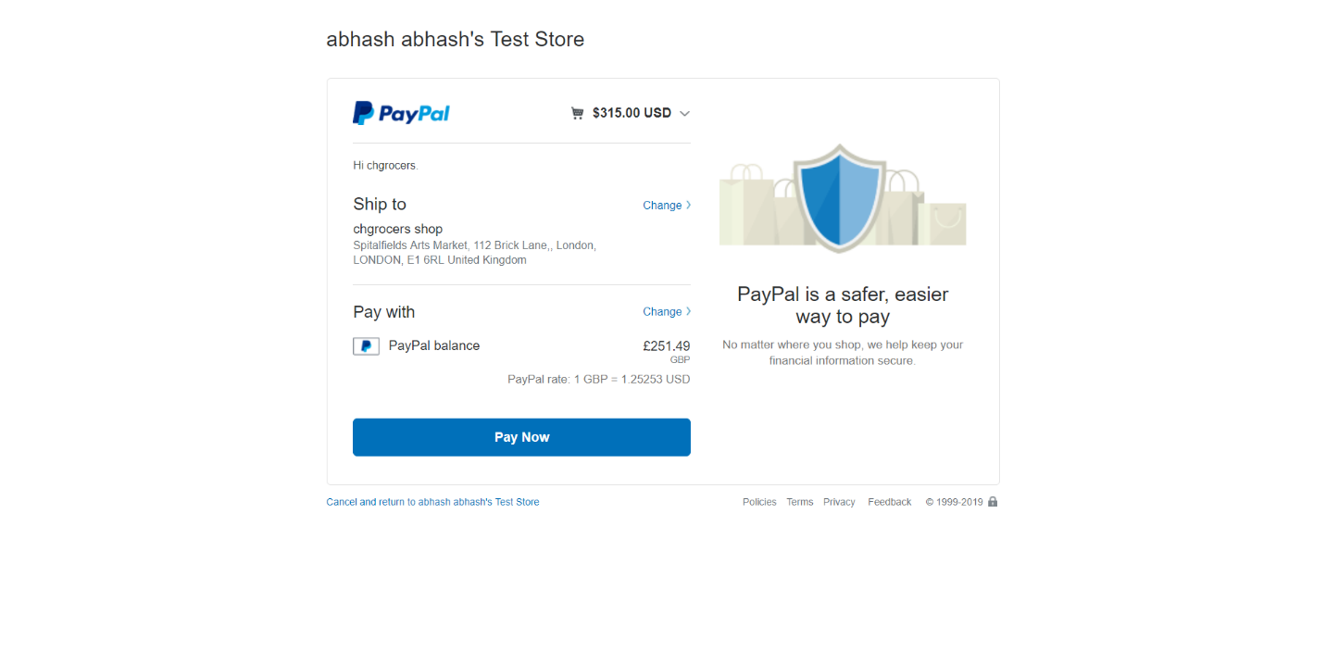

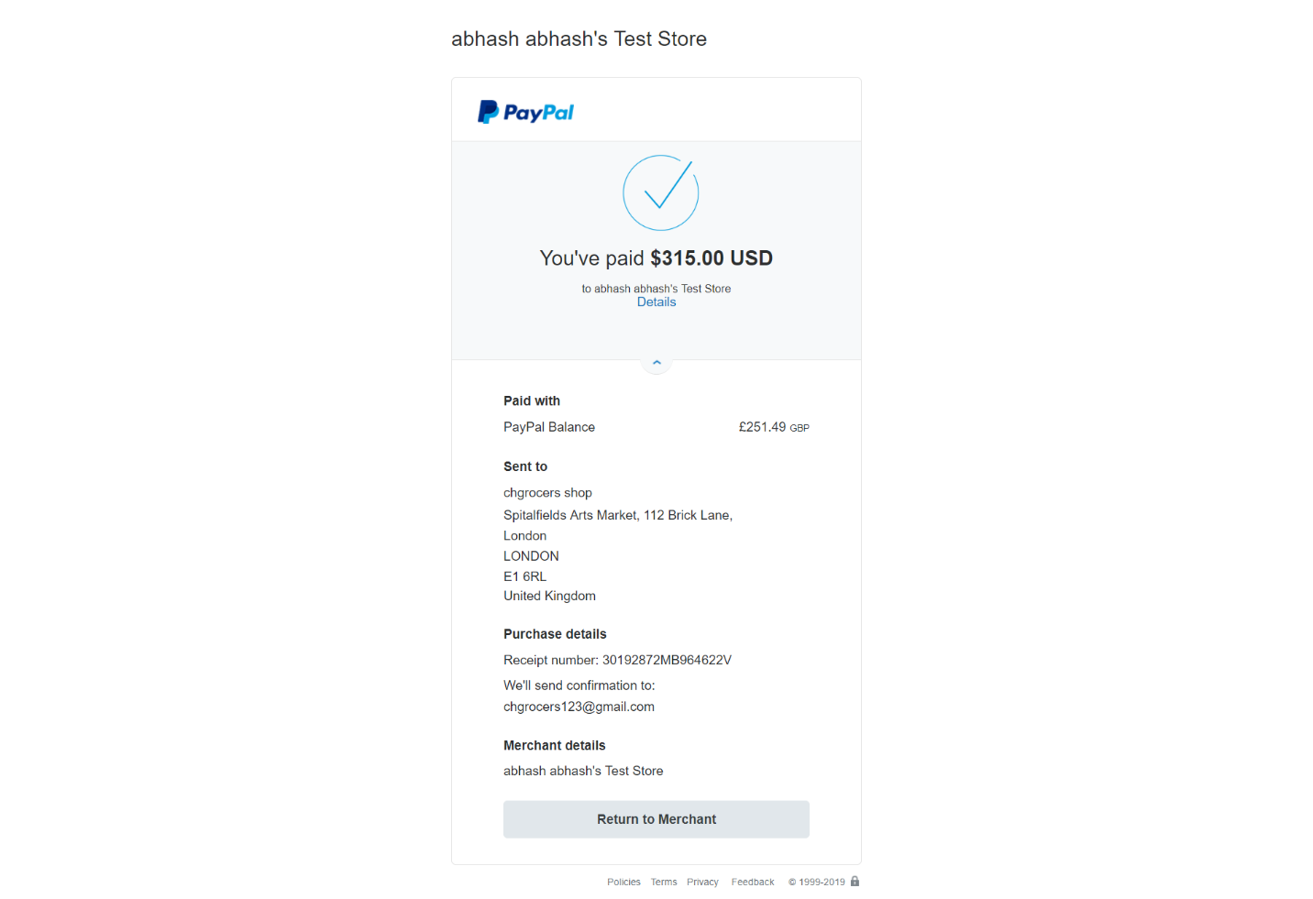

### 3.3.2 Management Interface Apex

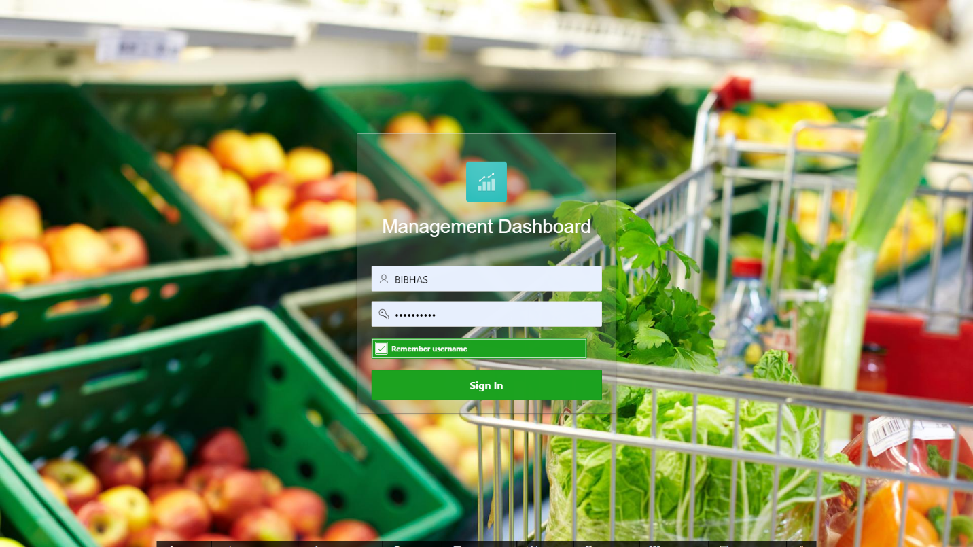

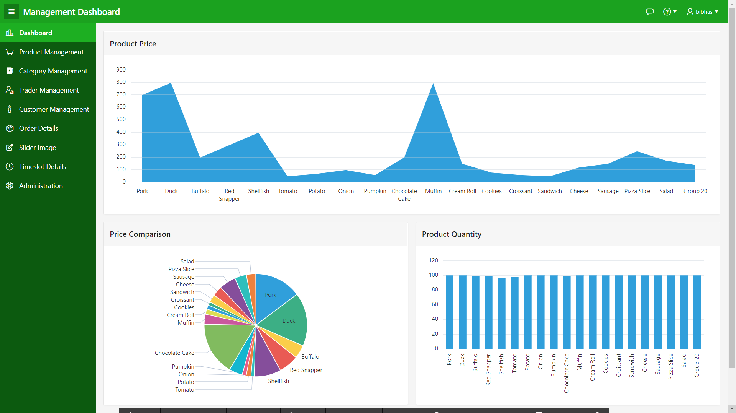

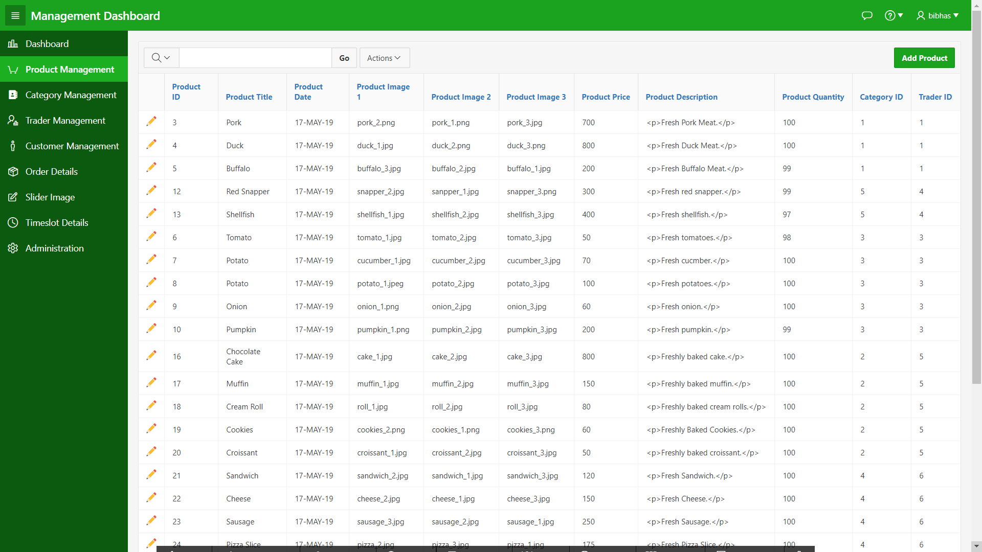

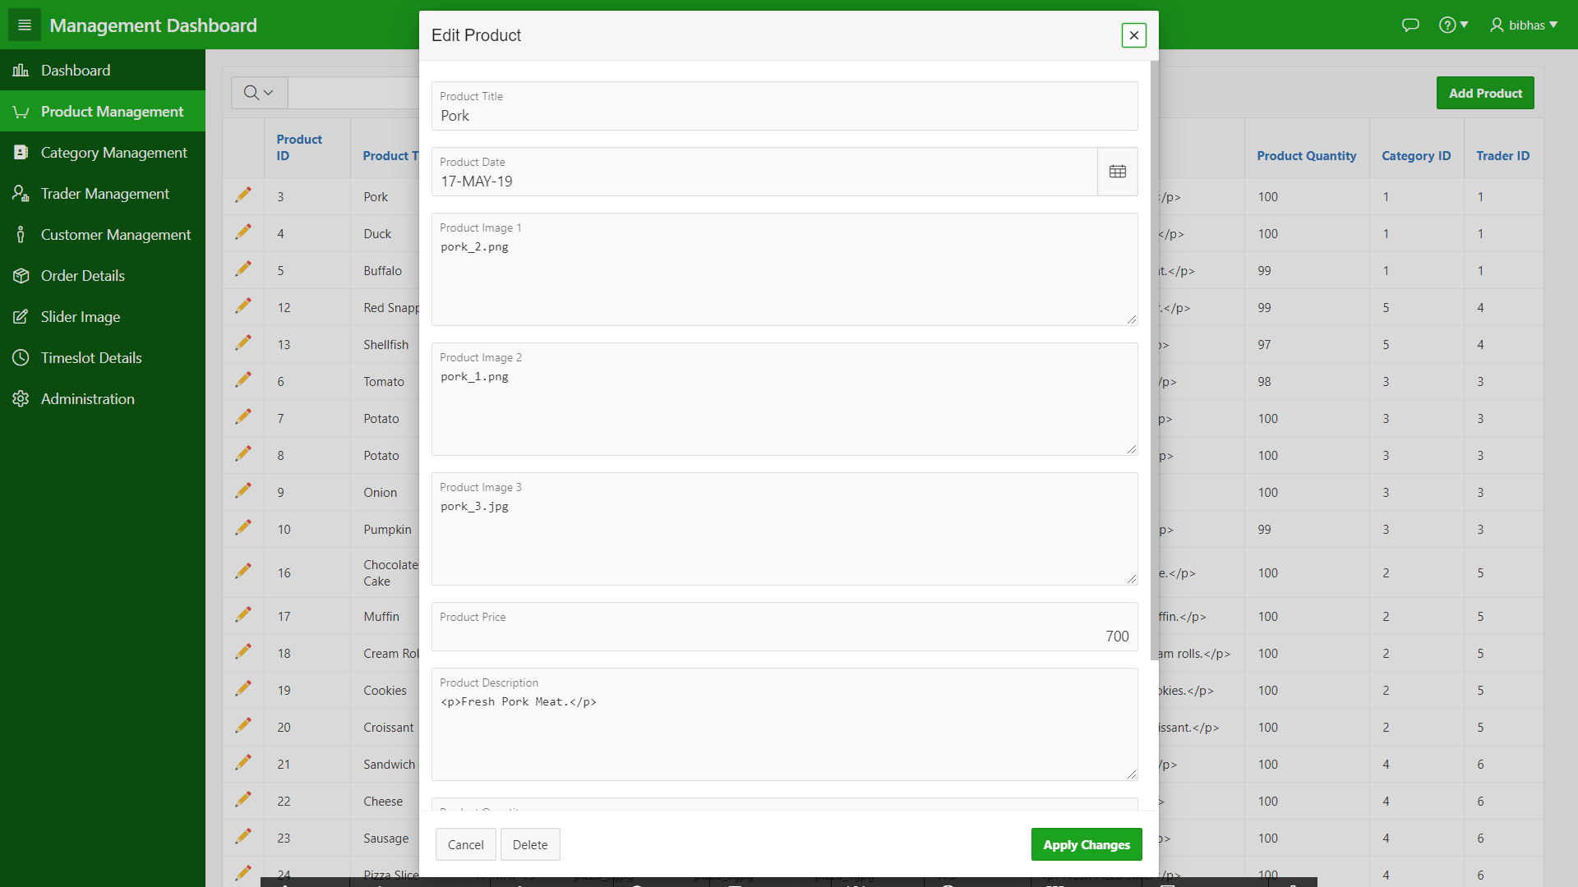

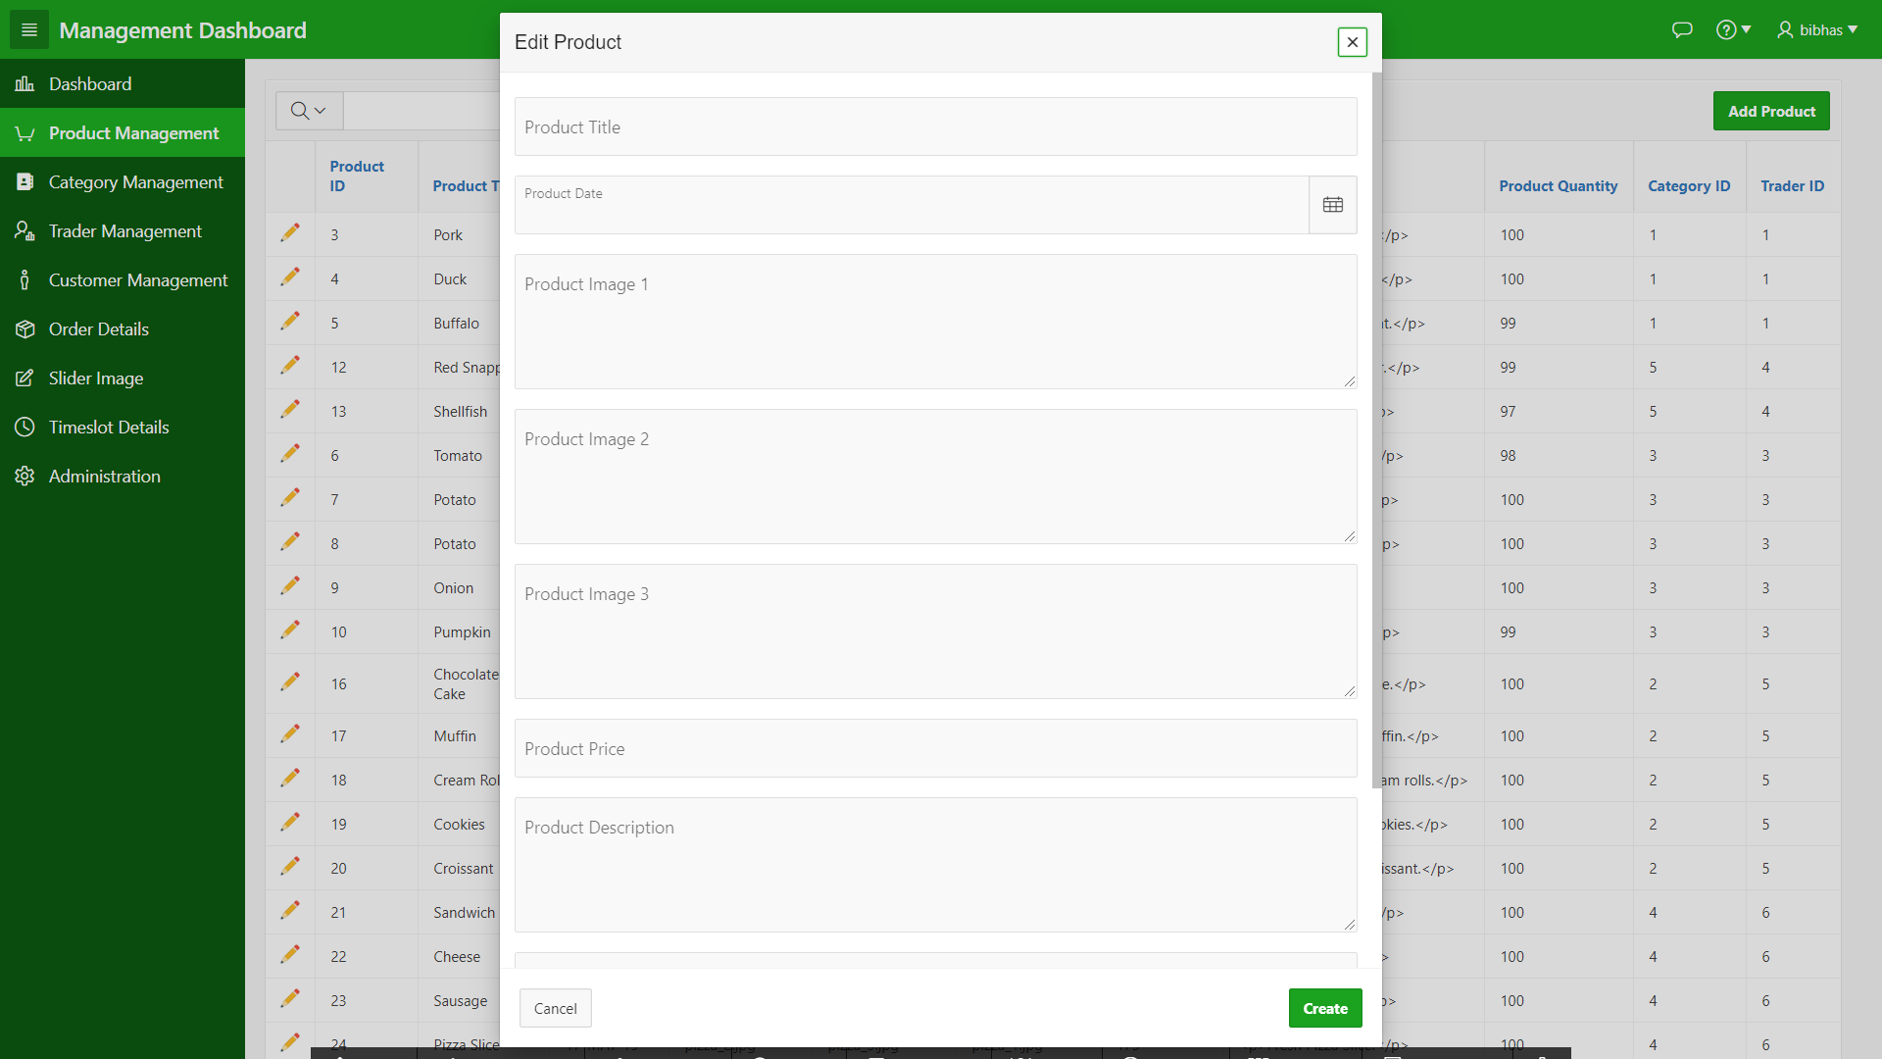

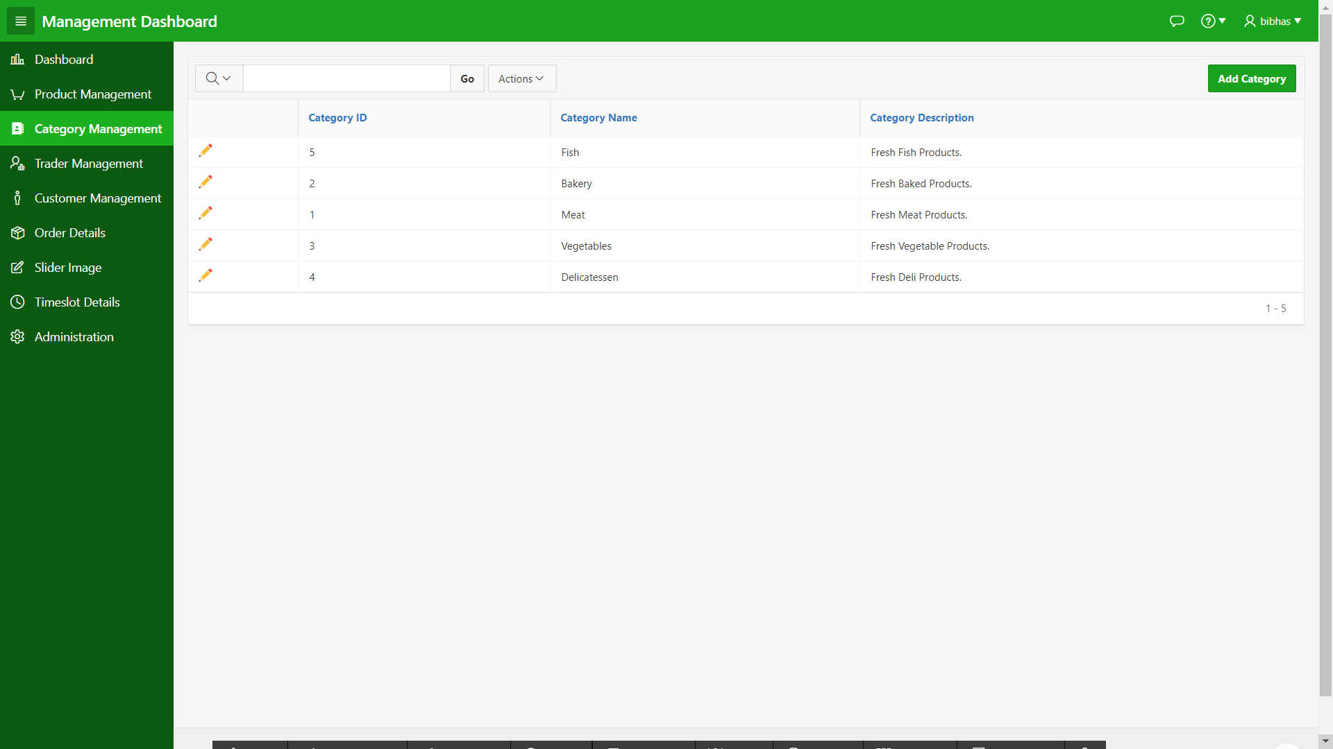

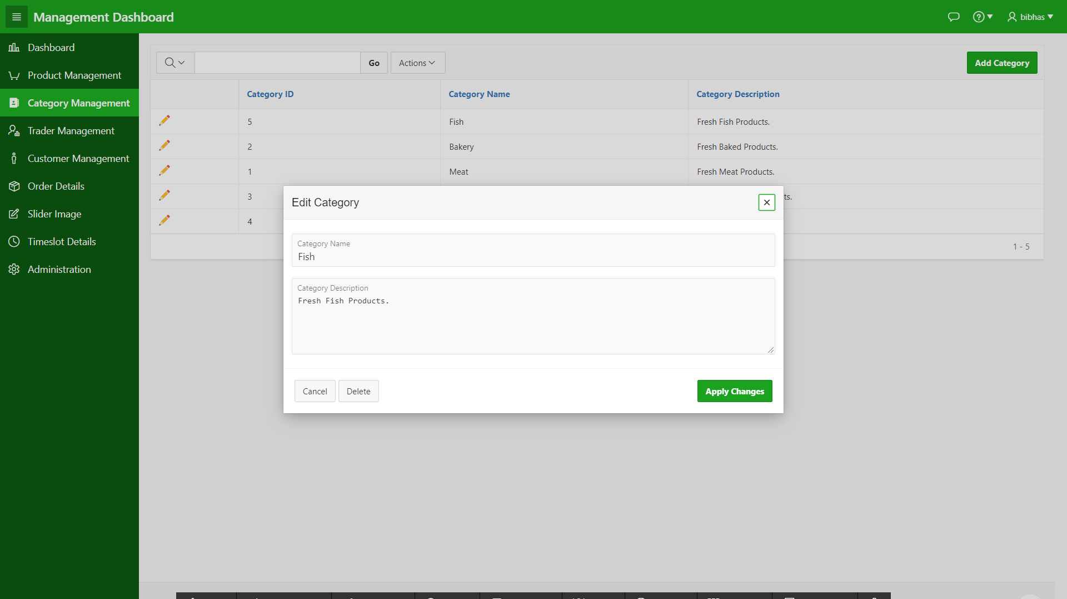

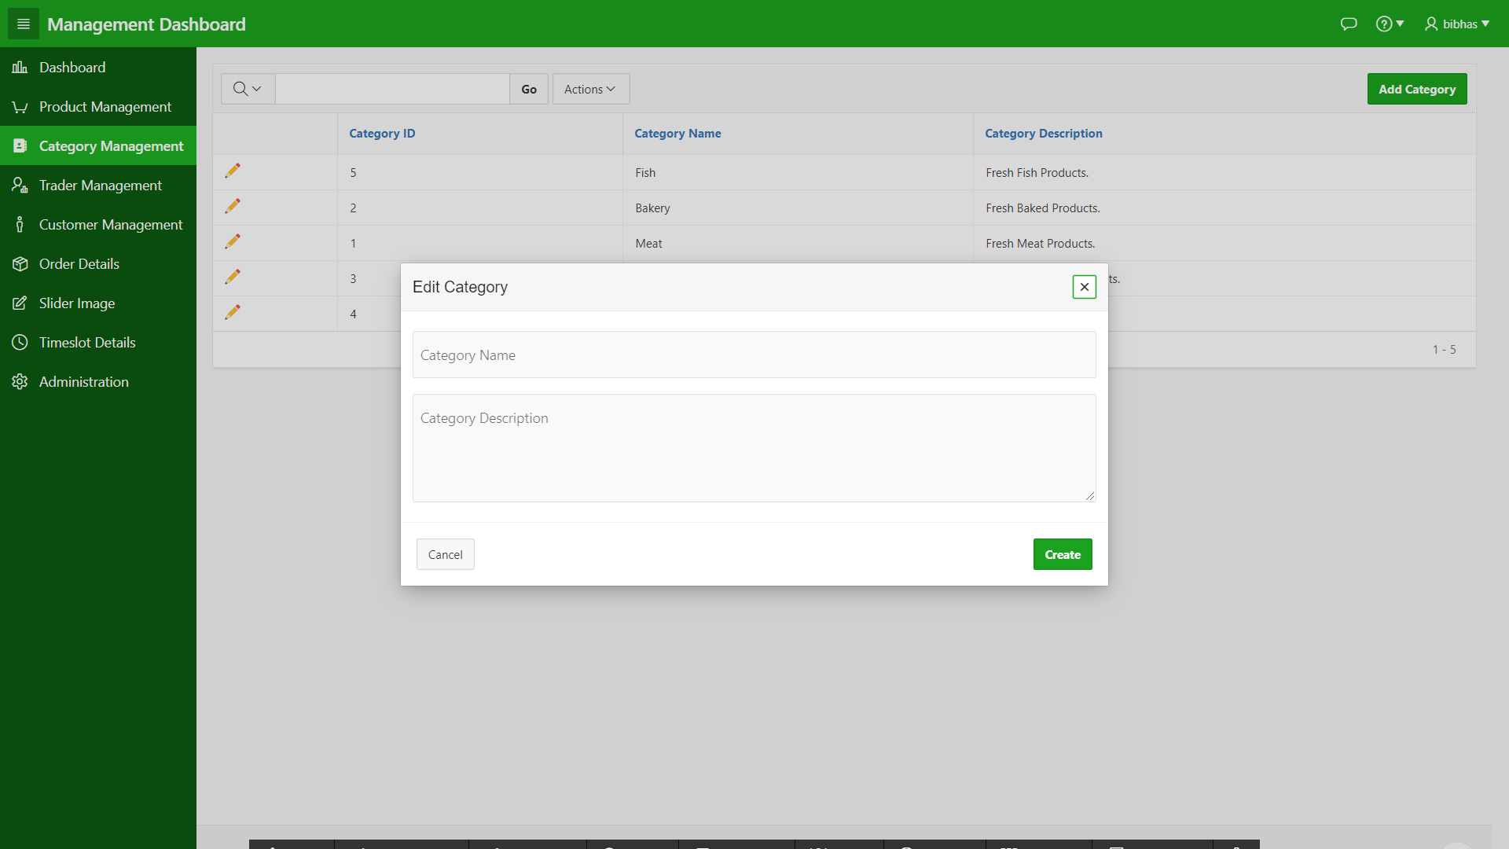

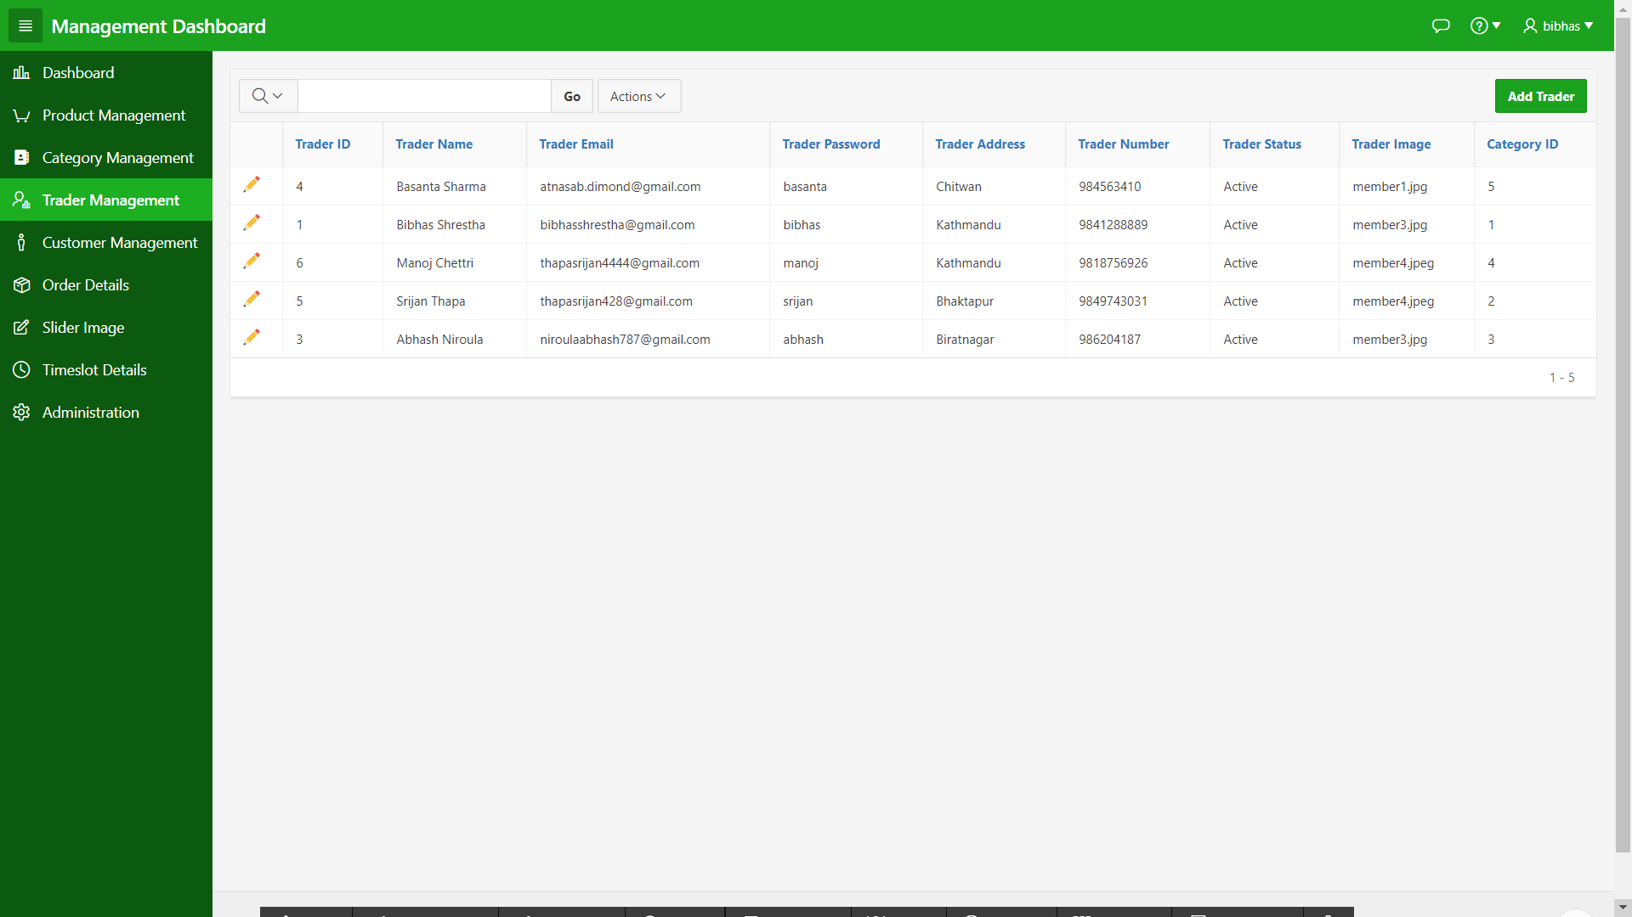

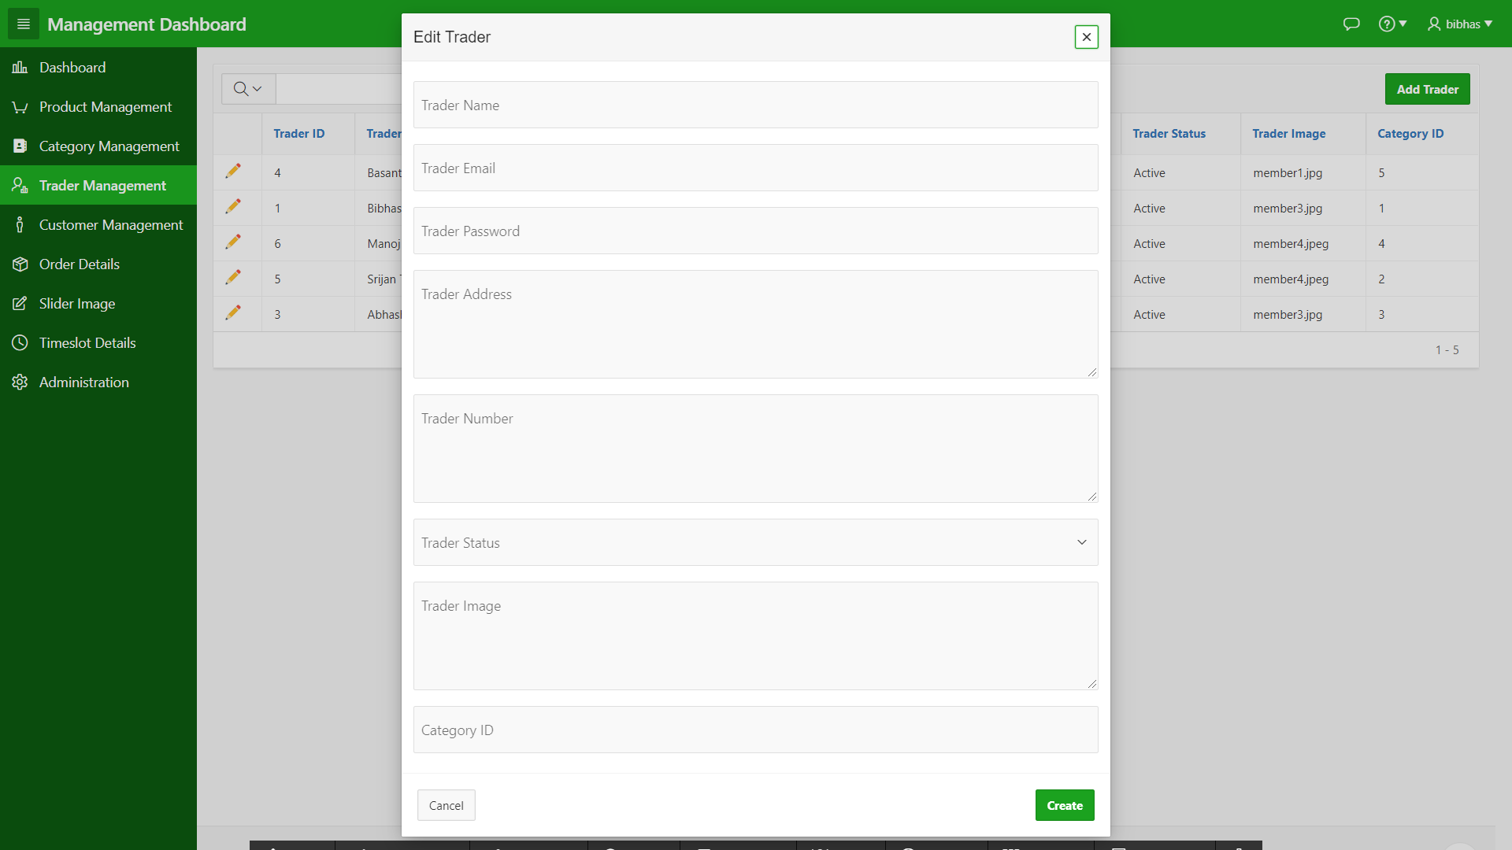

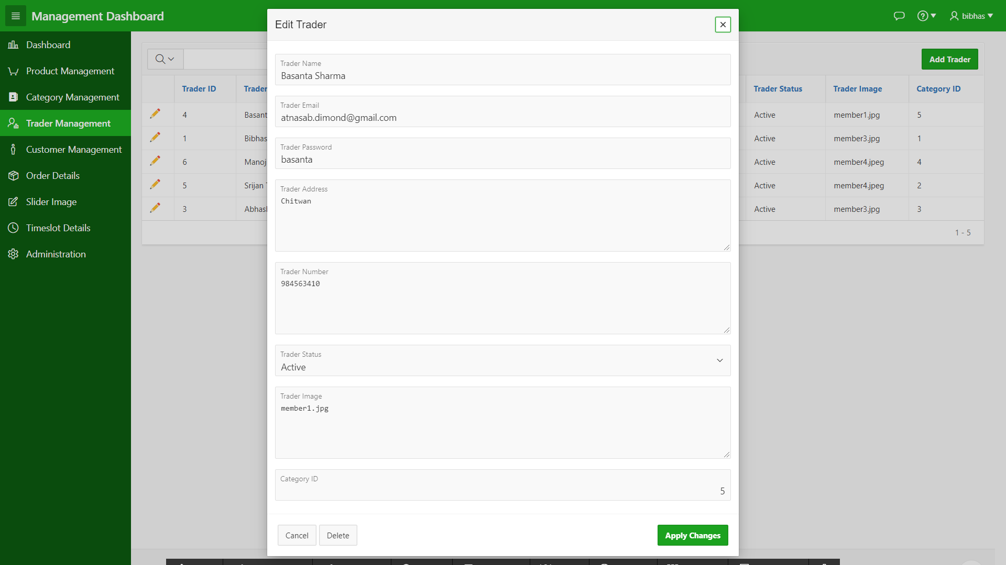

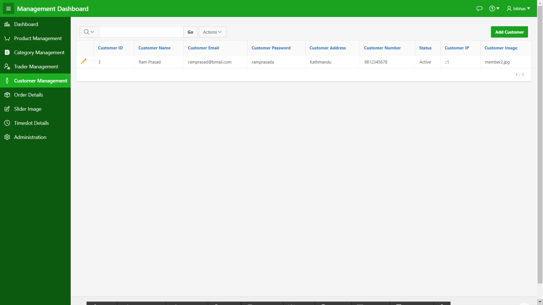

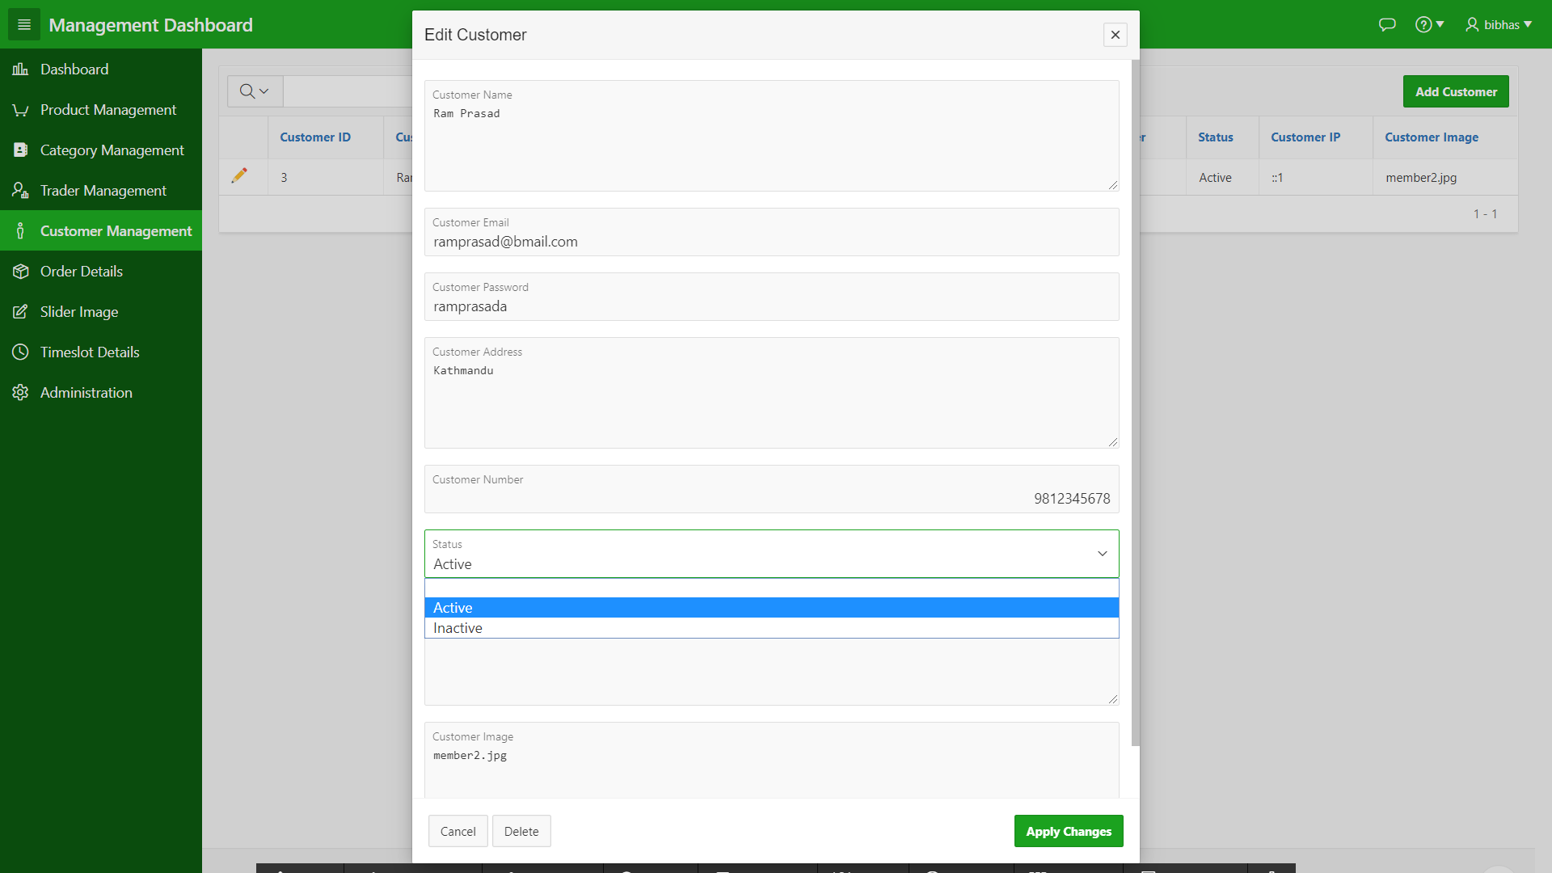

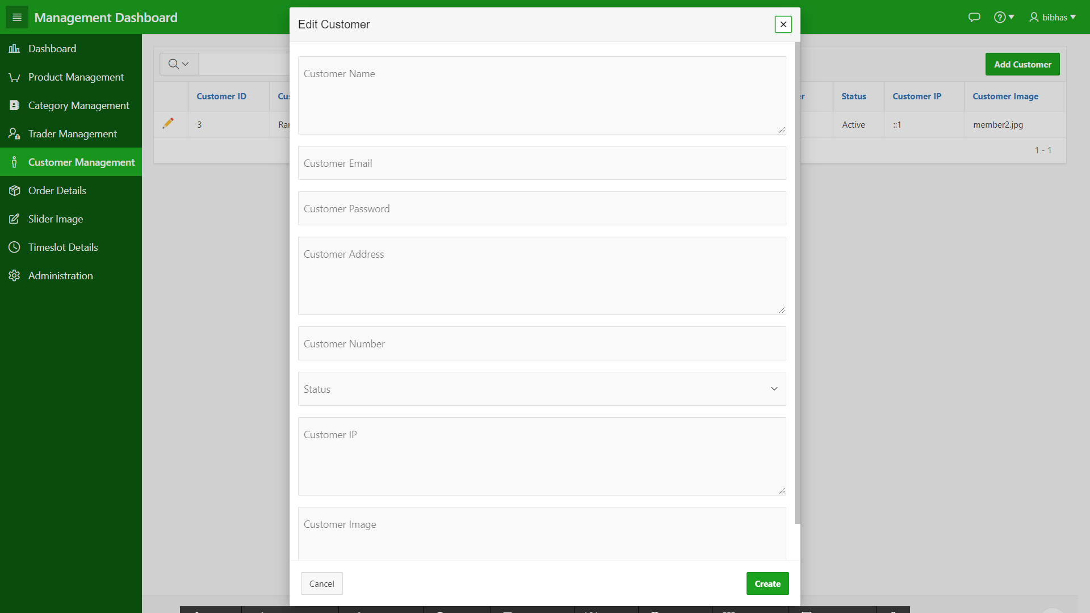

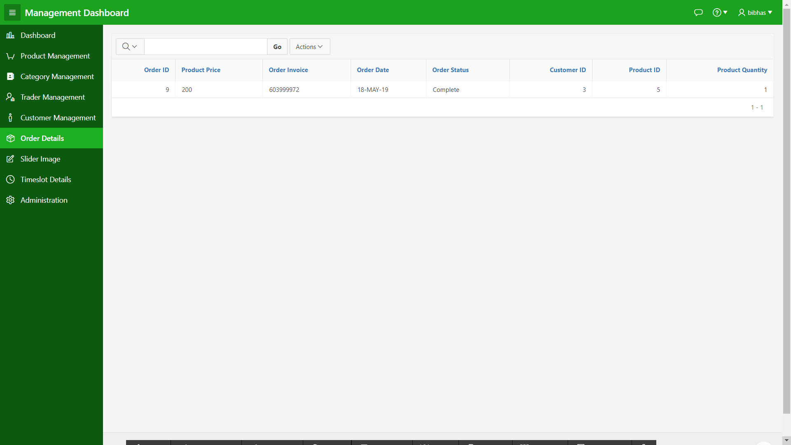

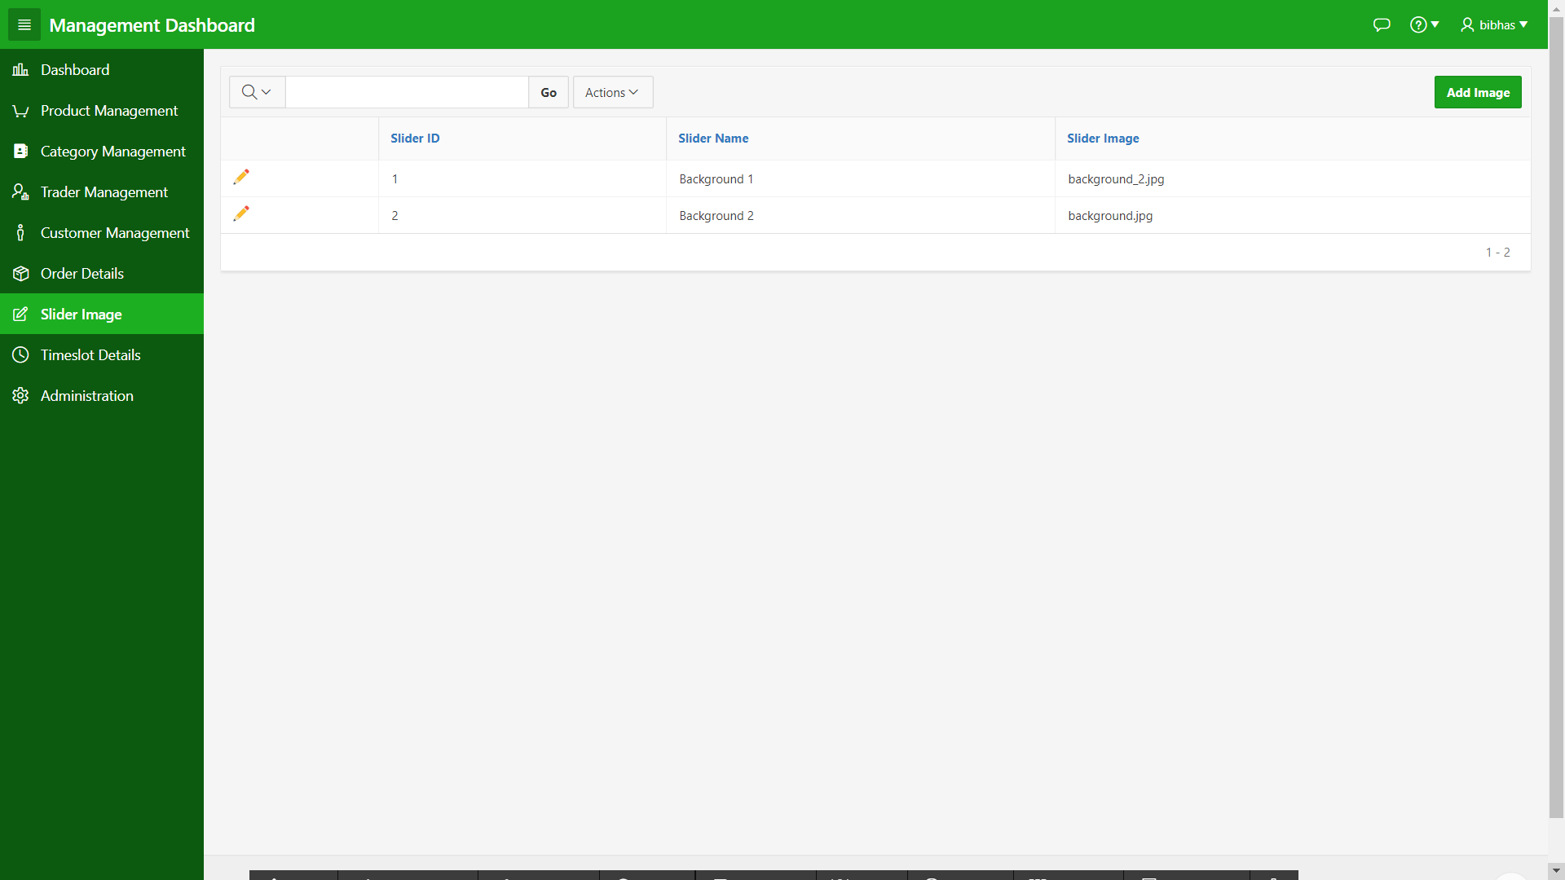

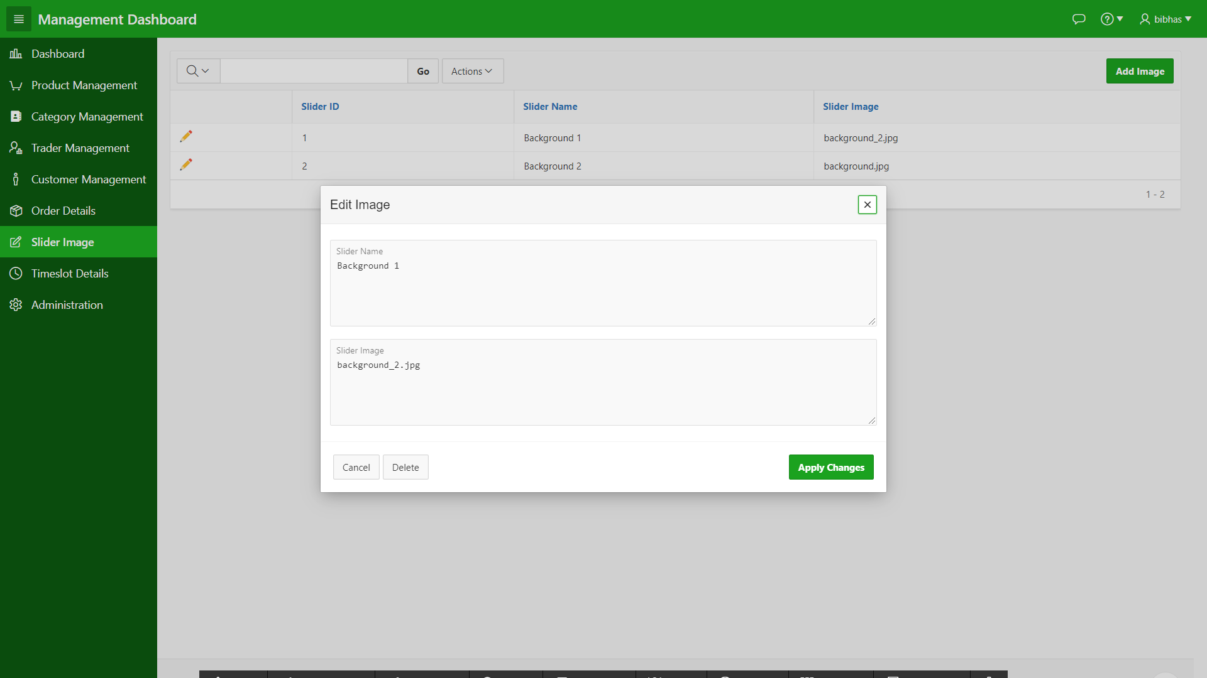

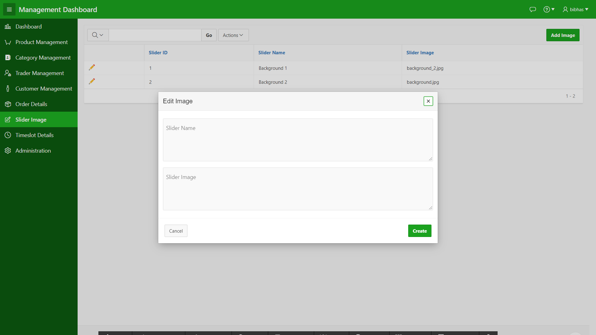

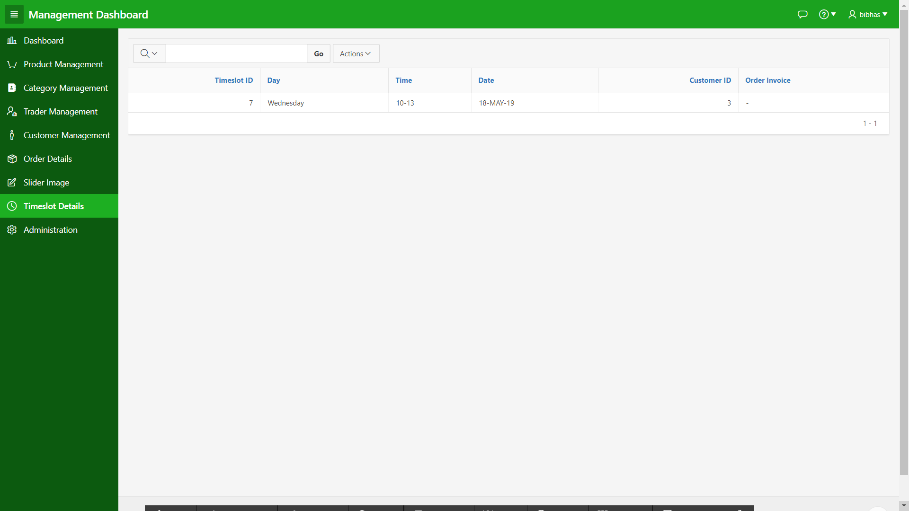

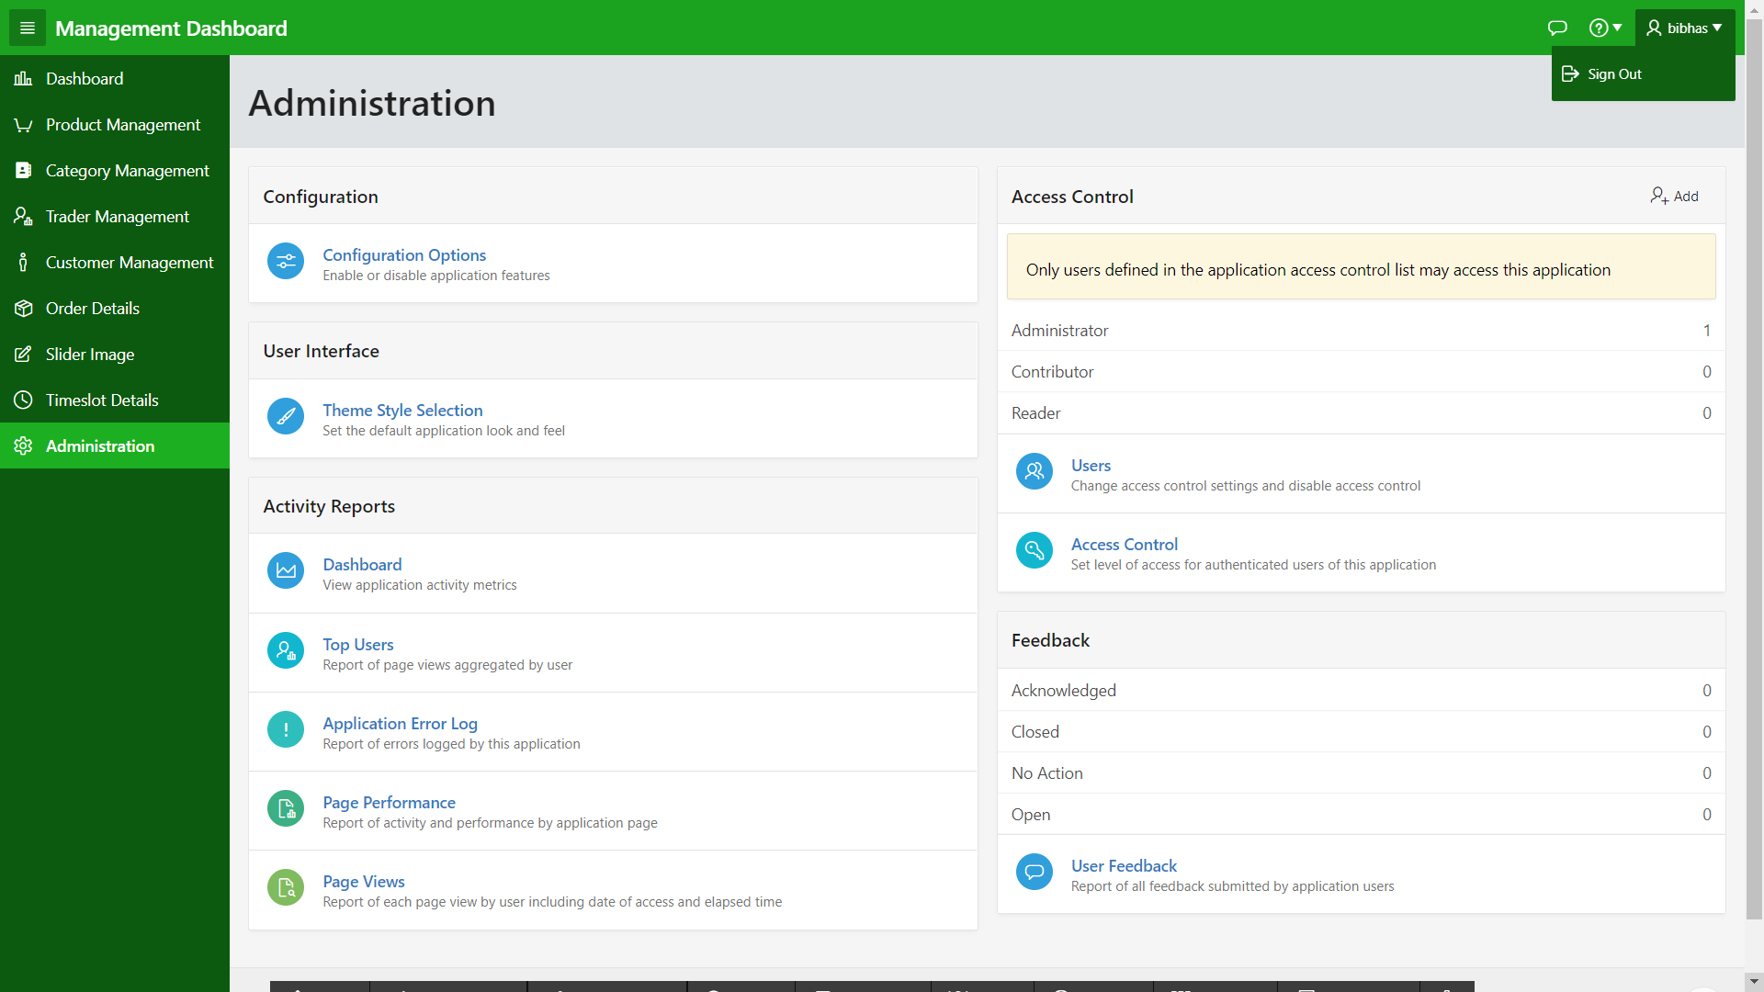

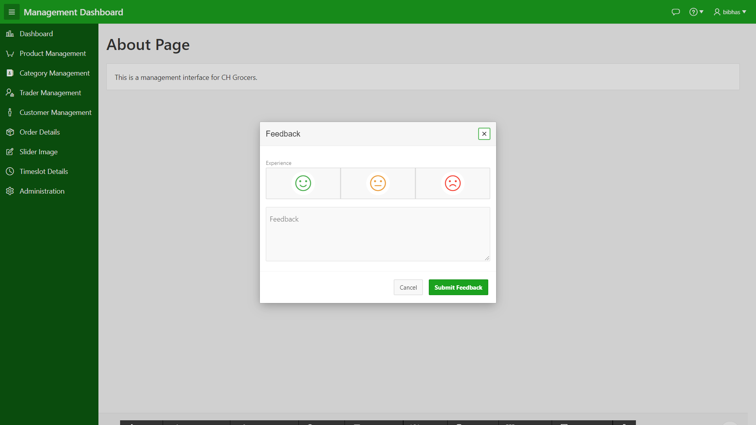

### 3.3.3 Trader Interface Apex

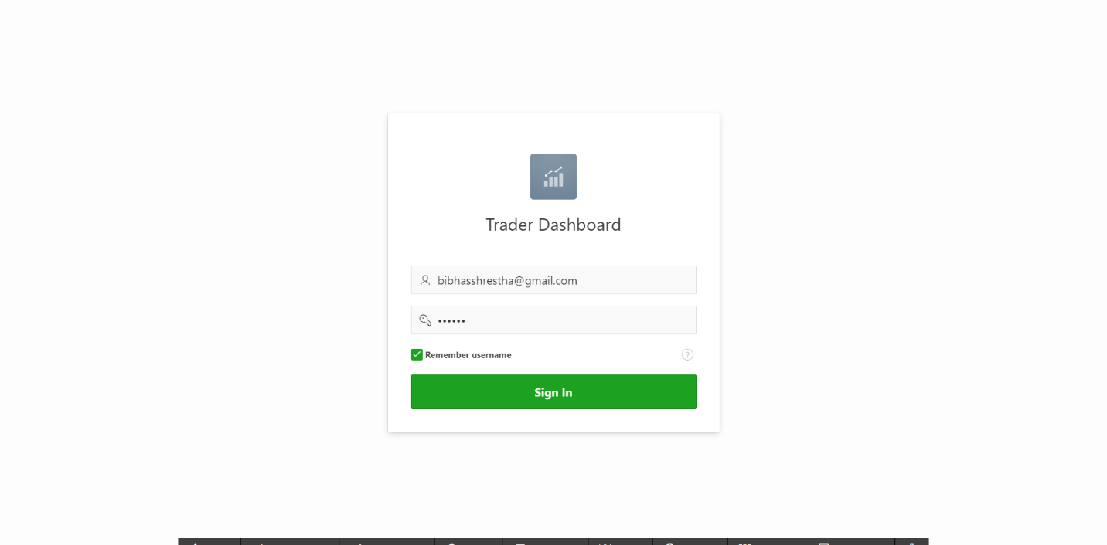

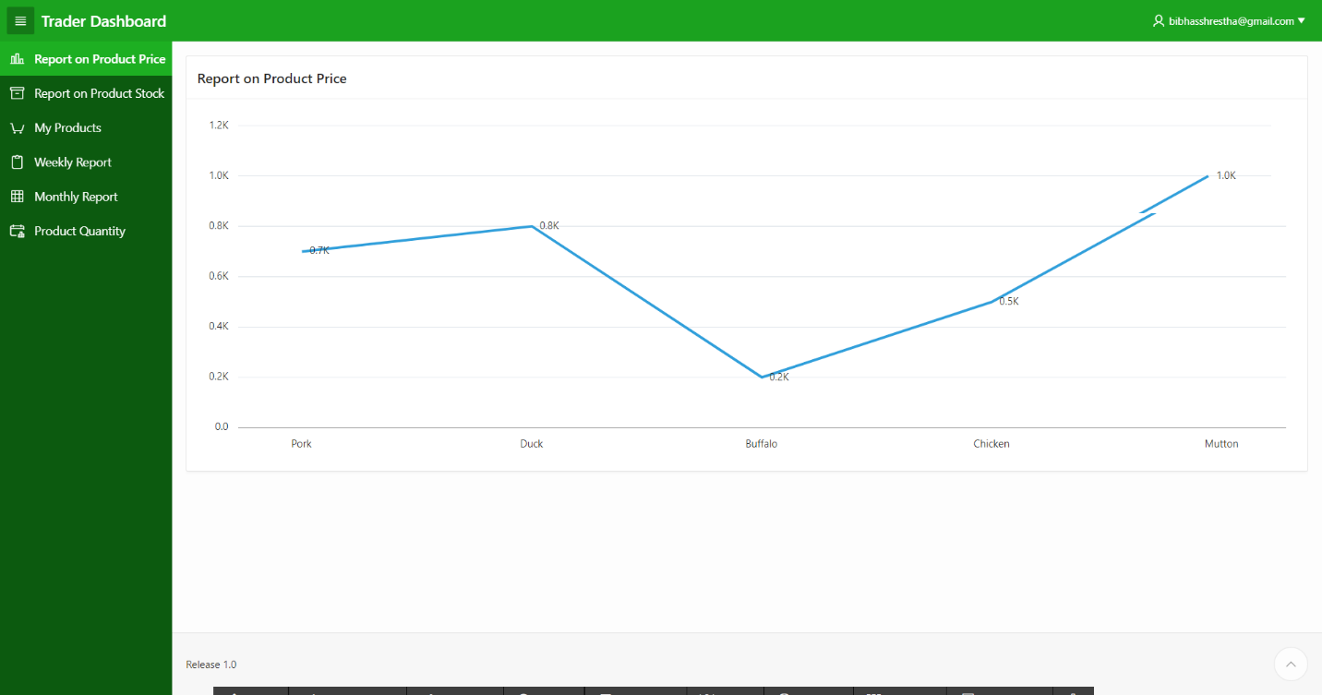

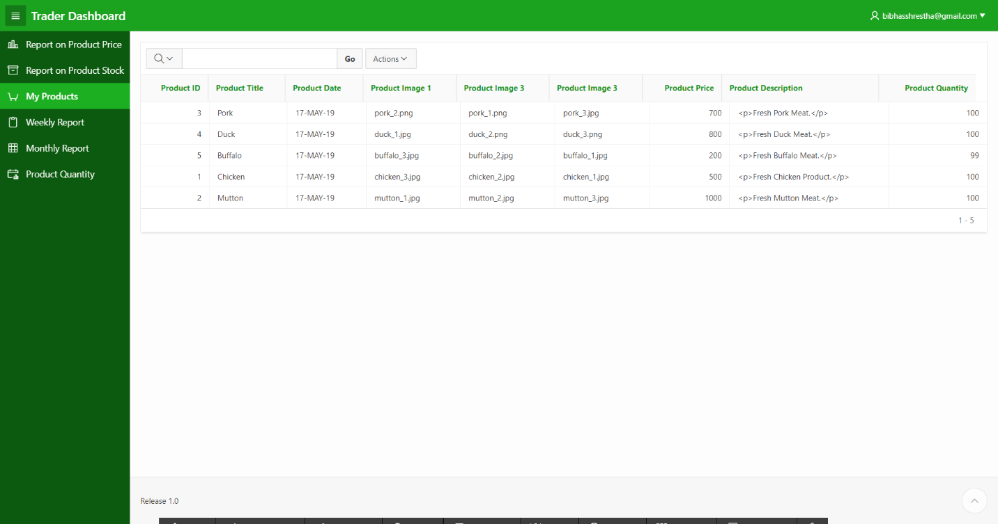

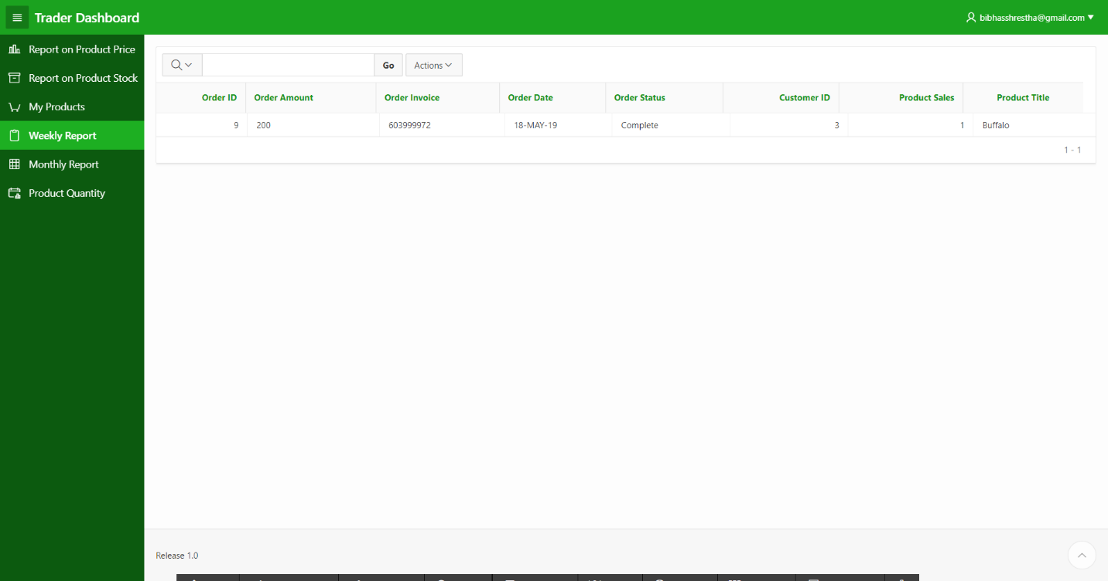

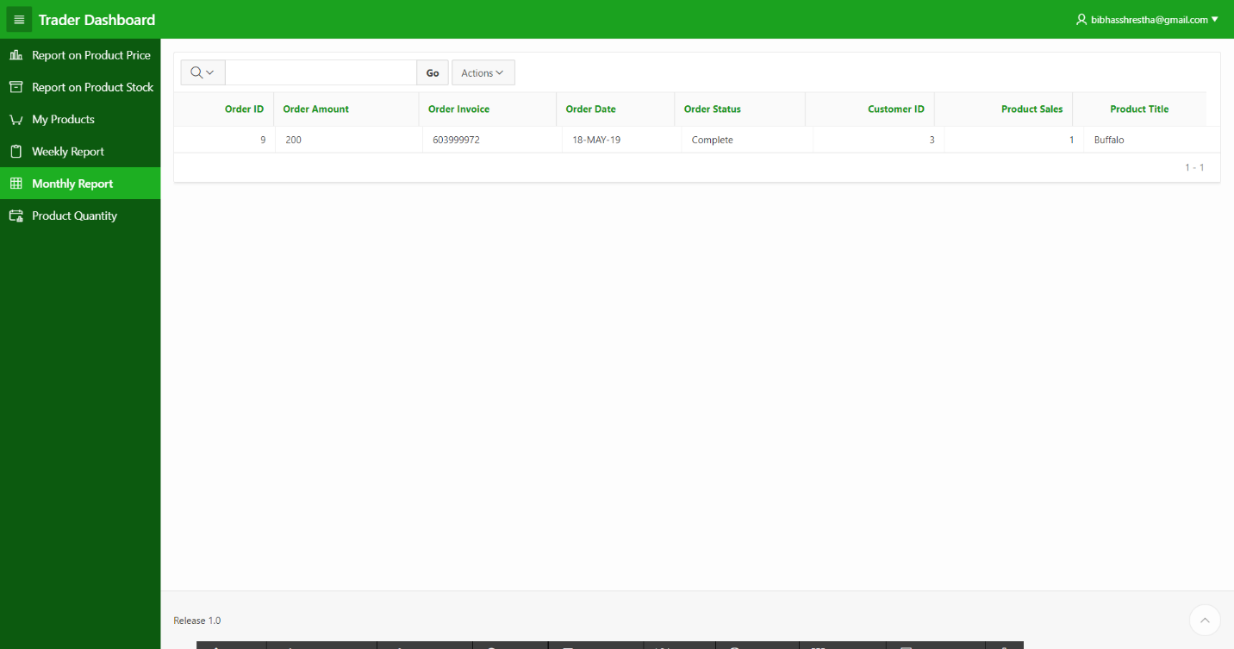

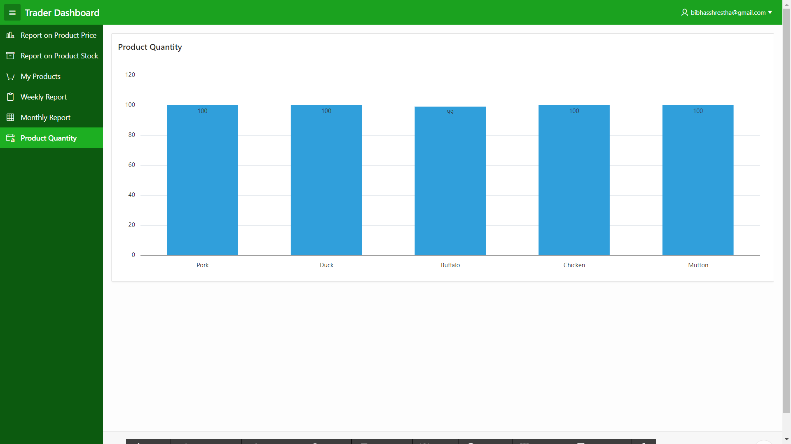

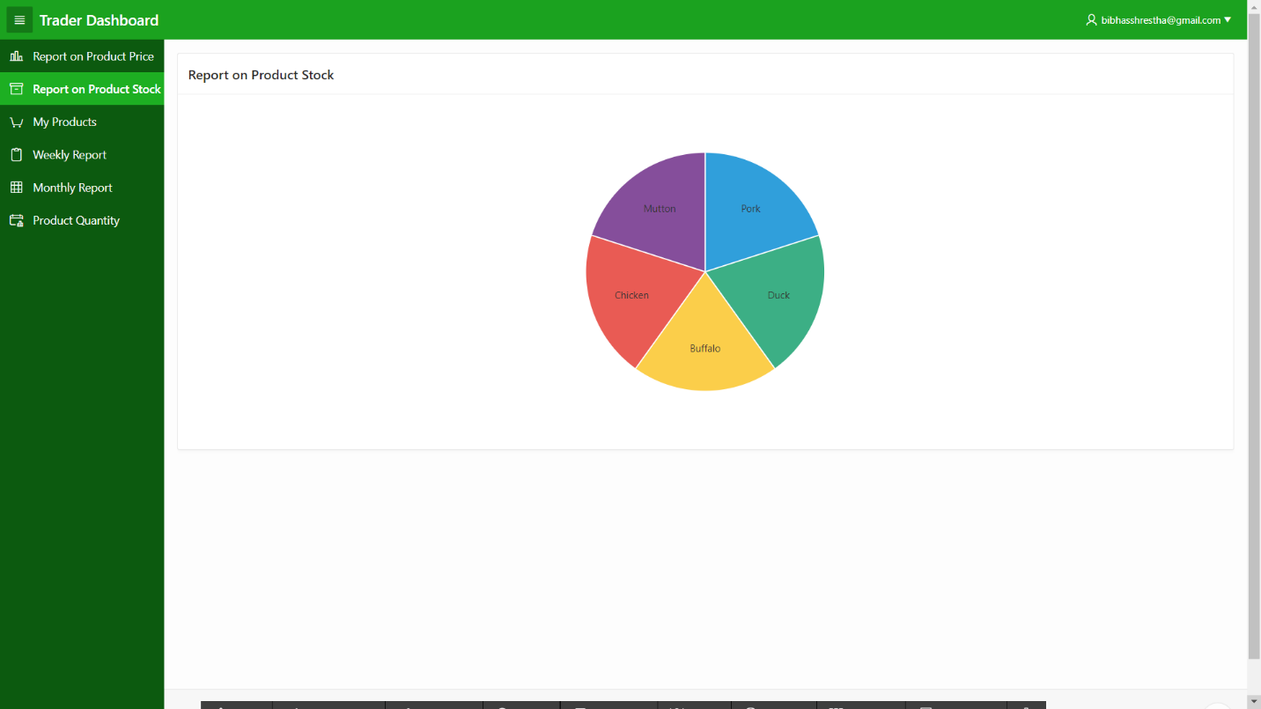

### 3.3.4 Trader Interface Web

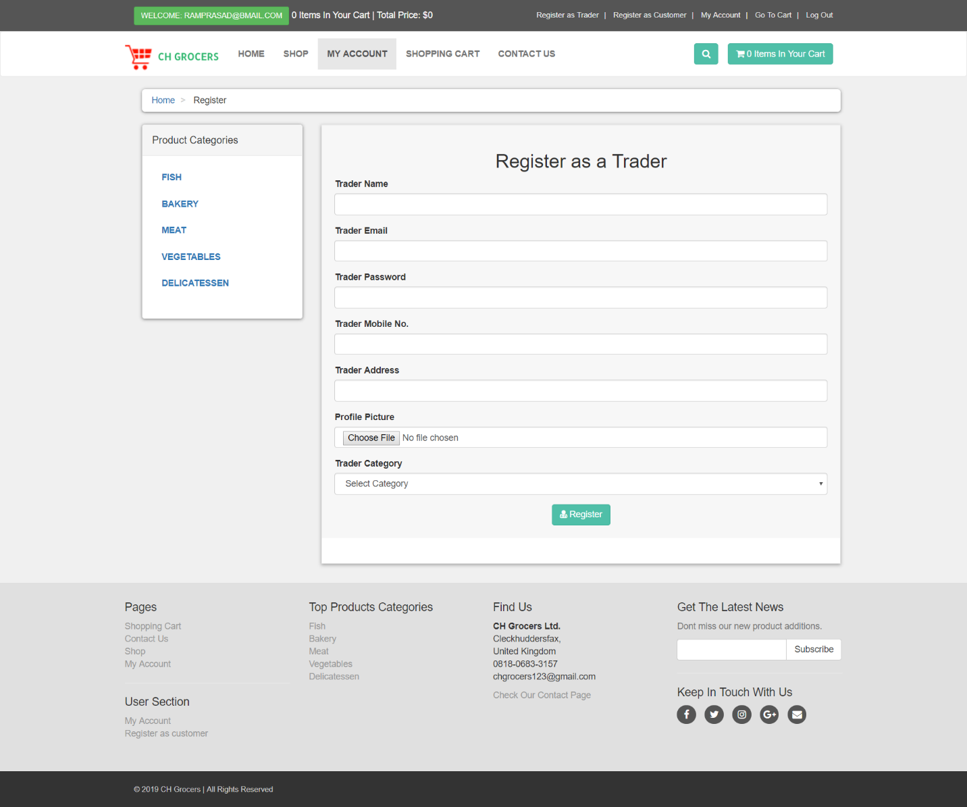

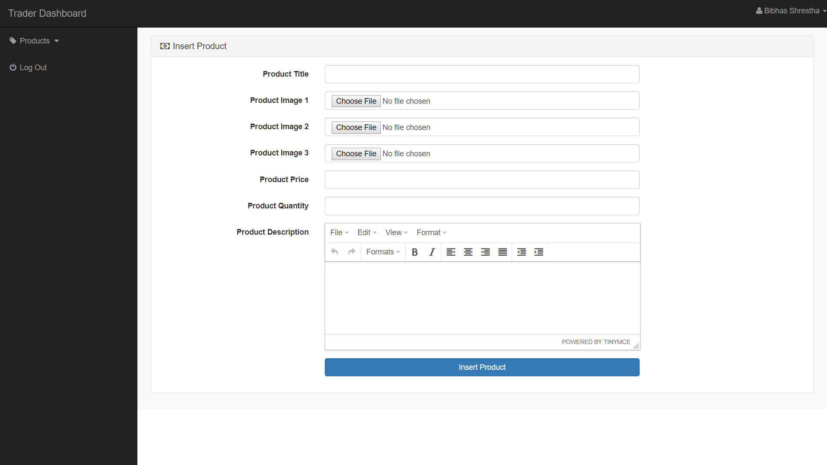

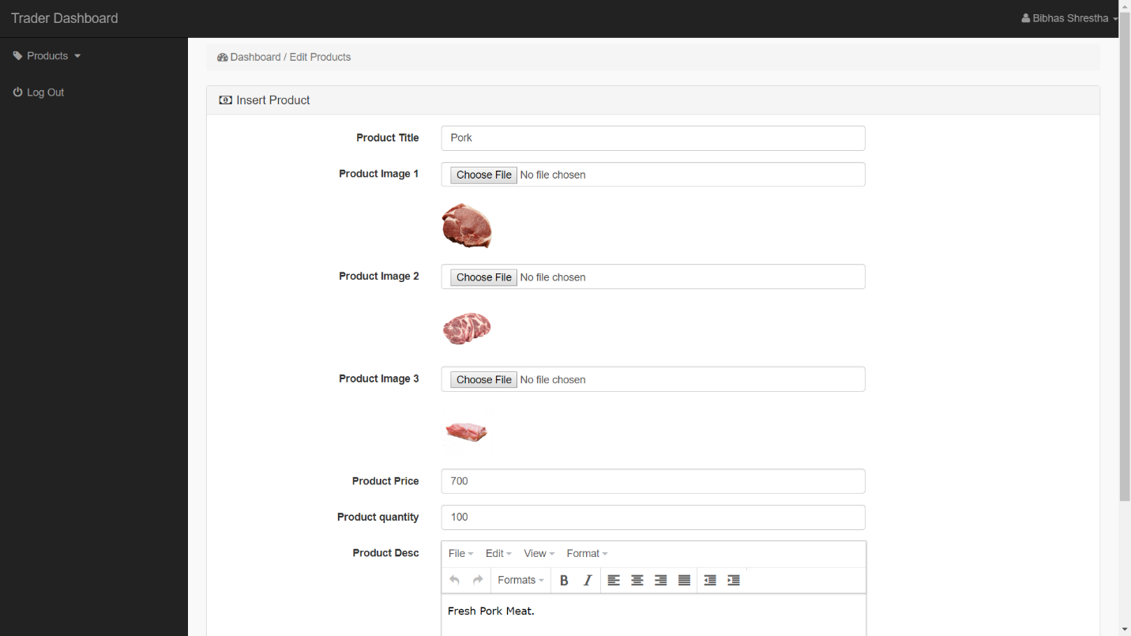

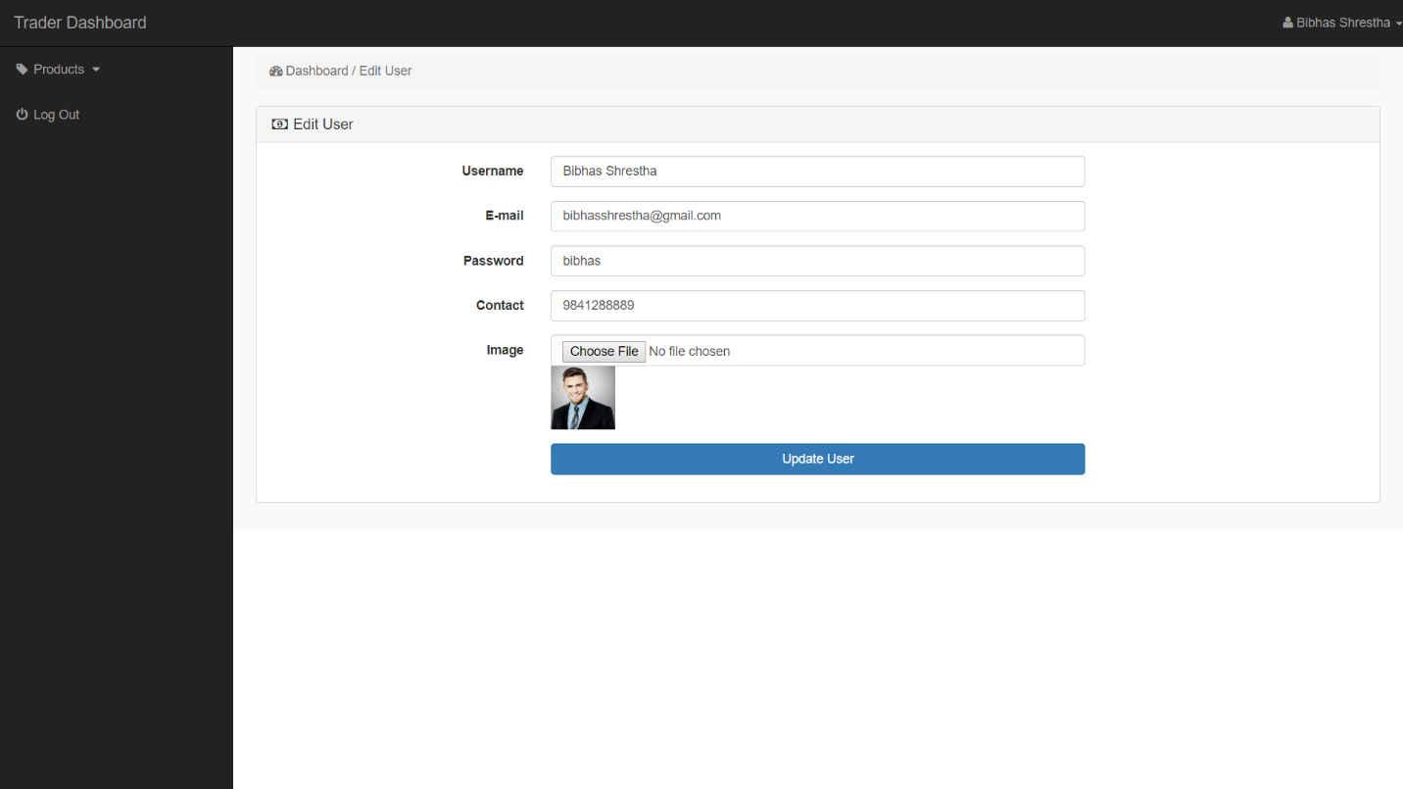

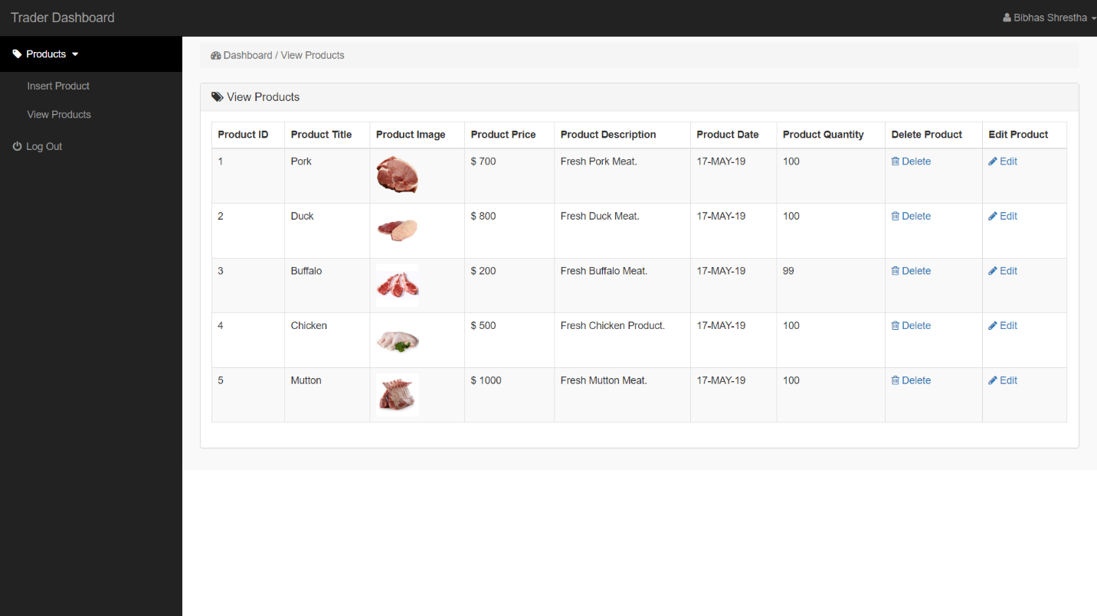

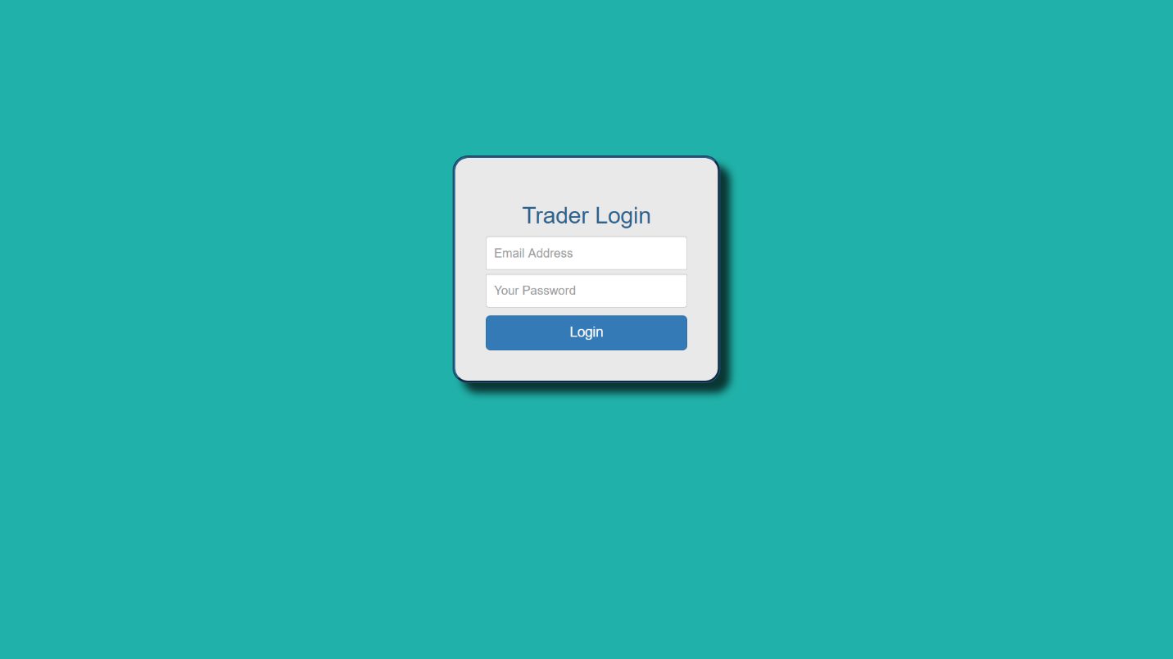

### 3.4 Website Mockup

### 3.4.1 Mockup Design

#### Homepage

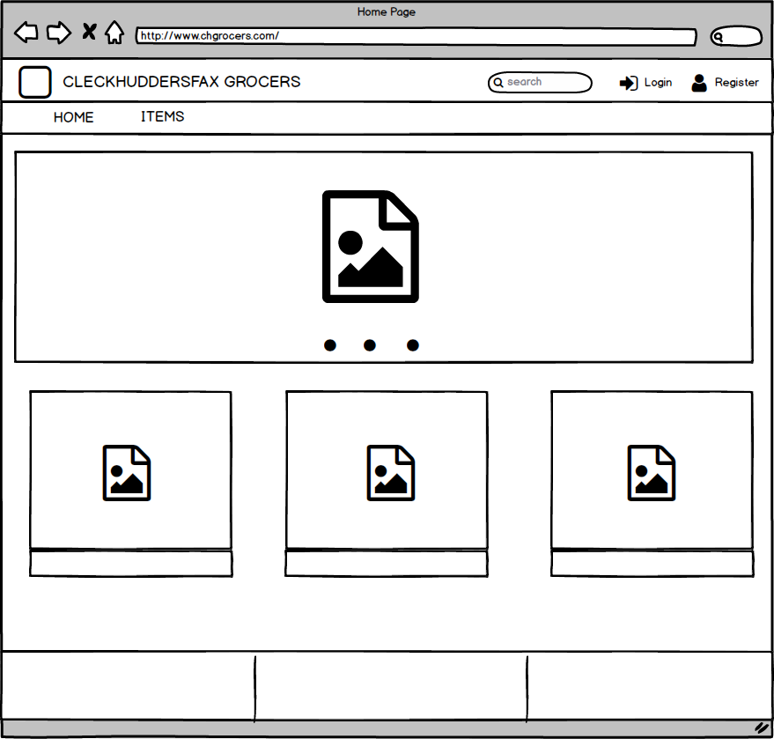

#### Login

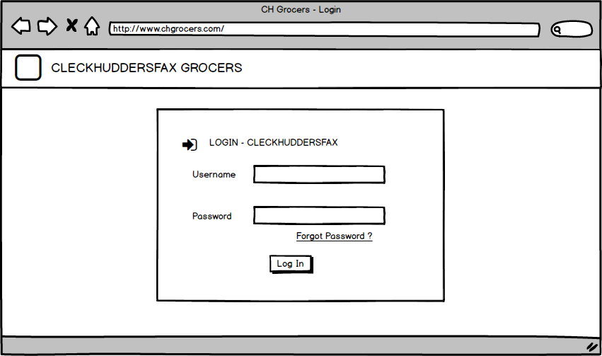

#### Trader Dashboard

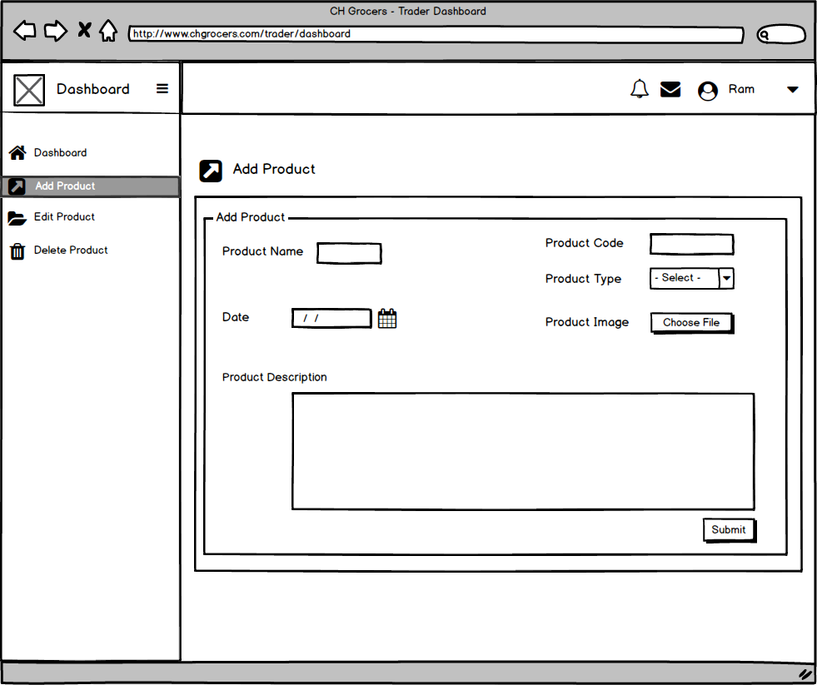

#### Management Dashboard

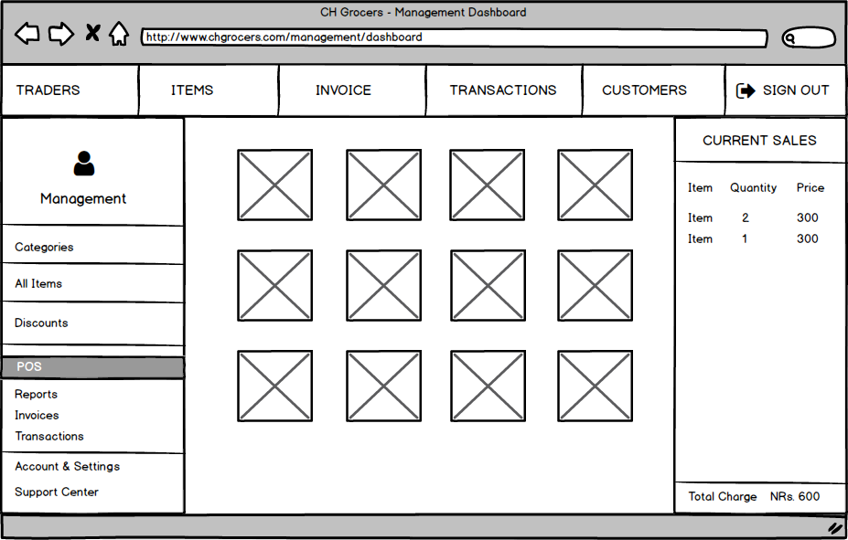

#### User Registration

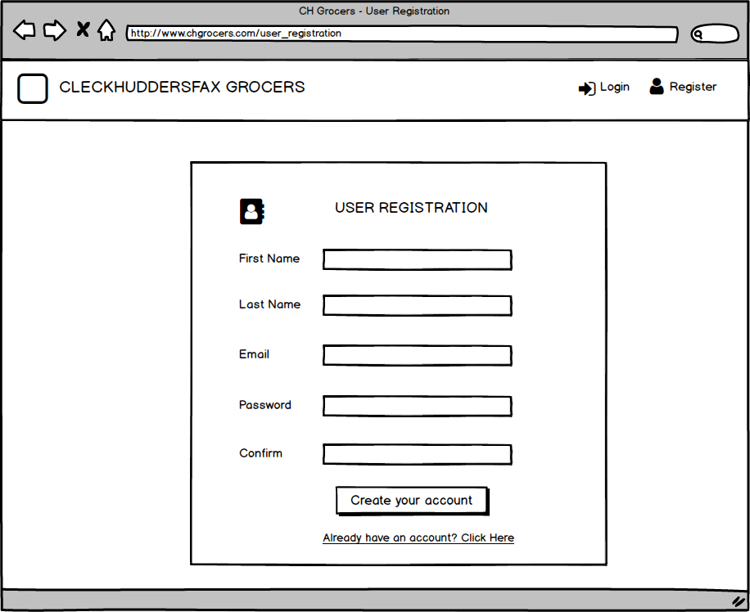

#### Trader Registration

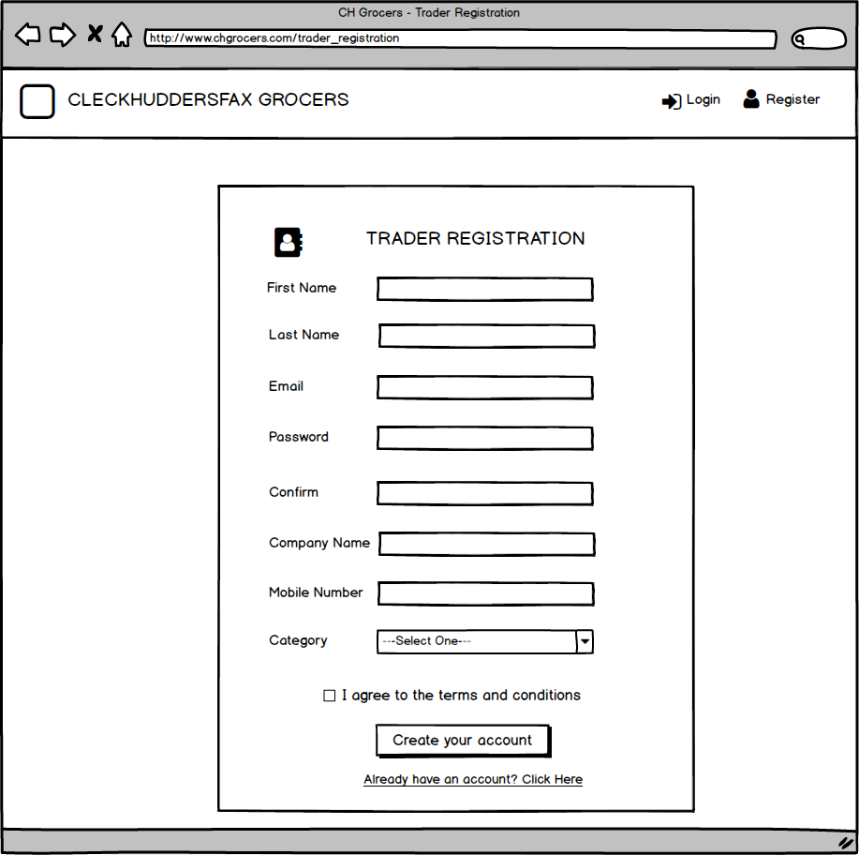

#### Account Settings and Preferences

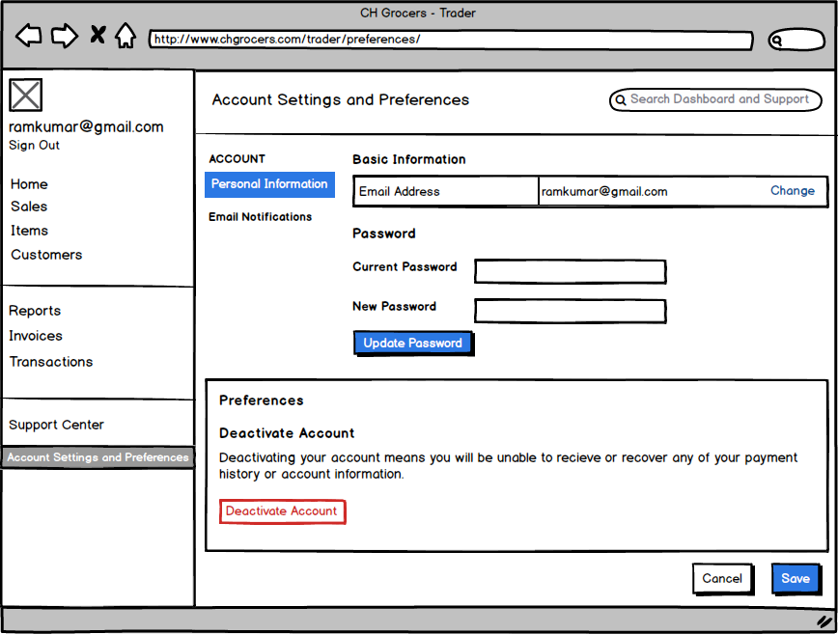

### 3.4.2 Product Logo



### 3.4.3 Team Logo



### 4.Project Closing

### 4.1Testing and Evaluation

### 4.1.1 CH GROCERS Testing

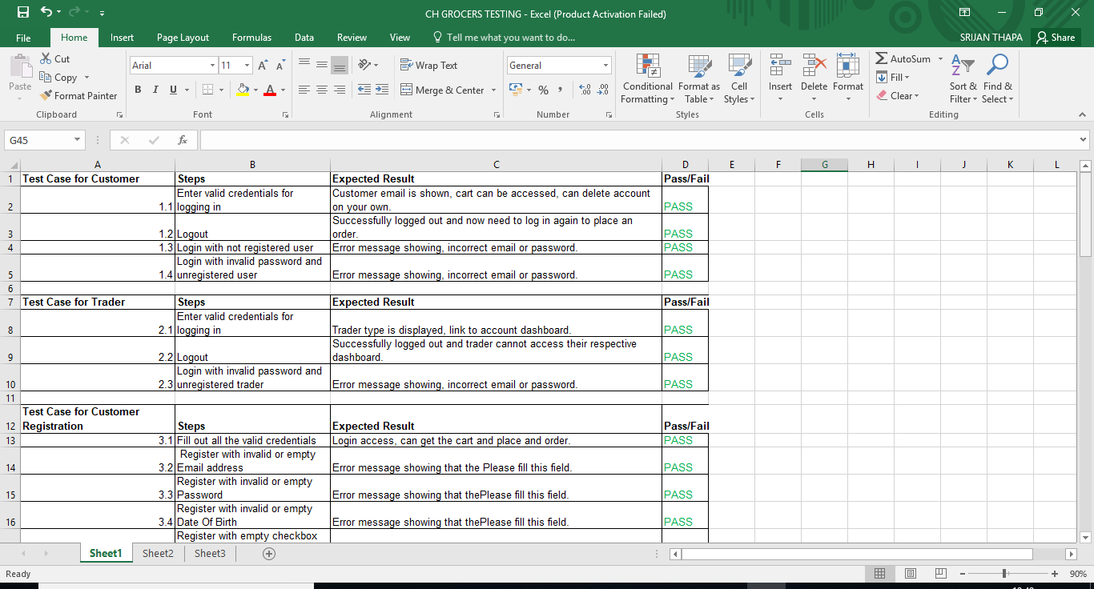

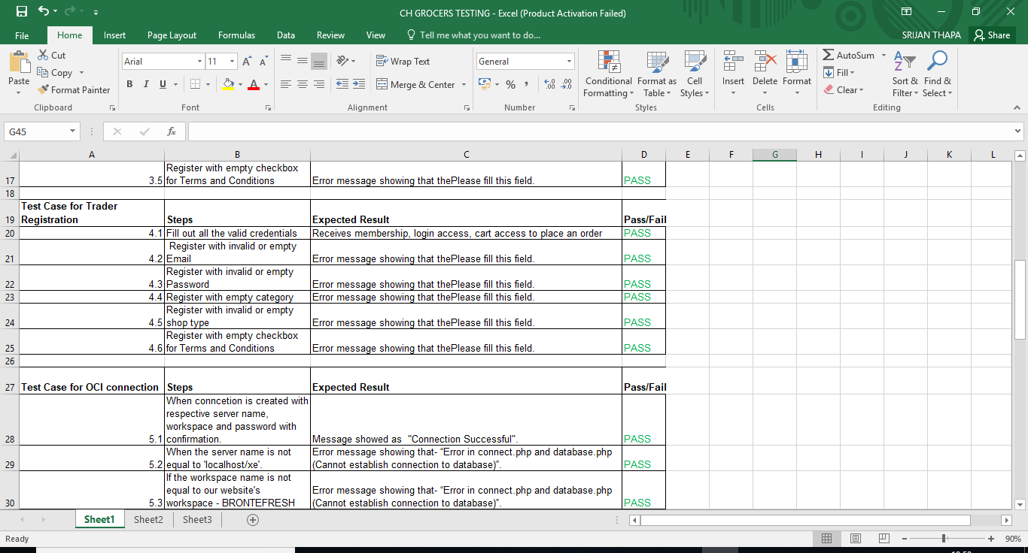

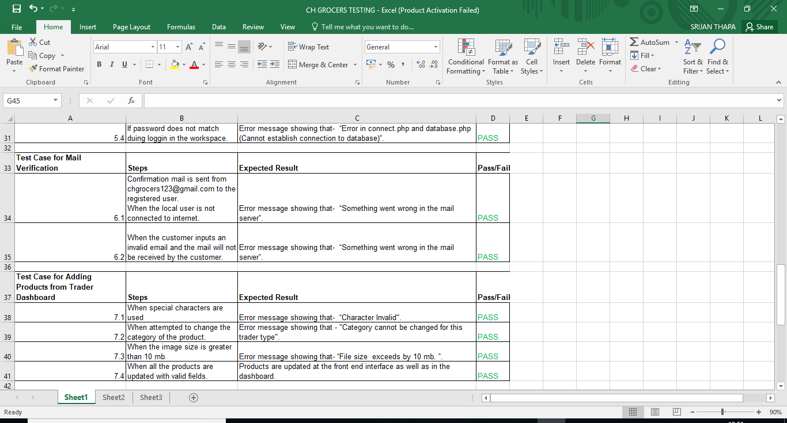

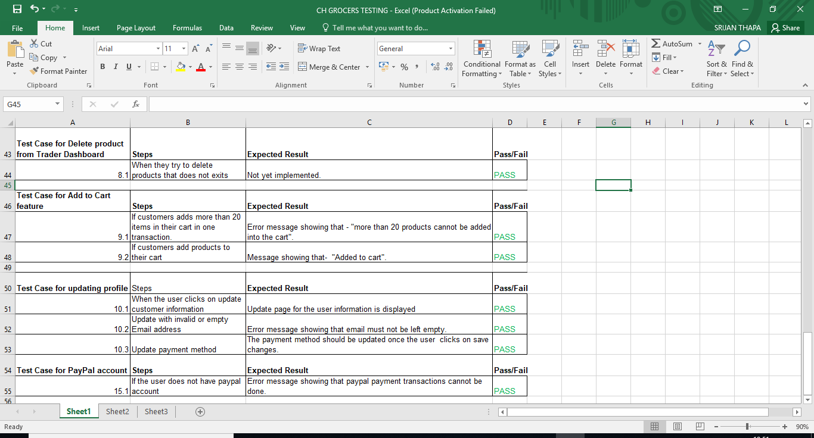

### 4.2 User Guide

### 4.2.1 Administrator Apex Guide

CH Grocers

Management Interface Guide

This management interface guide will control you through the features of the dashboard and will likewise enable you to explore through the management dashboard effortlessly. Likewise, to ensure you don't have the problem of perusing long, exhausting and pointless aides, we've attempted our best to make this short, straightforward and justifiable. In the event that you have any further inquiries that the guide couldn't deliver please don't hesitate to get in touch with us on [chgrocers123@gmail.com](mailto:chgrocers123@gmail.com)

# Management Interface Login

You can log in as and admin if you are given access by the team of developers. You can see a management login option where you can enter the right credentials to login.



# Management Dashboard

You can view the reports on products, categories and sales on the management dashboard.



# Product Management

You can view the interactive report on the product management page where you have the option to add new product or edit existing product.



# Edit Product

You can edit the product after clicking on the pencil icon. A modal dialog page opens where the product can be edited.



# Category Management

You can view the interactive report on the category management page where you have the option to add new category or edit existing category.



# Trader Management

You can view the interactive report on the trader management page where you have the option to add new trader or edit existing trader.



# Edit Trader

You can edit the trader after clicking on the pencil icon. A modal dialog page opens where the trader can be edited.



# Customer Management

You can view the interactive report on the customer management page where you have the option to add new customer or edit existing customer.



# Edit Customer

You can edit the customer after clicking on the pencil icon. A modal dialog page opens where the customer can be edited.



# Order Details

You can view the order detail where you can check product quantity, order date, order invoice.



# Slider Image

You can add the slider image on the website image from this interactive report.



# Timeslot Details

You can view the timeslot details where you can check order invoice, date and time of the order.

# 

# Administration

You can configure the application, select the them and use access control from this page.



### 4.2.2 Customer Guide

A CH GROCERS User Guide

Customer Guide

This customer guide will manage you through the highlights (main features) of the site and will likewise enable you to explore through our site easily. Likewise, to ensure you don't have the issue of perusing long, exhausting and pointless aides, we've attempted our best to make this short, straightforward and justifiable. On the off chance that you have any further questions that the guide couldn't deliver please don't hesitate to reach us on chgrocers123@gmail.com.

# User Registration

After going to our homepage you'll see register as customer on upper left of the site. Click on it to register after that you will be directed towards a registration form fill up the form and click on register. You will get an email from the admin with a link to activate your account click on the link to activate your account.

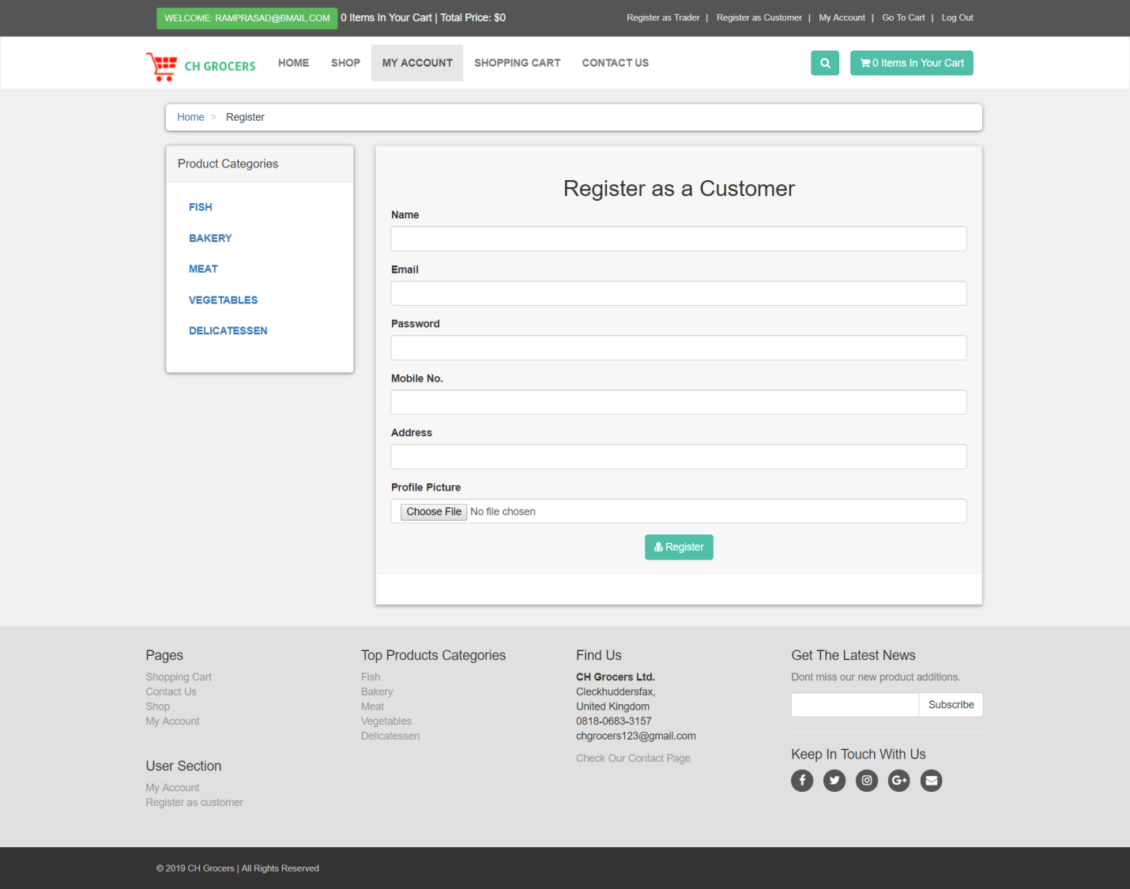

# User Login

You can log in as a customer after you click on the link sent by user. On homepage you will see login on right side of the site click on it and enter your email and password and click on login button to login.

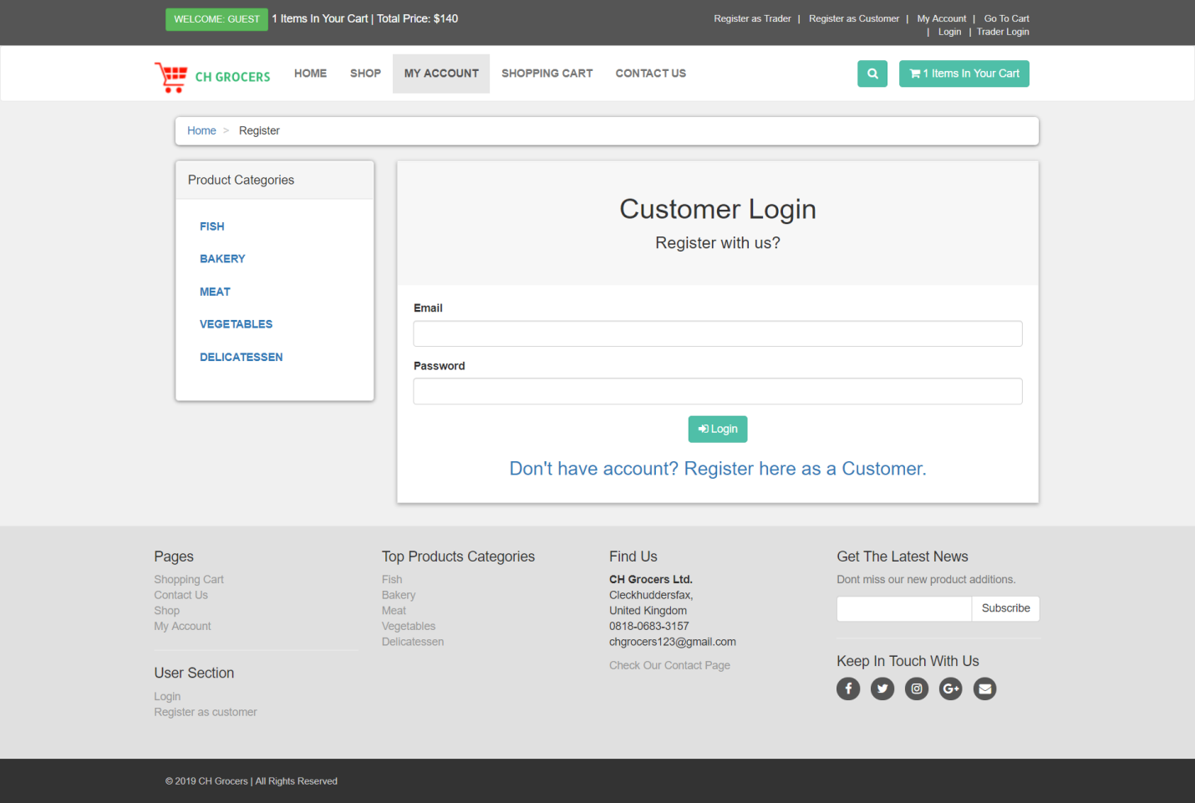

Product Browsing

You can browse products from shops and categories from different traders

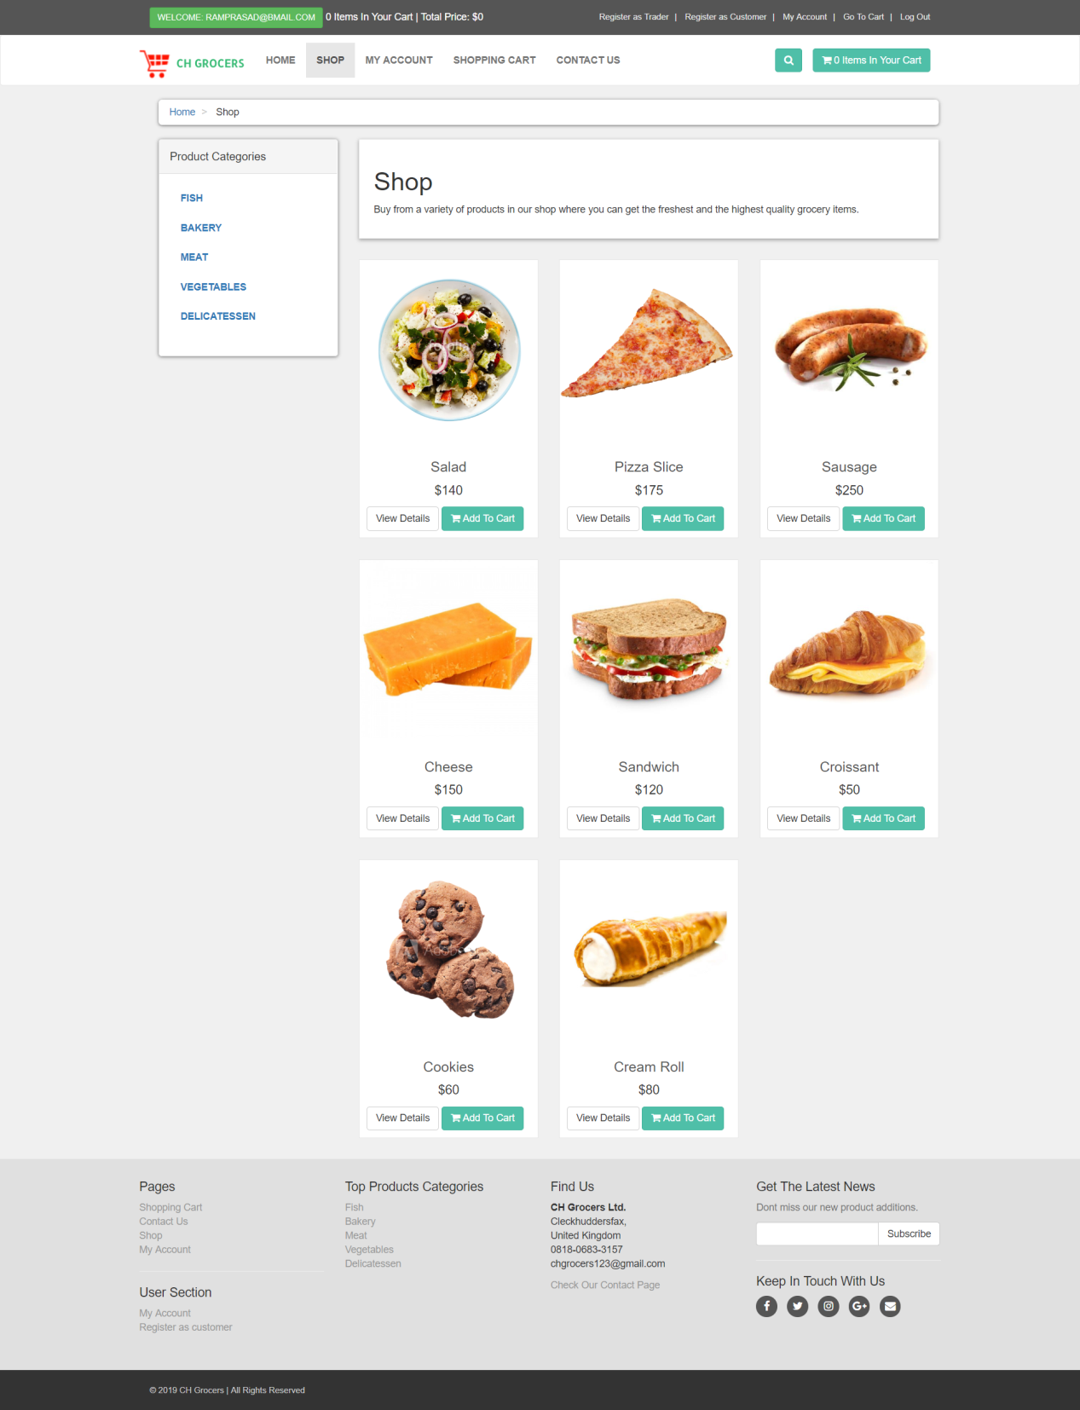

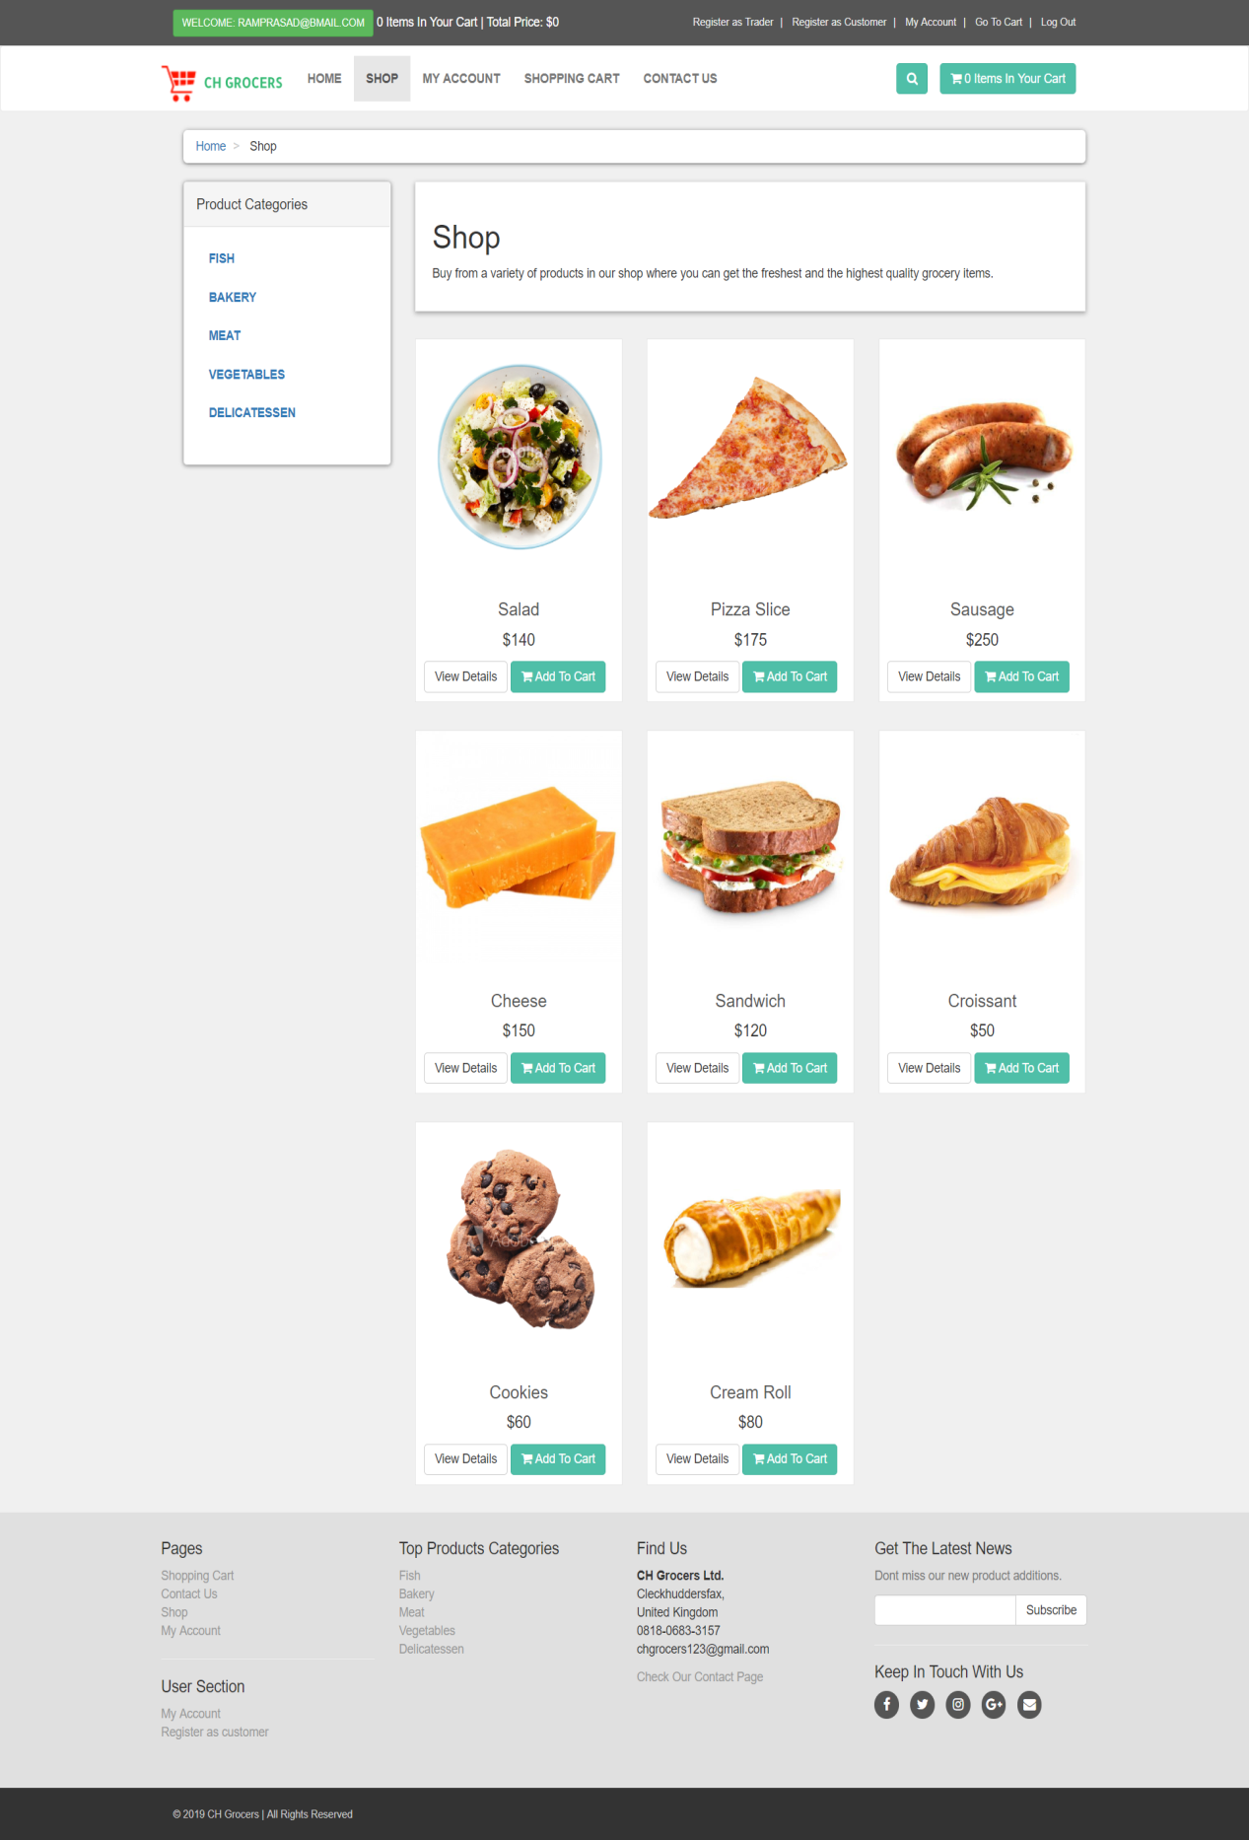

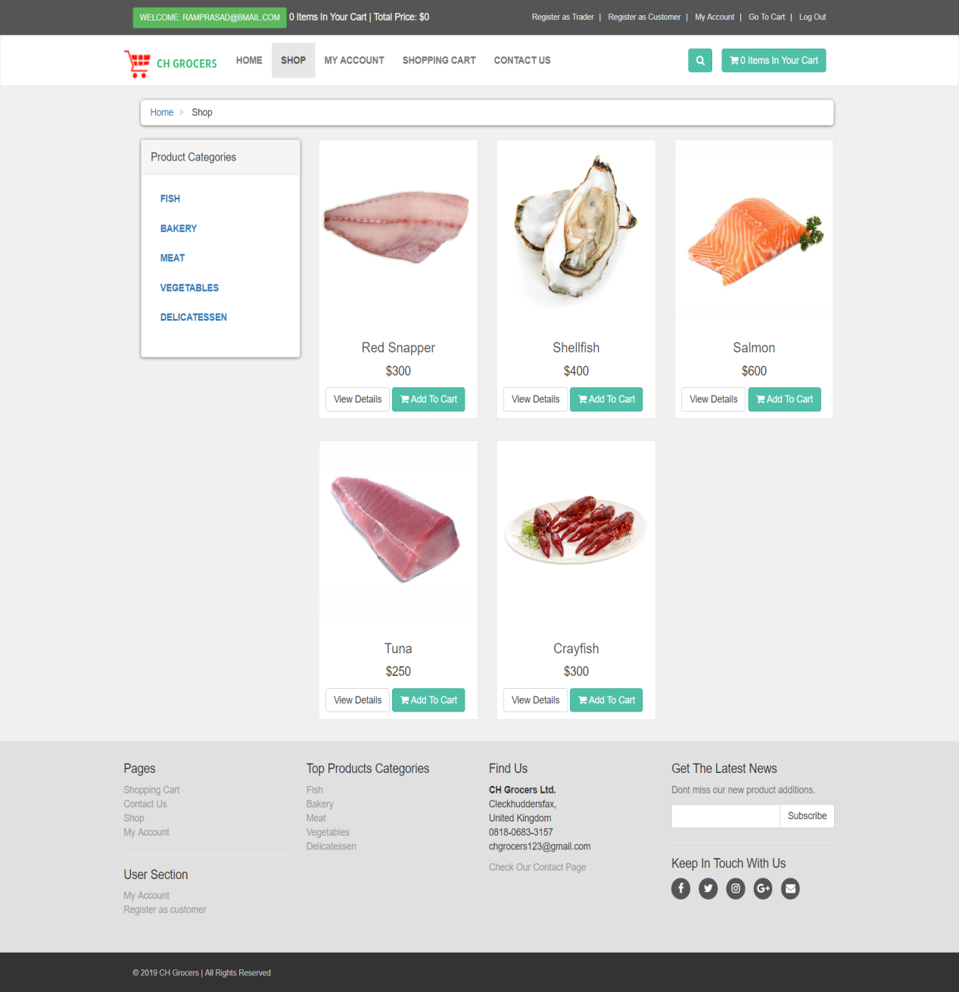

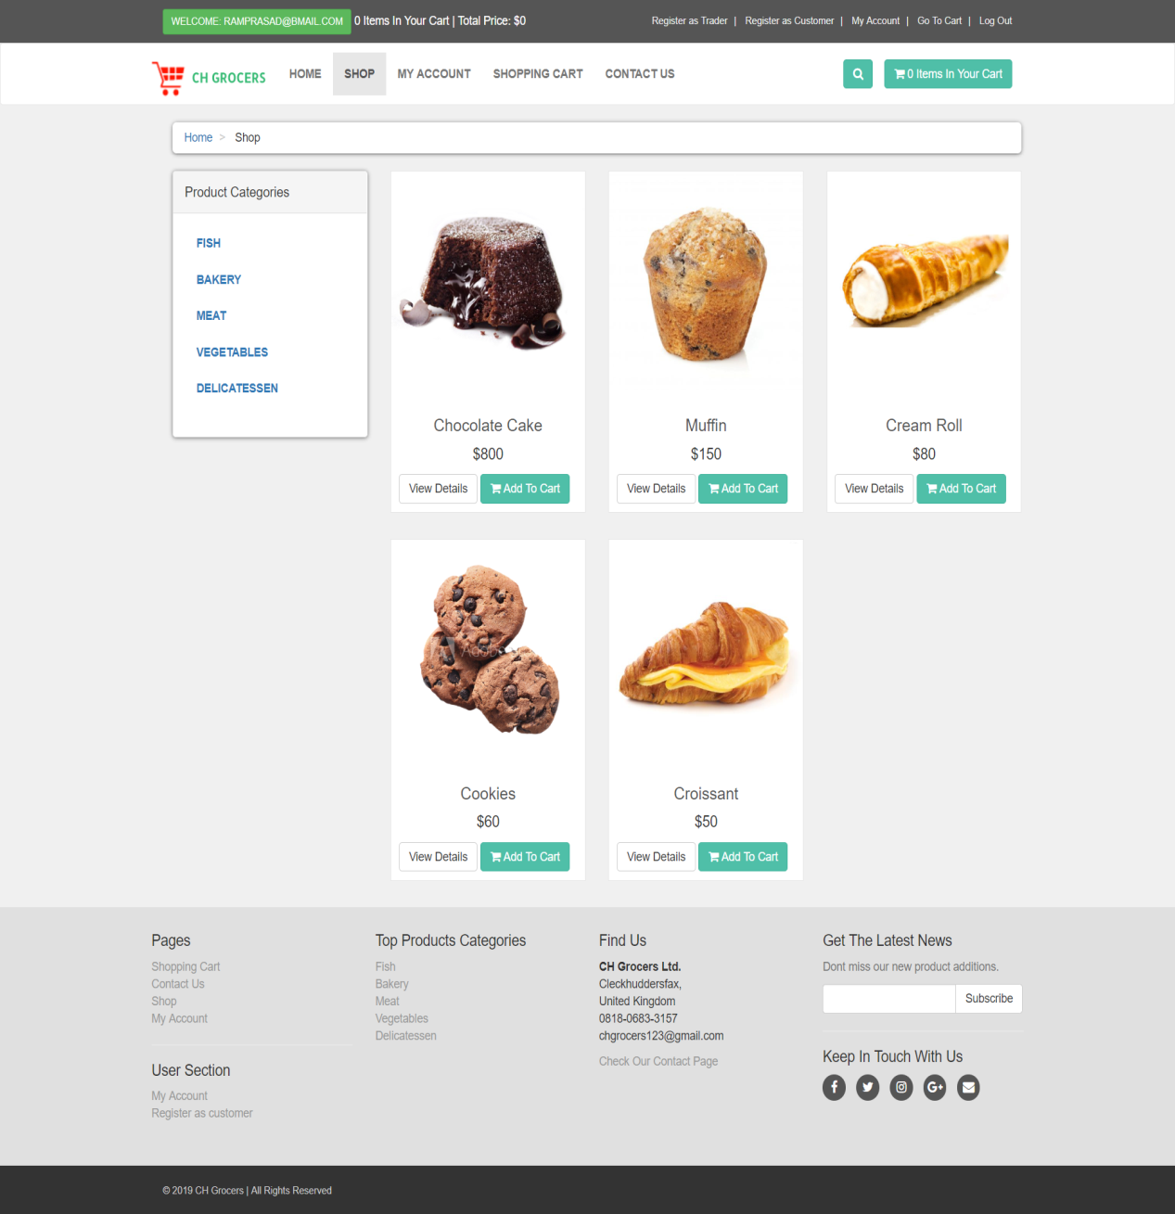

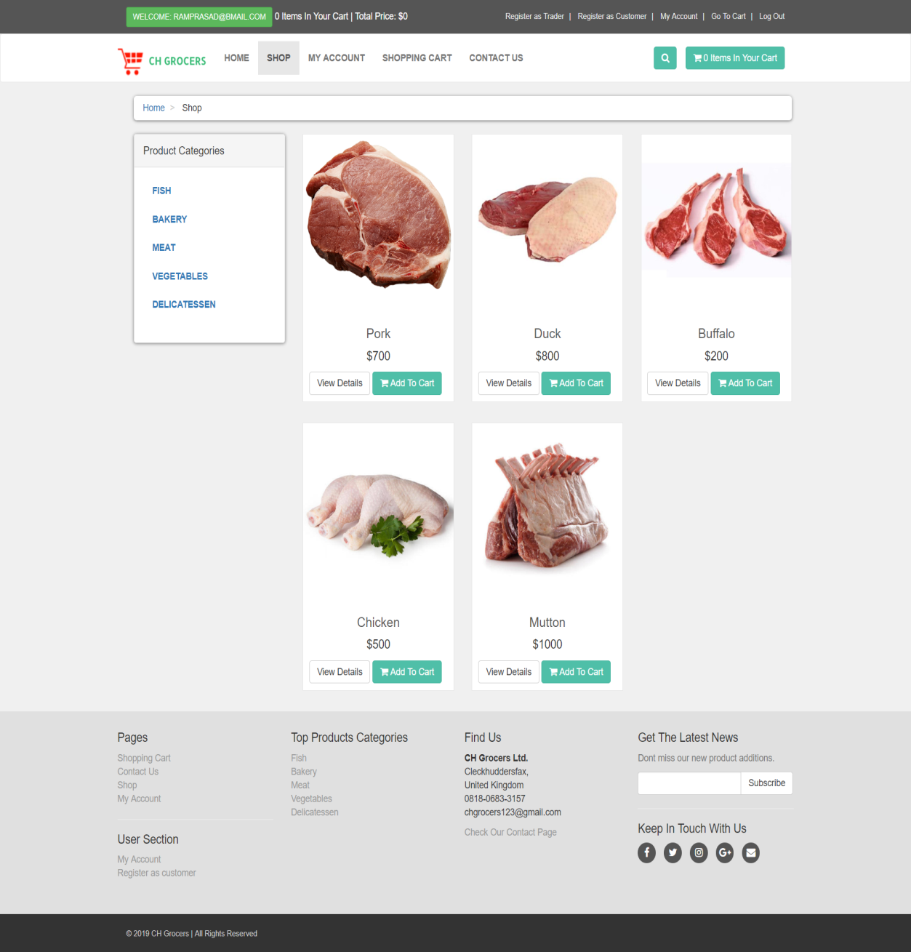

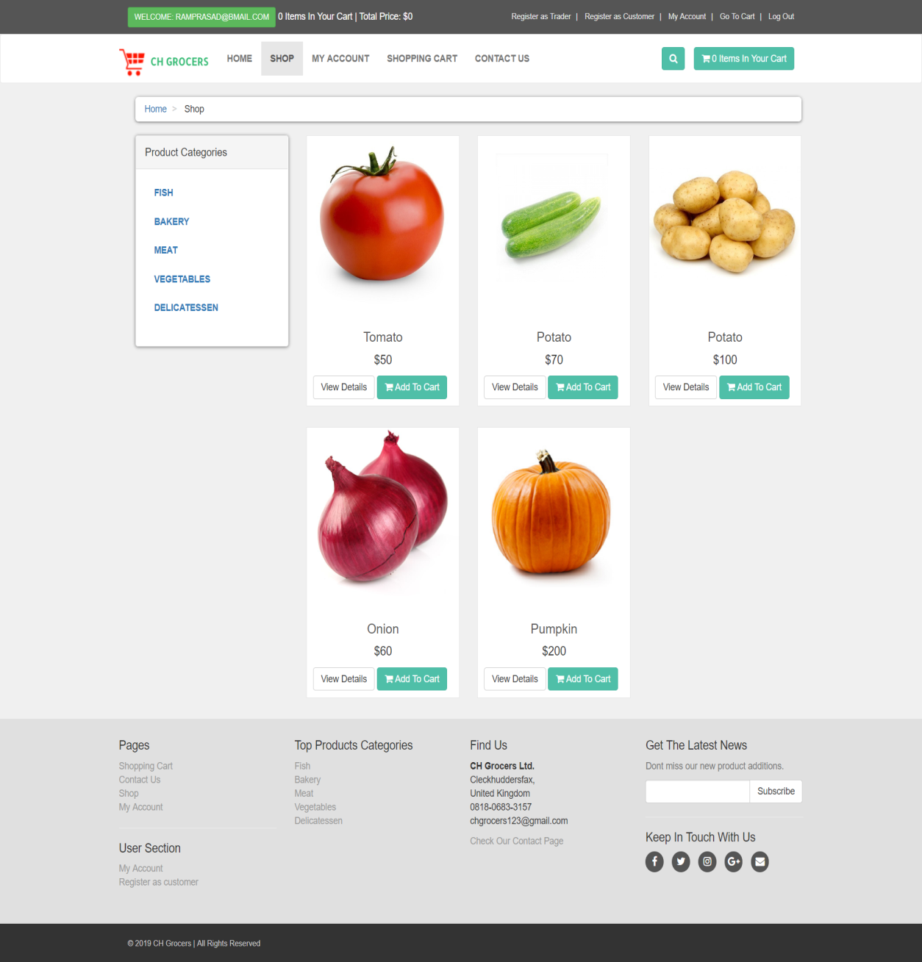

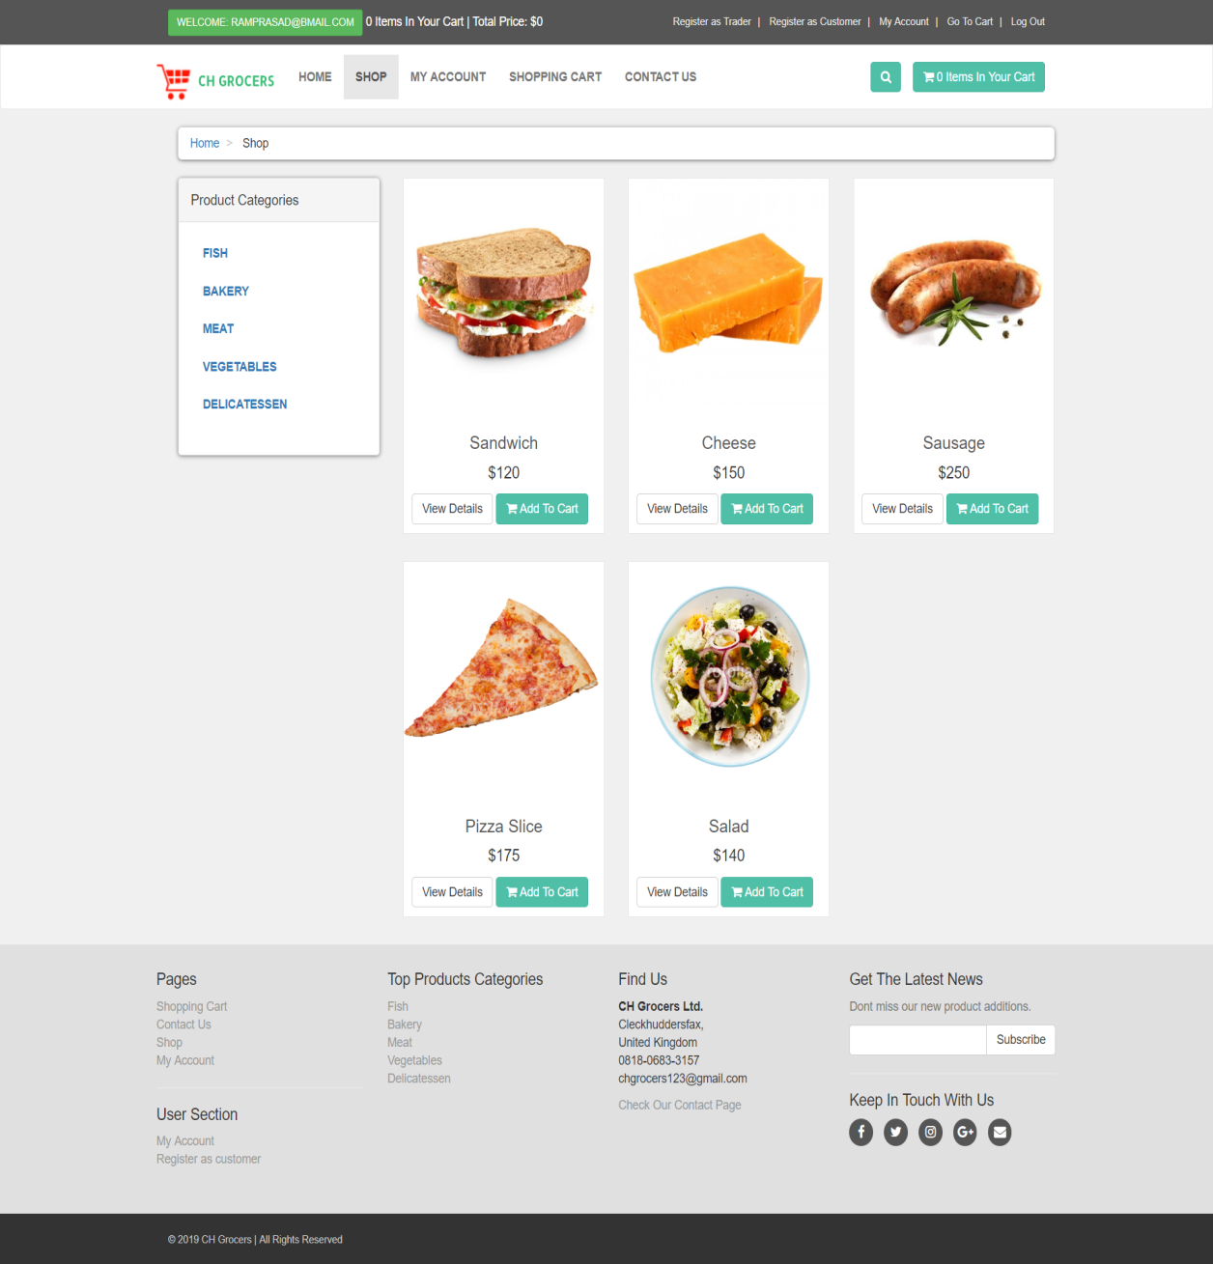

# 

# Adding Products to the Cart

You can add items to your cart by simply clicking on add to cart button. After clicking Add to cart button you will be directed towards a page where you can choose product quantity.

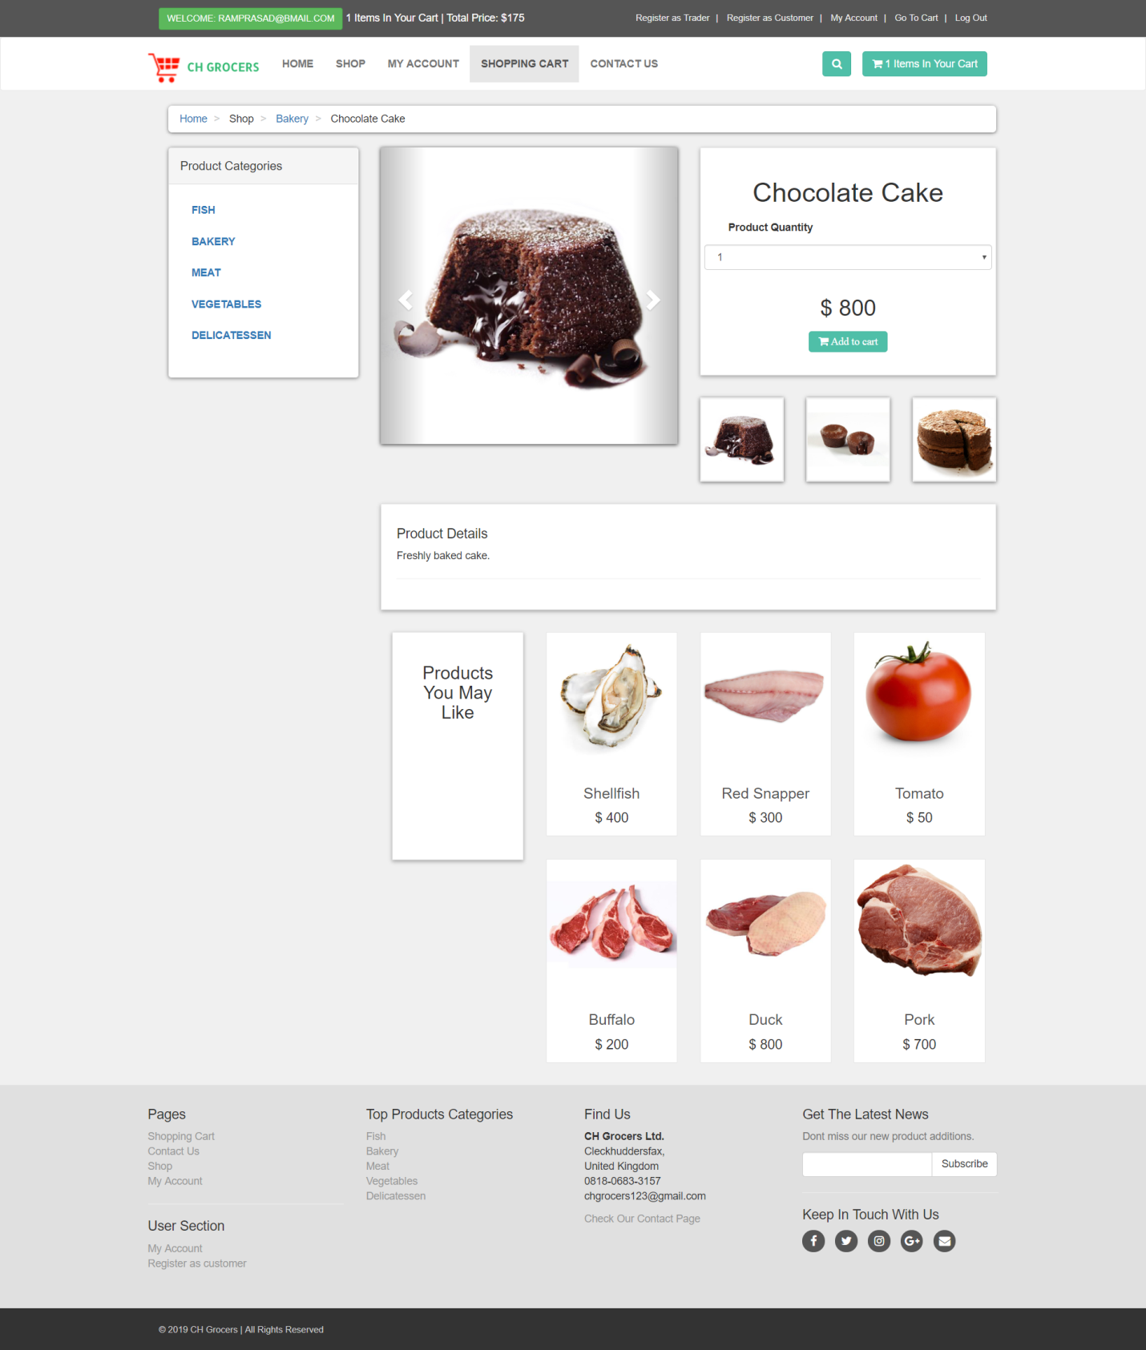

**Viewing the Cart**

Click on cart button on right hand of the site to view items in your cart you can also delete items added on your cart by simply checking delete checkbox and clicking on update cart.

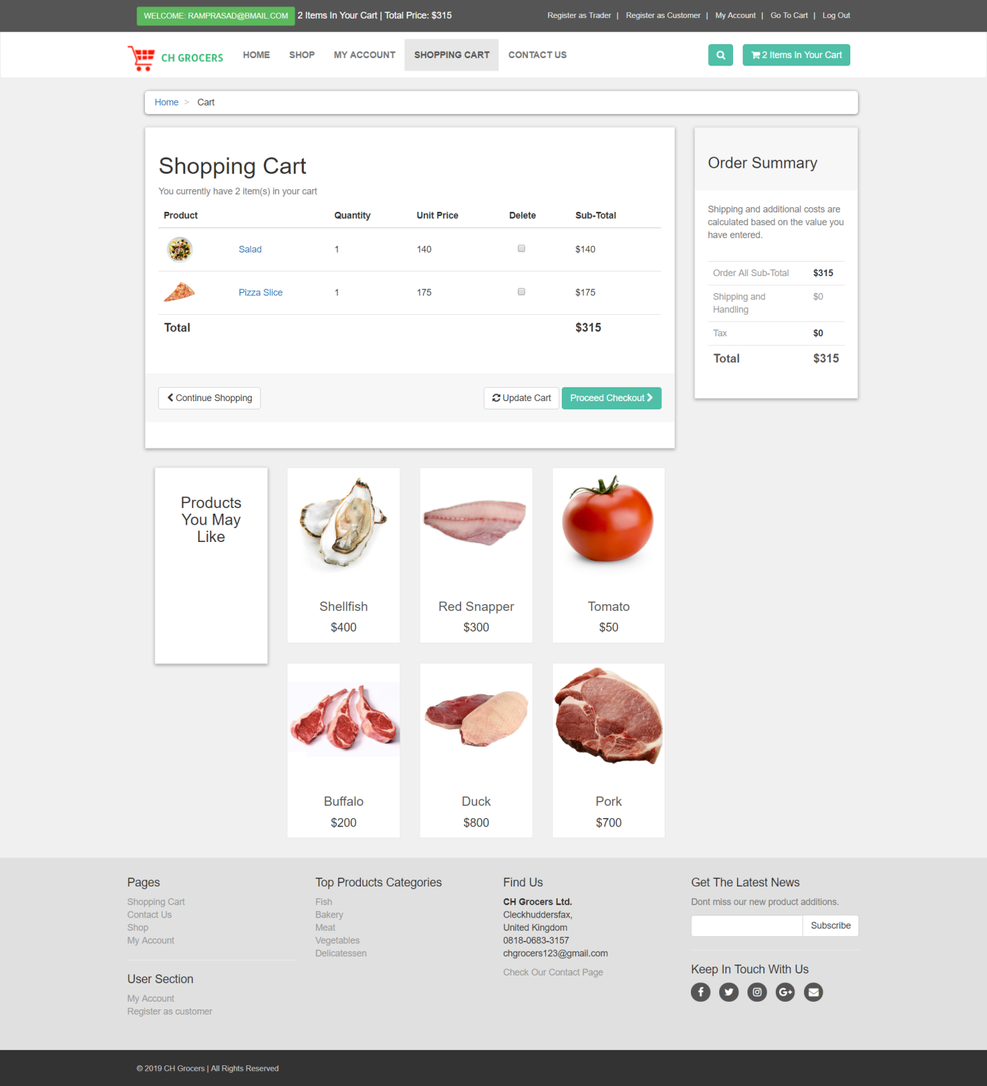

# Check Out

To checkout simply click on proceed checkout button after that you will be directed towards a page there you should choose your time of delivery and click on submit after that click on submit to process after that you directed towards pay pal login page

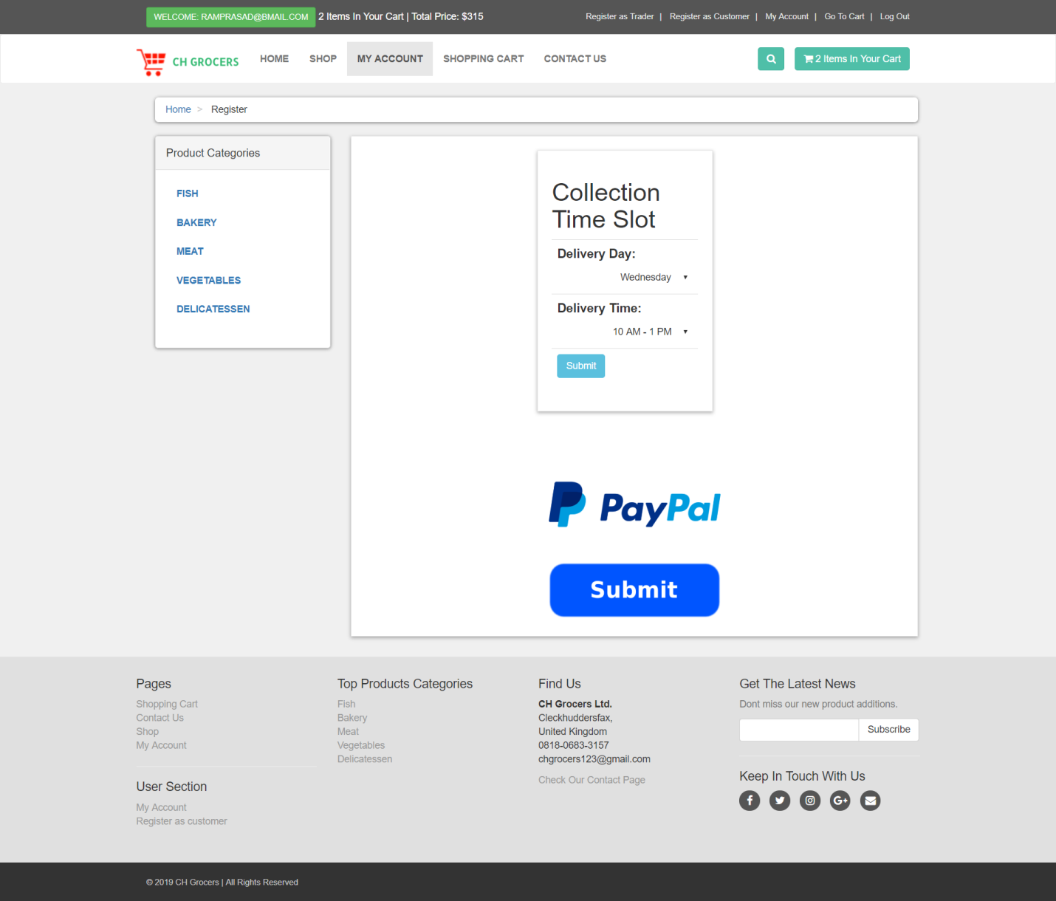

# 

# After login into pay pal you get this screen

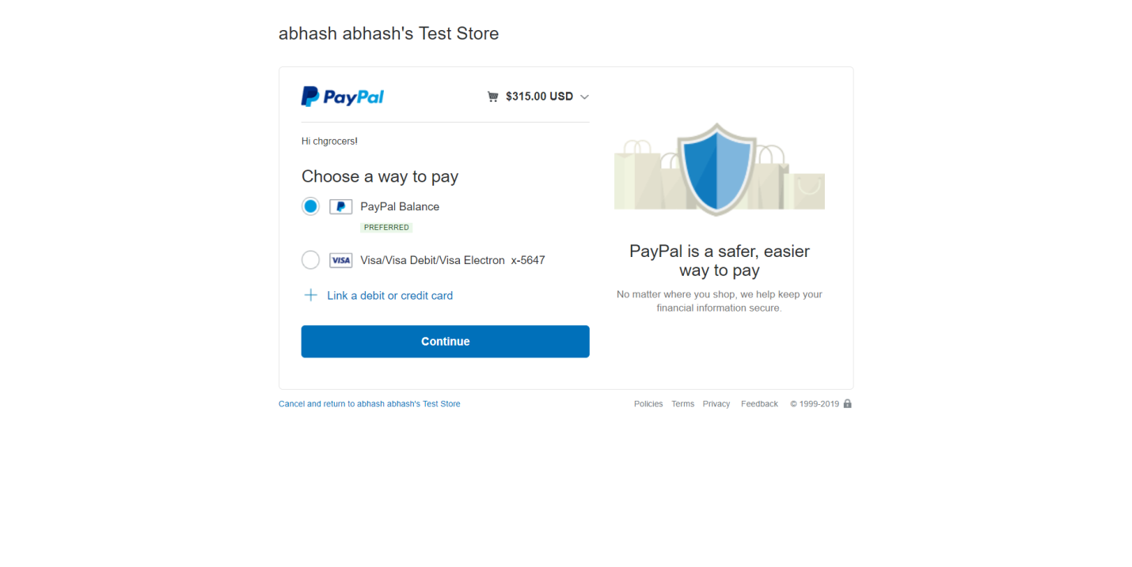Choose pay pal balance and click continue you will be forwarded to this page

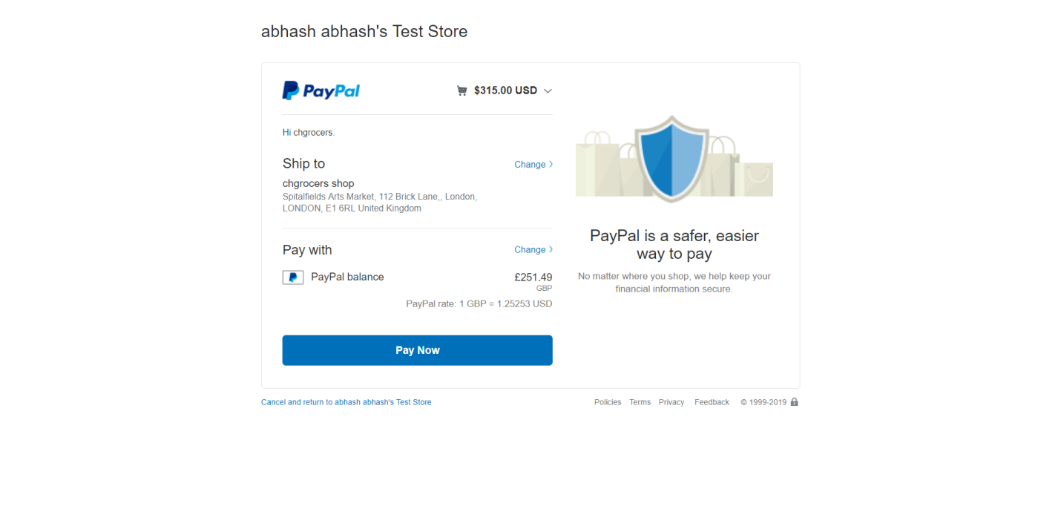

Click on pay now and the payment is complete and you will be directed towards this page

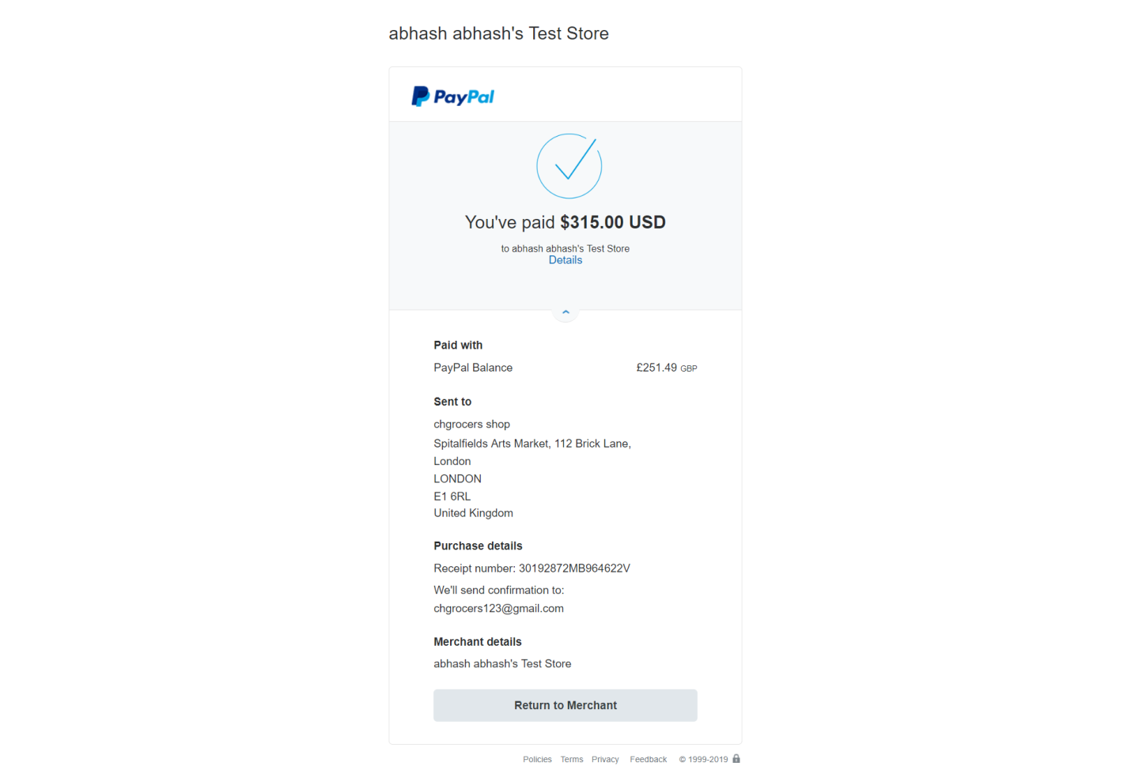

# 

# View orders, invoice

You can view your orders by clicking on my order on the sidebar there on left hand side you will find a view invoice button click it to view invoice and click on mail invoice button to invoice mail

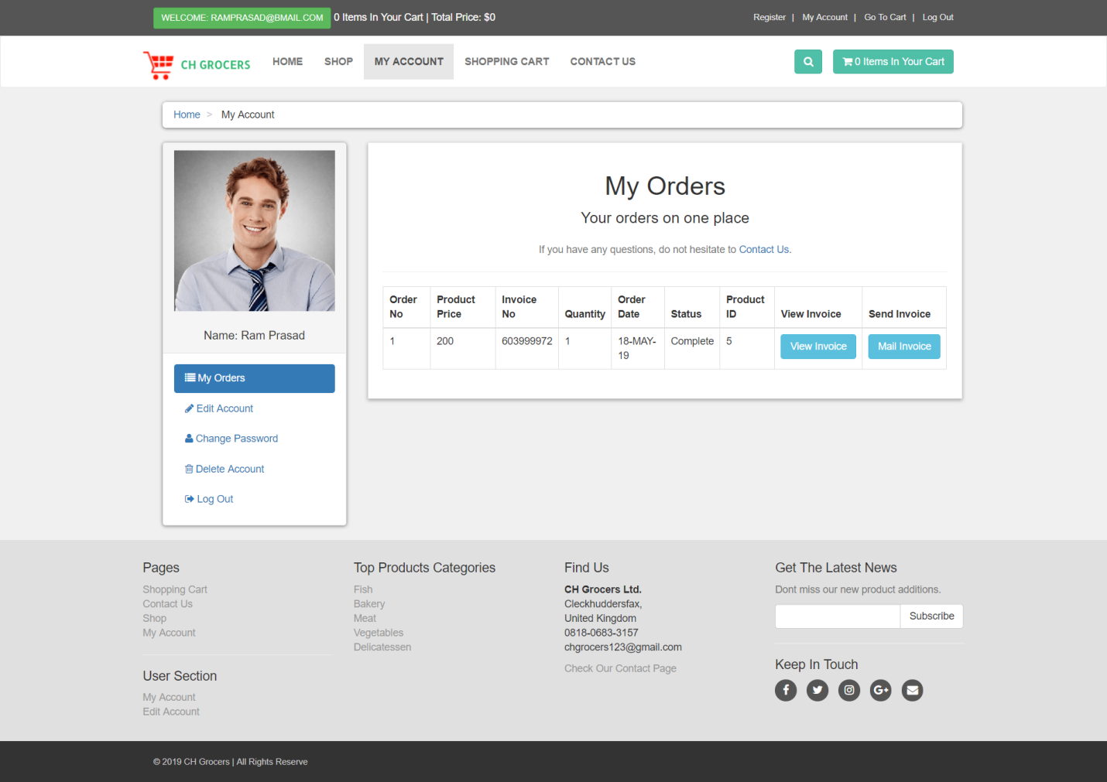

# Edit Profile

To edit your profile first you should login with your valid credentials. After that you should click on my account on the left hand side there you will see a sidebar there you will find edit account

Click on edit account and fill the details again to edit and click update now.

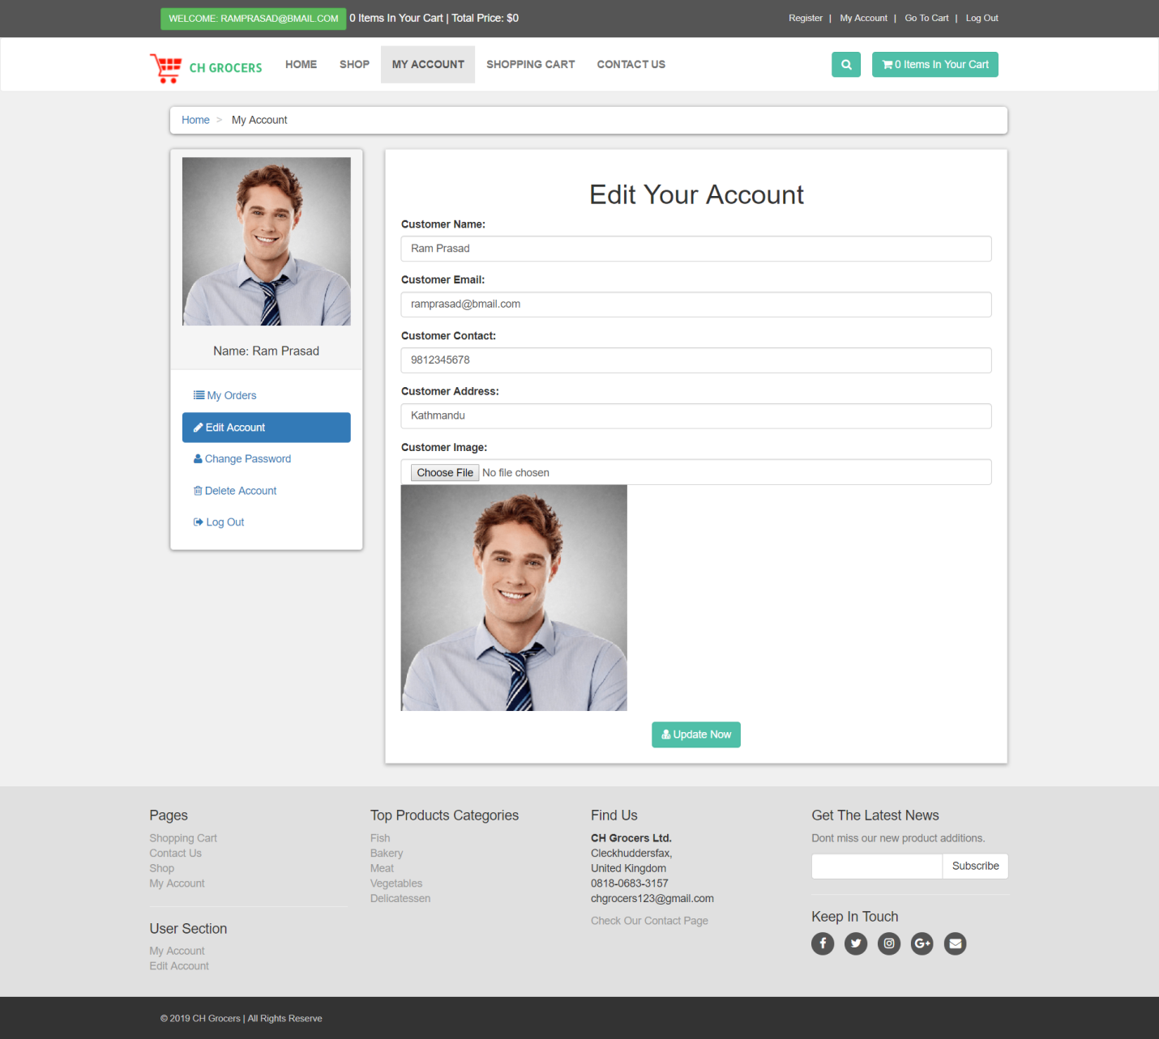

# 

# **Delete Account**

You can easily delete your account by clicking delete account on left hand side of the sidebar

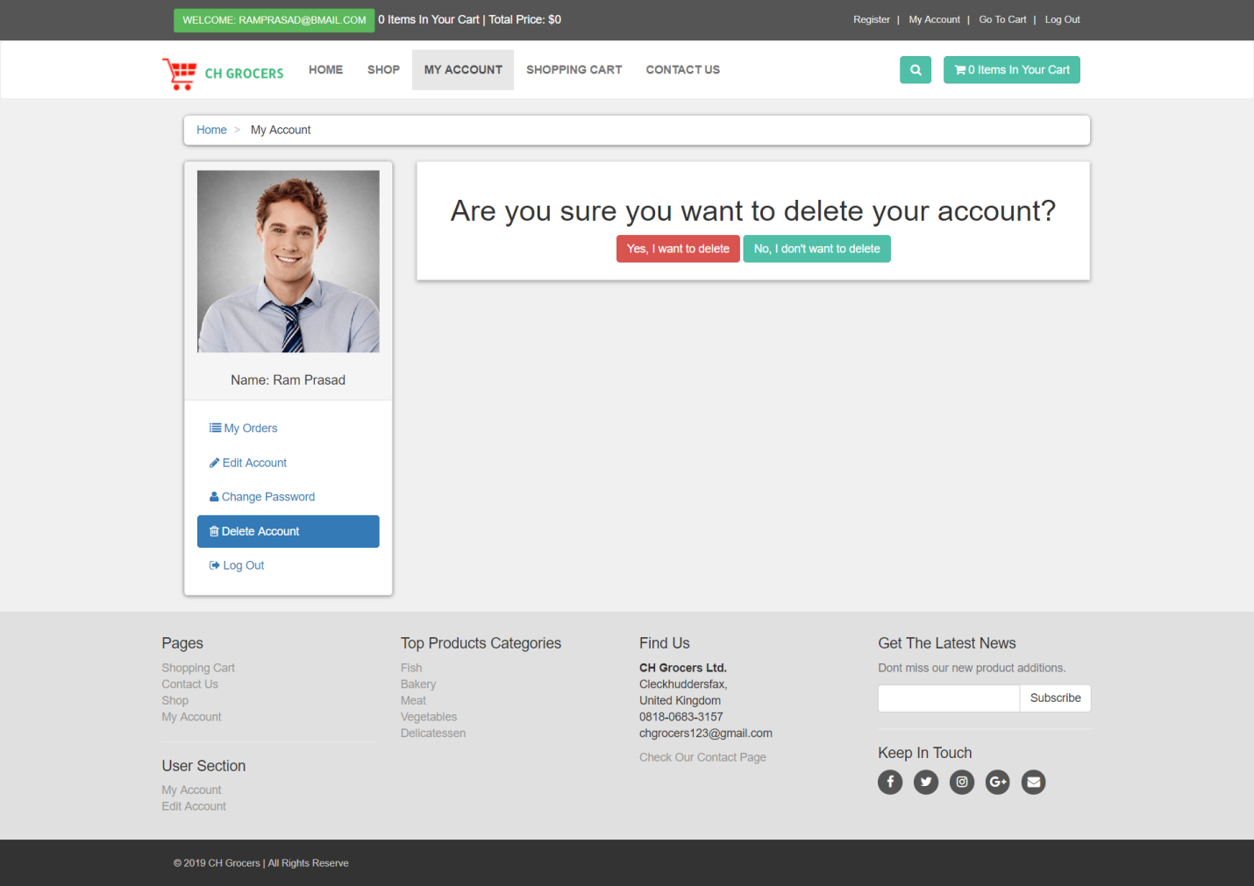

Click on yes I want to delete to delete your account

### 4.2.3 Trader Guide

Trader Guide

This trader guide will control you through the features of the site and will likewise enable you to explore through our site effortlessly. Likewise, to ensure you don't have the problem of perusing long, exhausting and pointless aides, we've attempted our best to make this short, straightforward and justifiable. In the event that you have any further inquiries that the guide couldn't deliver please don't hesitate to get in touch with us on chgrocers123@gmail.com

# Trader Registration

Right going to our homepage you’ll notice a sign-up link on top right of the website. Click the Register as trader to register yourself.

After clicking a Register as trader button, a Trader registration fill up form will appear, fill up the form and click register. Trader will receive email from admin with a link to activate account click on the link to activate account.

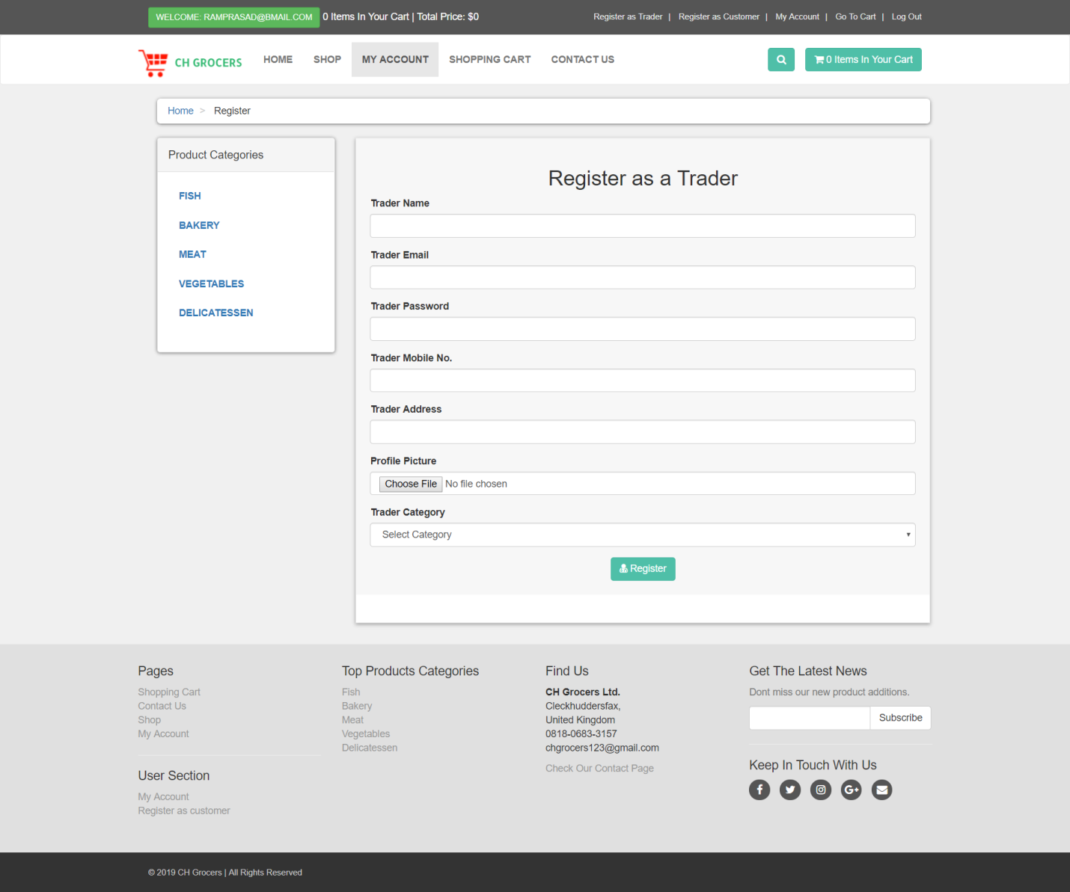

# Trader Login

You can log in as trader after you click on the link sent by admin to activate your account.

You can see a trader login option on the right hand site of the homepage click on it and a login page will appear enter your valid credentials to login and click on login.

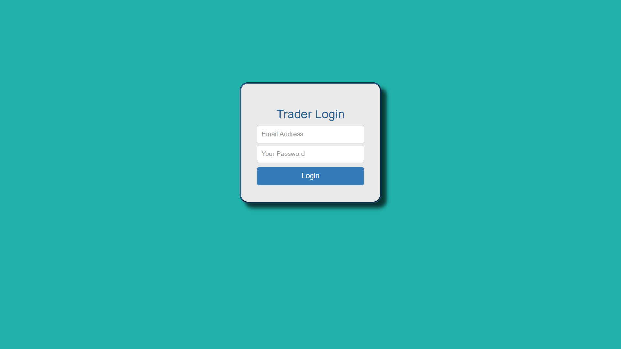

# Trader Products Dashboard

In the trader product dashboard you can insert,view,edit and delete your product and edit your account too.

# Insert products

Click on product drop down and click on insert product an insert product form will appear fill the details and click on insert product.

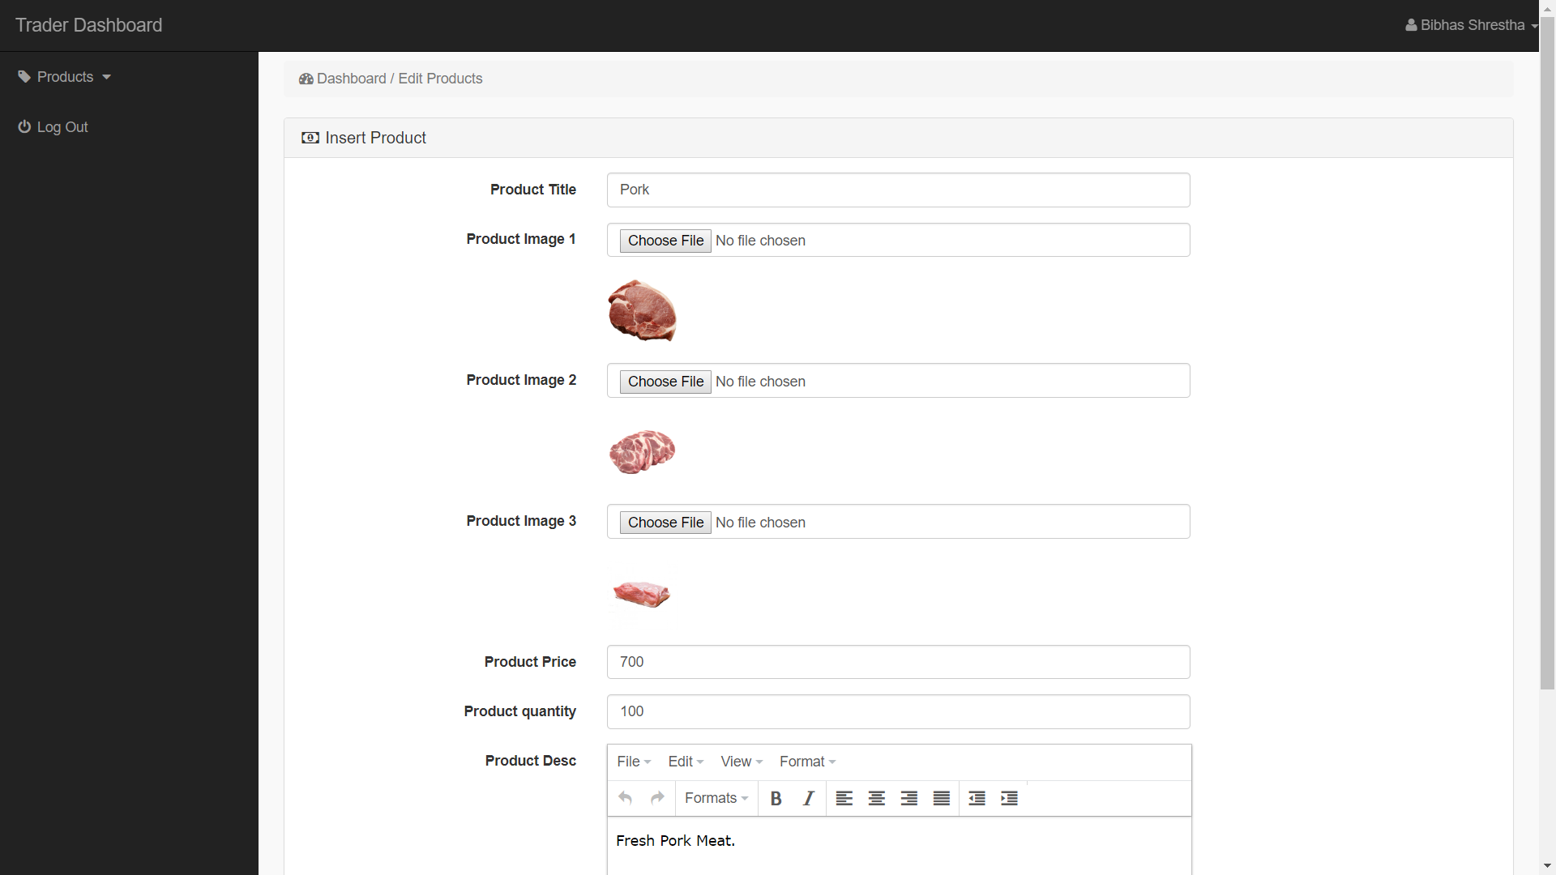

# View products

Click on product drop down click on view products here you can see the inserted products by you.

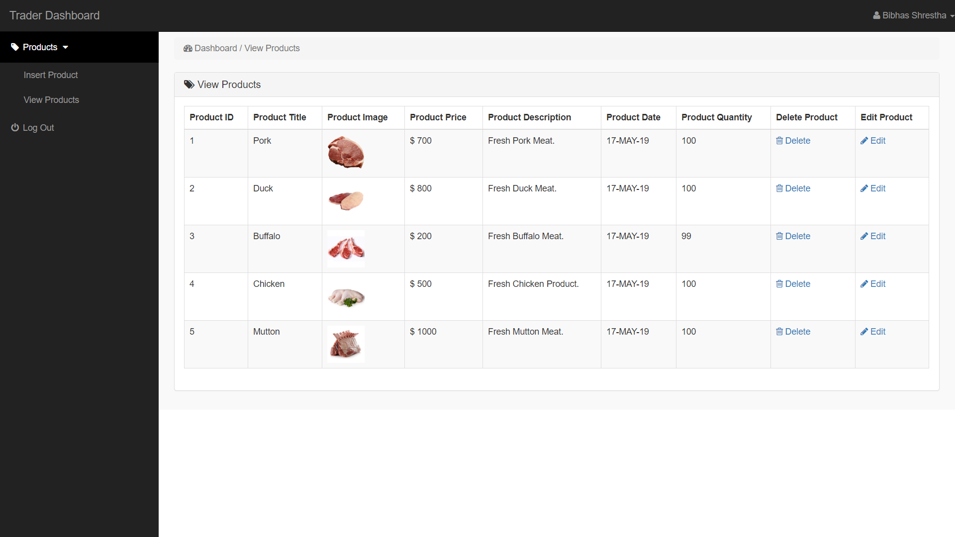

# Edit products

On the view products page you will see an edit button on the right hand side of the page click on edit an edit form will appear you can change the details and click on update product.



# Delete products

On the view products page you will see a delete button on the right hand side of the site. Click on it to delete your product.



# Edit Trader Profile

Click on trader name on the top right side of the trader dashboard and then click on profile, an edit user form will appear where you can again insert your details and click on update user.

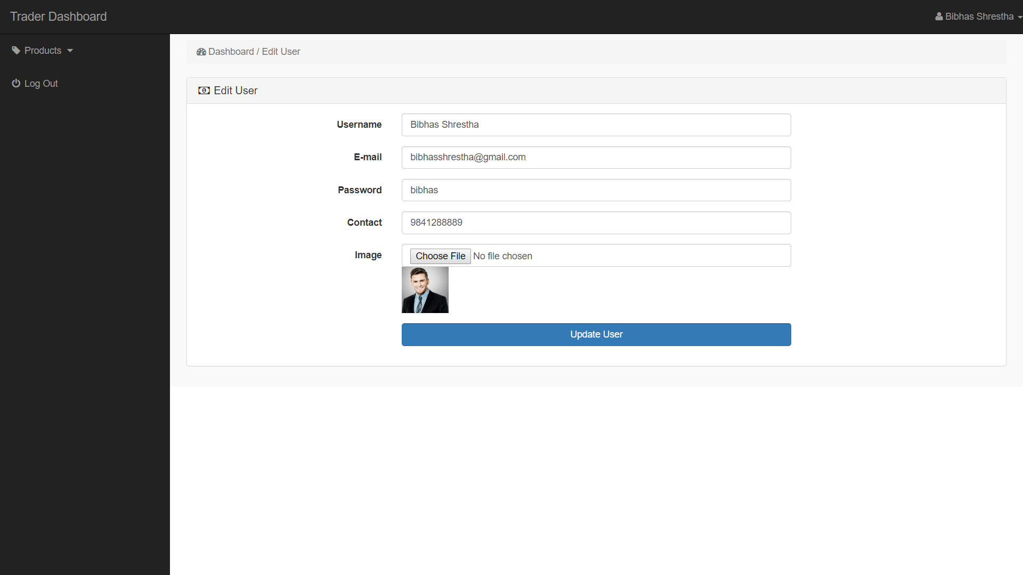

### 4.2.4 Trader Apex Guide

CH Grocers

Trader Dashboard Guide

This trader dashboard guide will control you through the features of the trader dashboard and will likewise enable you to explore through the trader dashboard effortlessly. Likewise, to ensure you don't have the problem of perusing long, exhausting and pointless aides, we've attempted our best to make this short, straightforward and justifiable. In the event that you have any further inquiries that the guide couldn't deliver please don't hesitate to get in touch with us on [chgrocers123@gmail.com](mailto:chgrocers123@gmail.com)

# Trader Interface Login

You can log in as a trader if you are registered as a trader on the website. You can see a trader login option where you can enter the right credentials to login.

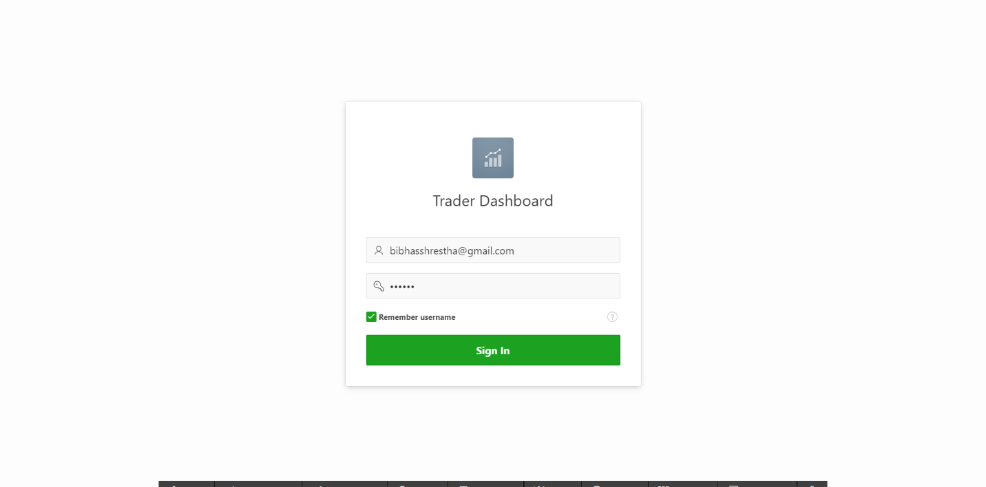

# Trader Dashboard

You can view the report on the price of the products.

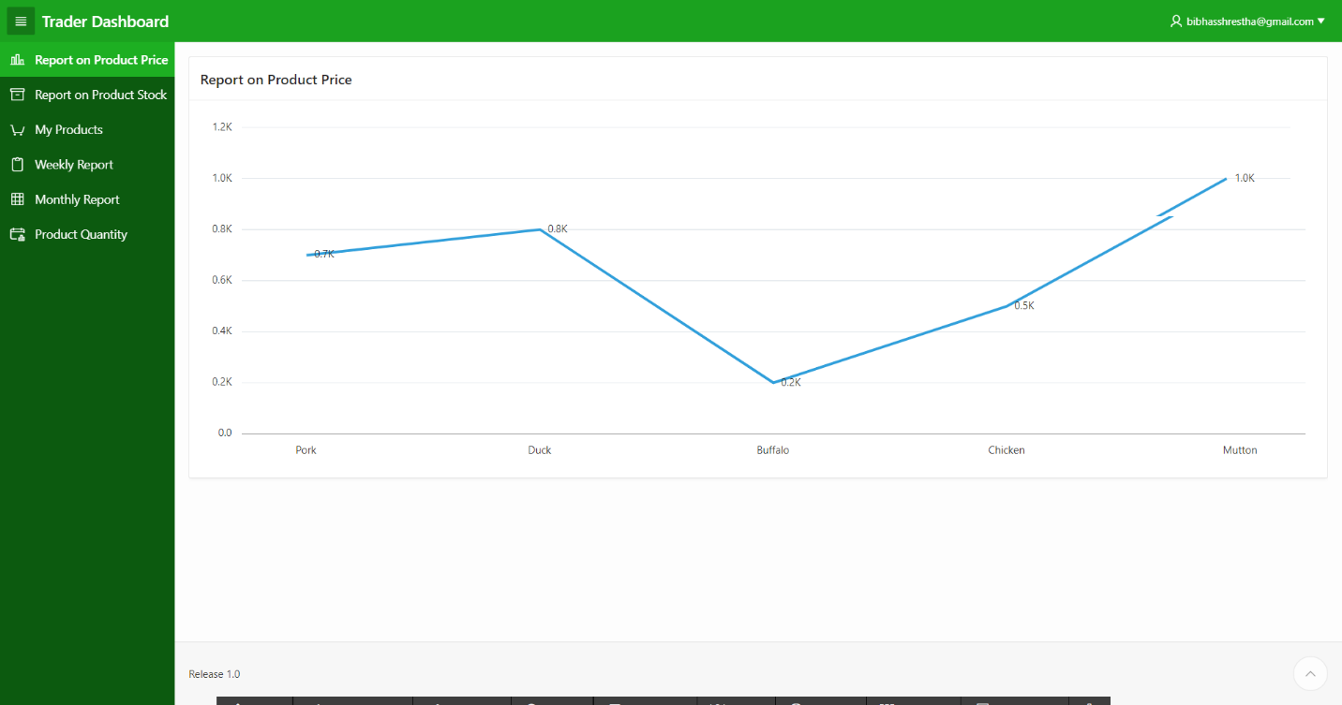

# Product Management

The trader can view the interactive report on my products page where the trader can check the product date, product price, product quantity.



# Report on Product Stock

The trader can view the stock of his product which is graphically represented through a pie-chart.



# Report on Product Quantity

The trader can view the quantity of his product which is graphically represented through a bar graph.

r

# Weekly Report

The trader can view the weekly report after clicking on the link where the trader can view the order amount, order invoice and the product sales.

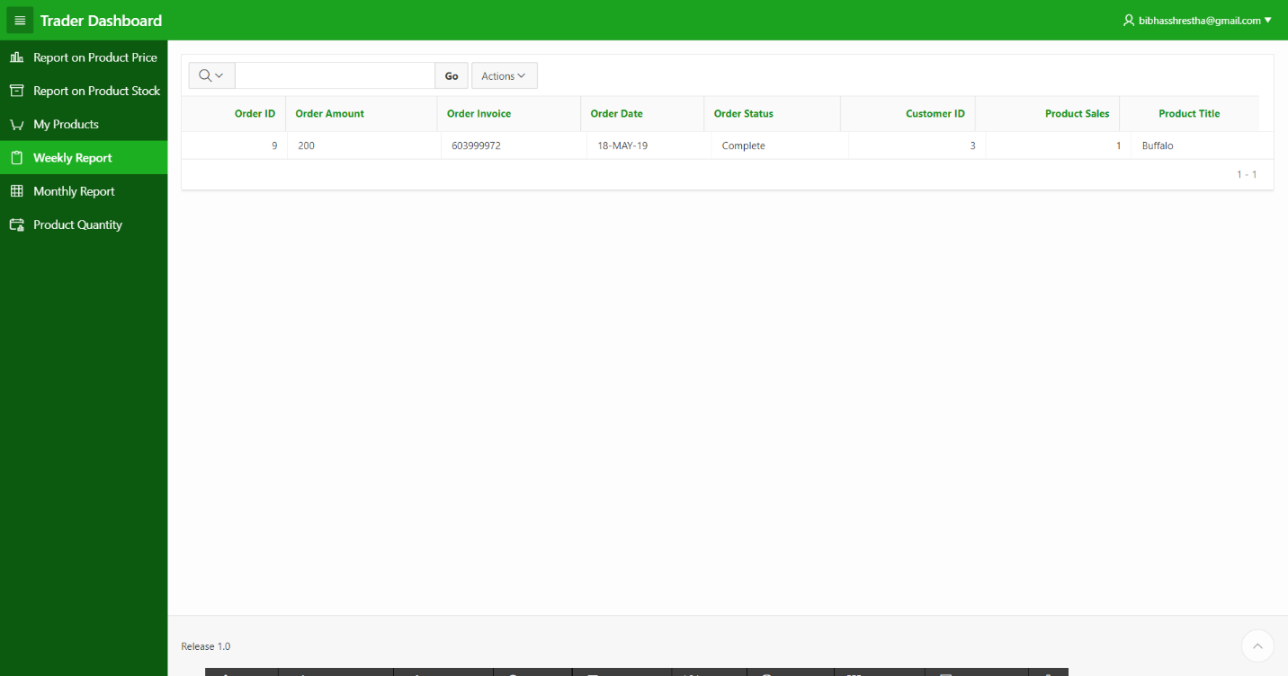

# Monthly Report

The trader can view the monthly report after clicking on the link where the trader can view the order amount, order invoice and the product sales.

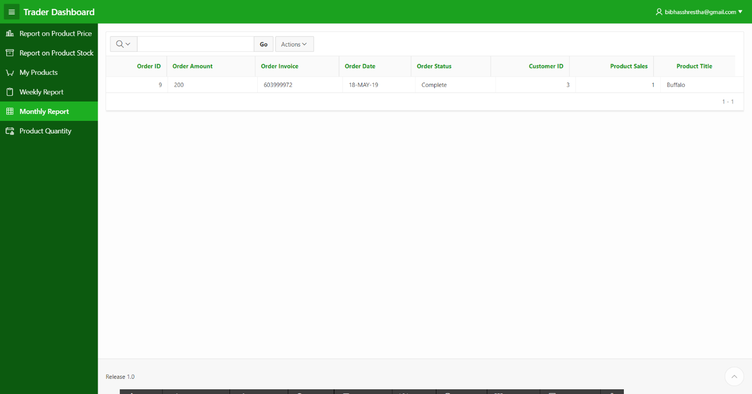

### 5.Project Closing

### 5.1 User Guide

### 5.1.1 Installation Guide

**Installation Guide**

1. Install XAMPP program

To download t click on this link: <https://www.apachefriends.org/download.html> and download XAMPP for Windows (32-bit). Select the PHP 7.2.4 version, then the file will proceed to download automatically.

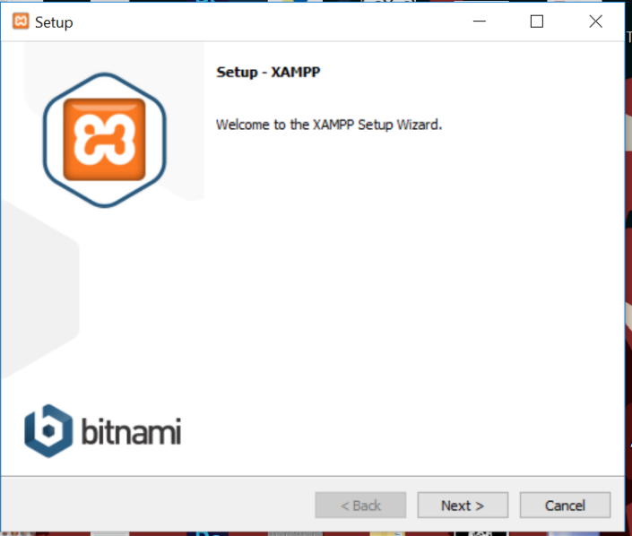

Click Next.

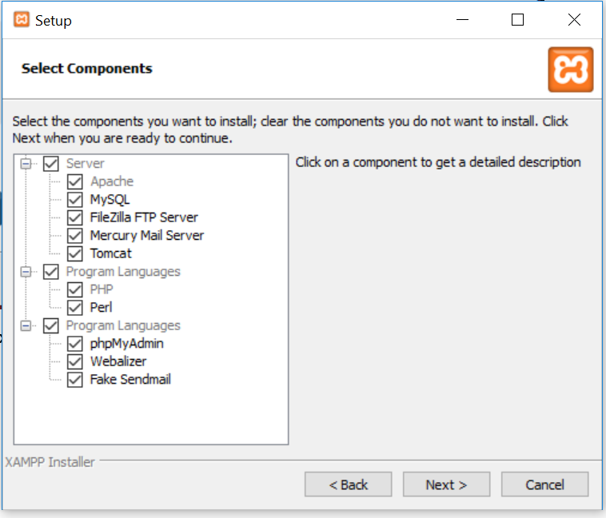

Choose the default selected checkboxes and click on Next.

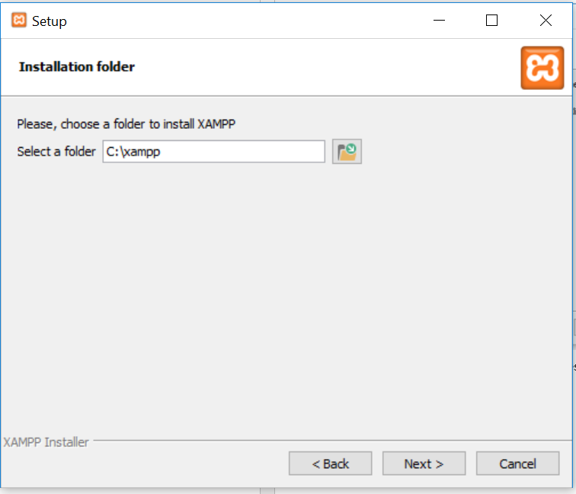

Install in C:\xampp and click Next.

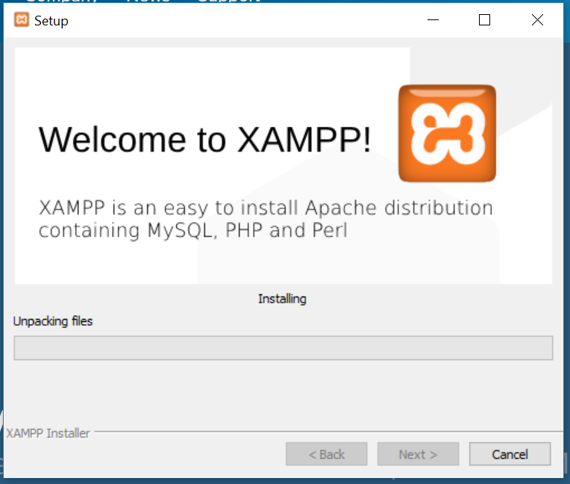

Keep hitting next and wait for the installation to complete

After installation is complete open XAMPP and start apache server to test

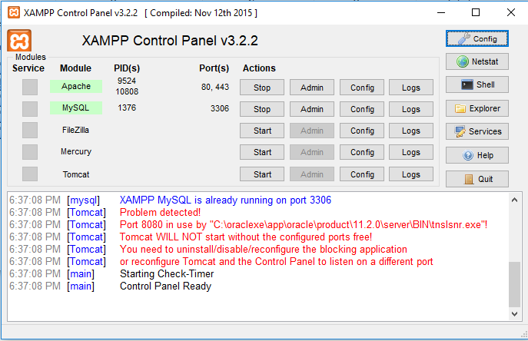

Install Oracle Database

Go to the following link to download:

<http://www.oracle.com/technetwork/database/database-technologies/express-edition/downloads/index.html>

And select [Oracle Database Express Edition 11g Release 2 for Windows x64](http://www.oracle.com/technetwork/database/database-technologies/express-edition/downloads/index.html)

Click on the setup file

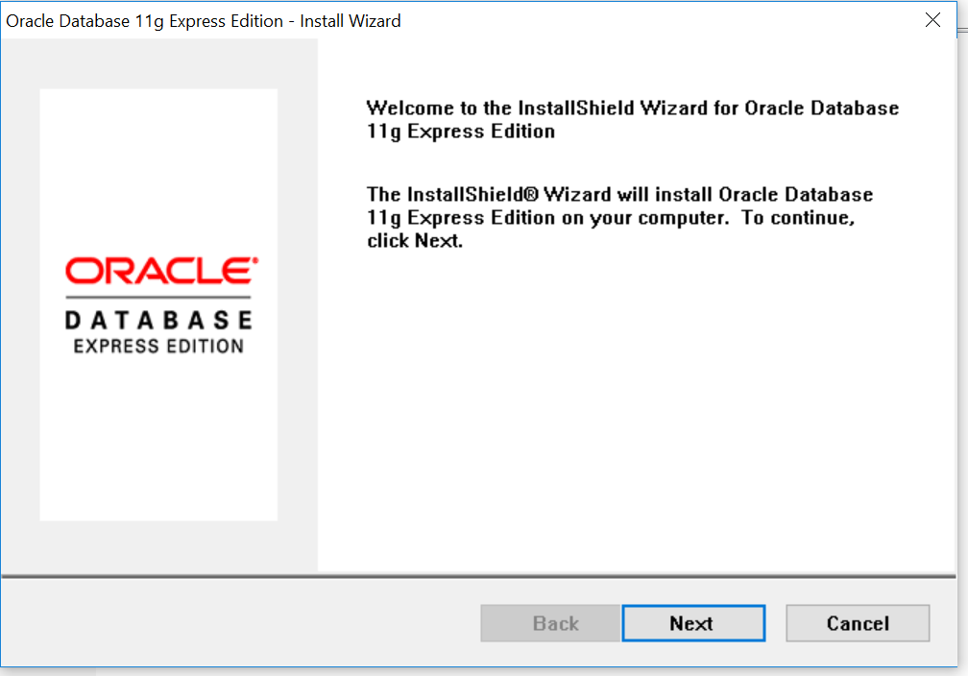

Click Next

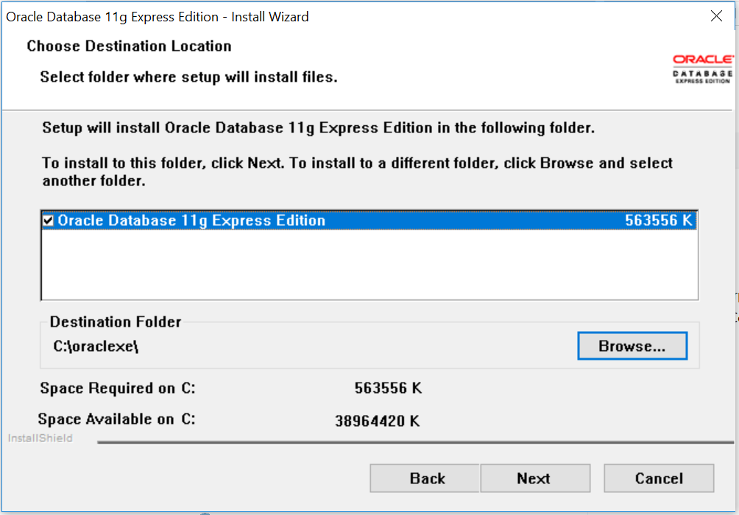

Browse to the directory you want to install and then click next

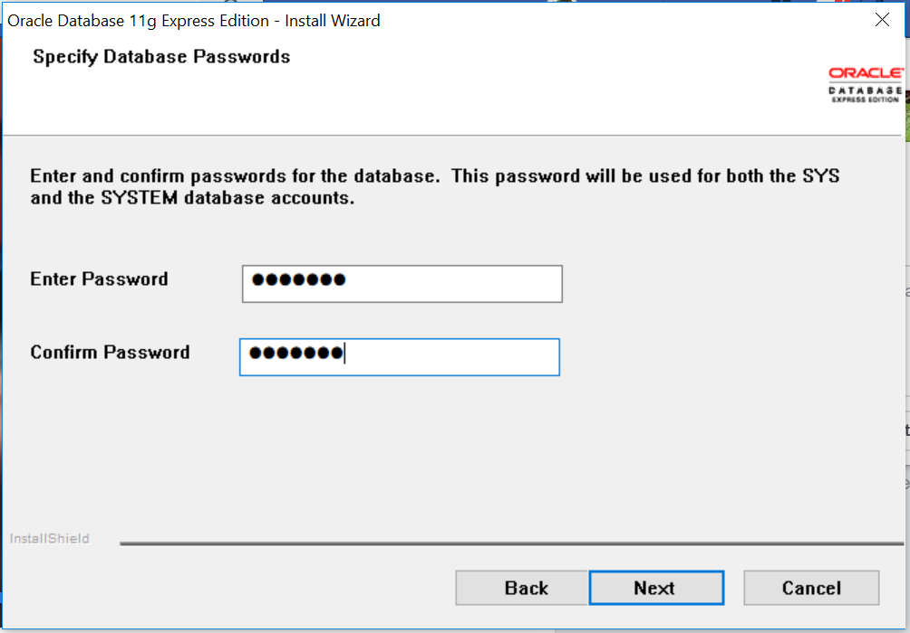

Set the password to “confirm” and proceed

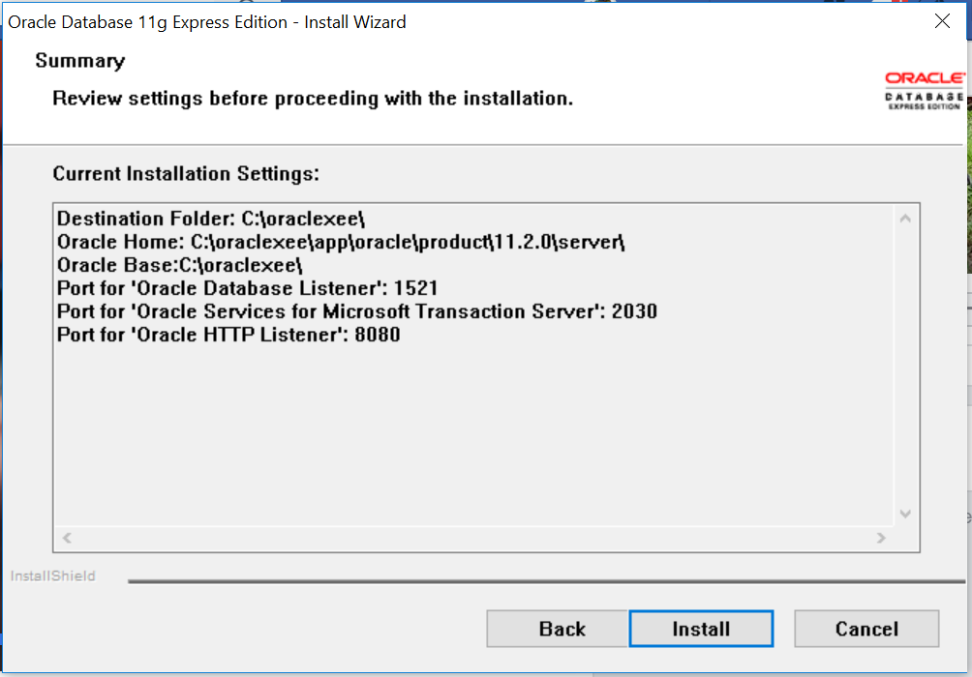

Click on Install

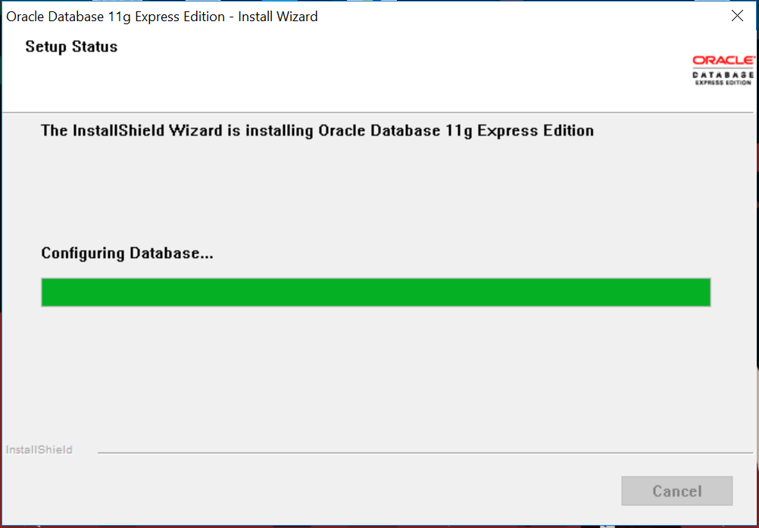

Wait for installation process to complete

After the download completes, search for “Start Database” and a command prompt will open and execute.

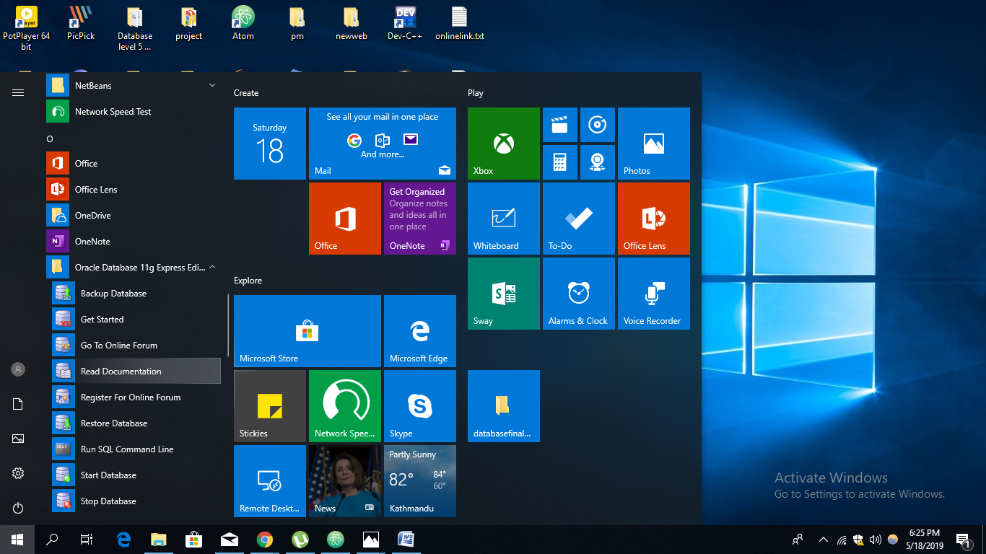

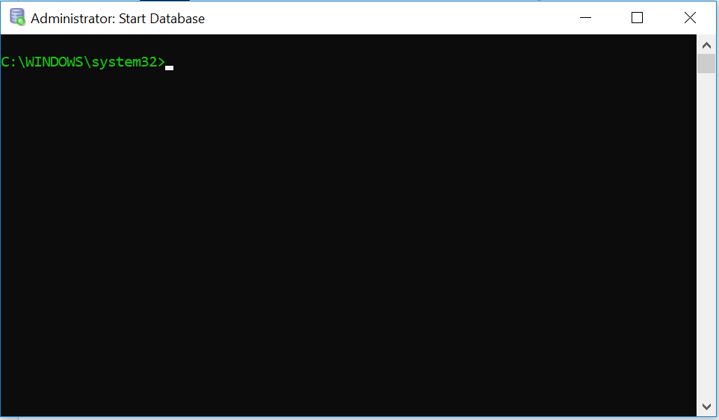

Close the Command prompt once this shows up

Open which browser you like and go to the following link

[**http://127.0.0.1:8080/apex/f?p=4950:1:1204799924348321:::::**](http://127.0.0.1:8080/apex/f?p=4950:1:1204799924348321:::::)

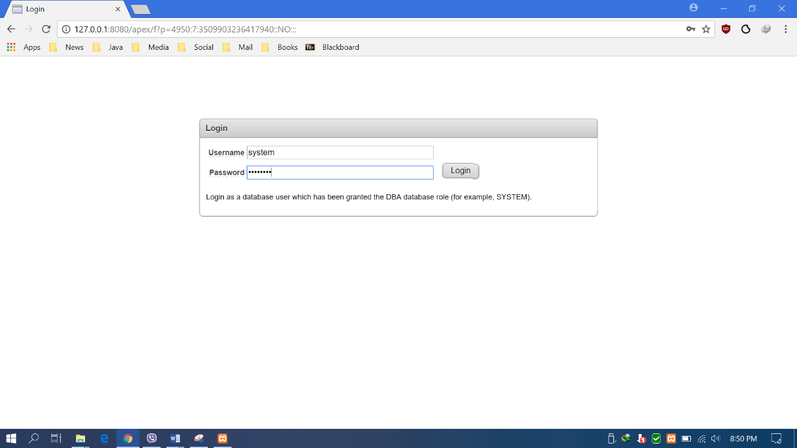

Enter username: system

Enter password: Bibha$123

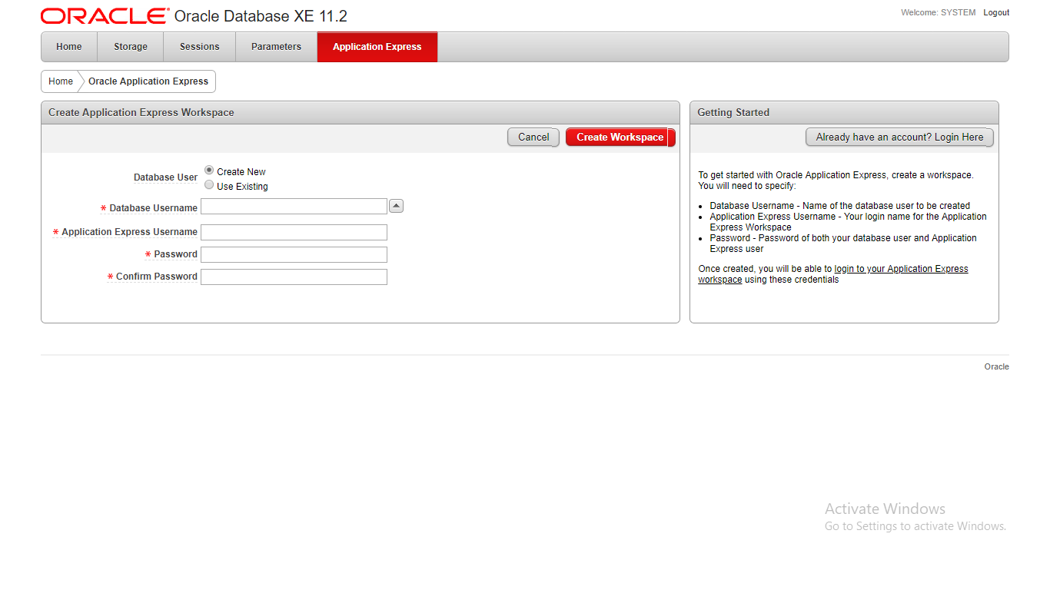

Schema Name: C7190018

Schema Password: 9841288889

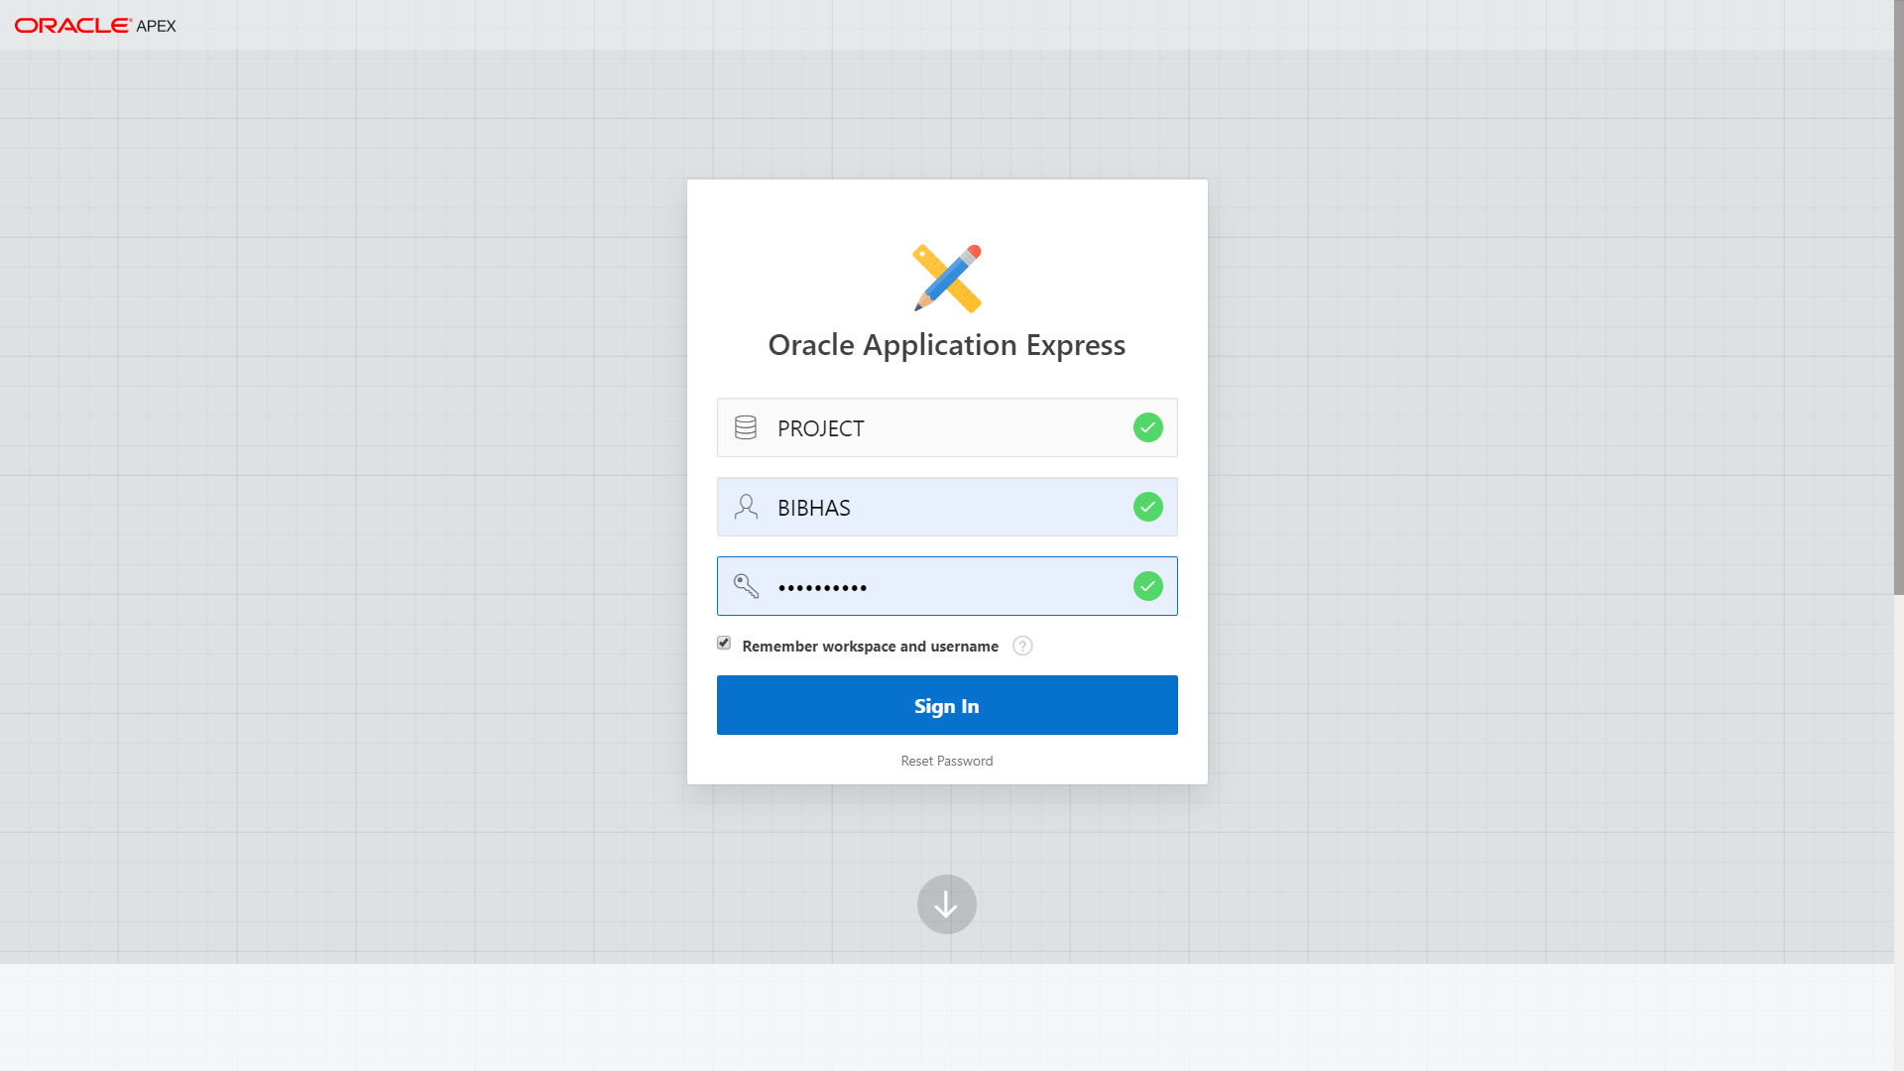

Click here to login.

Workspace name: PROJECT

Use your password, 9841288889

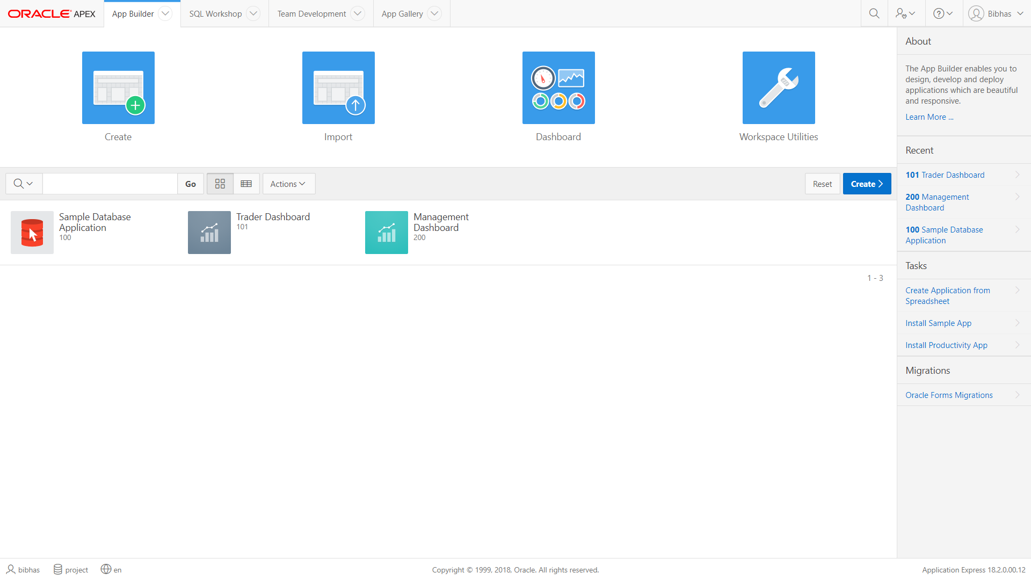

This is the home page

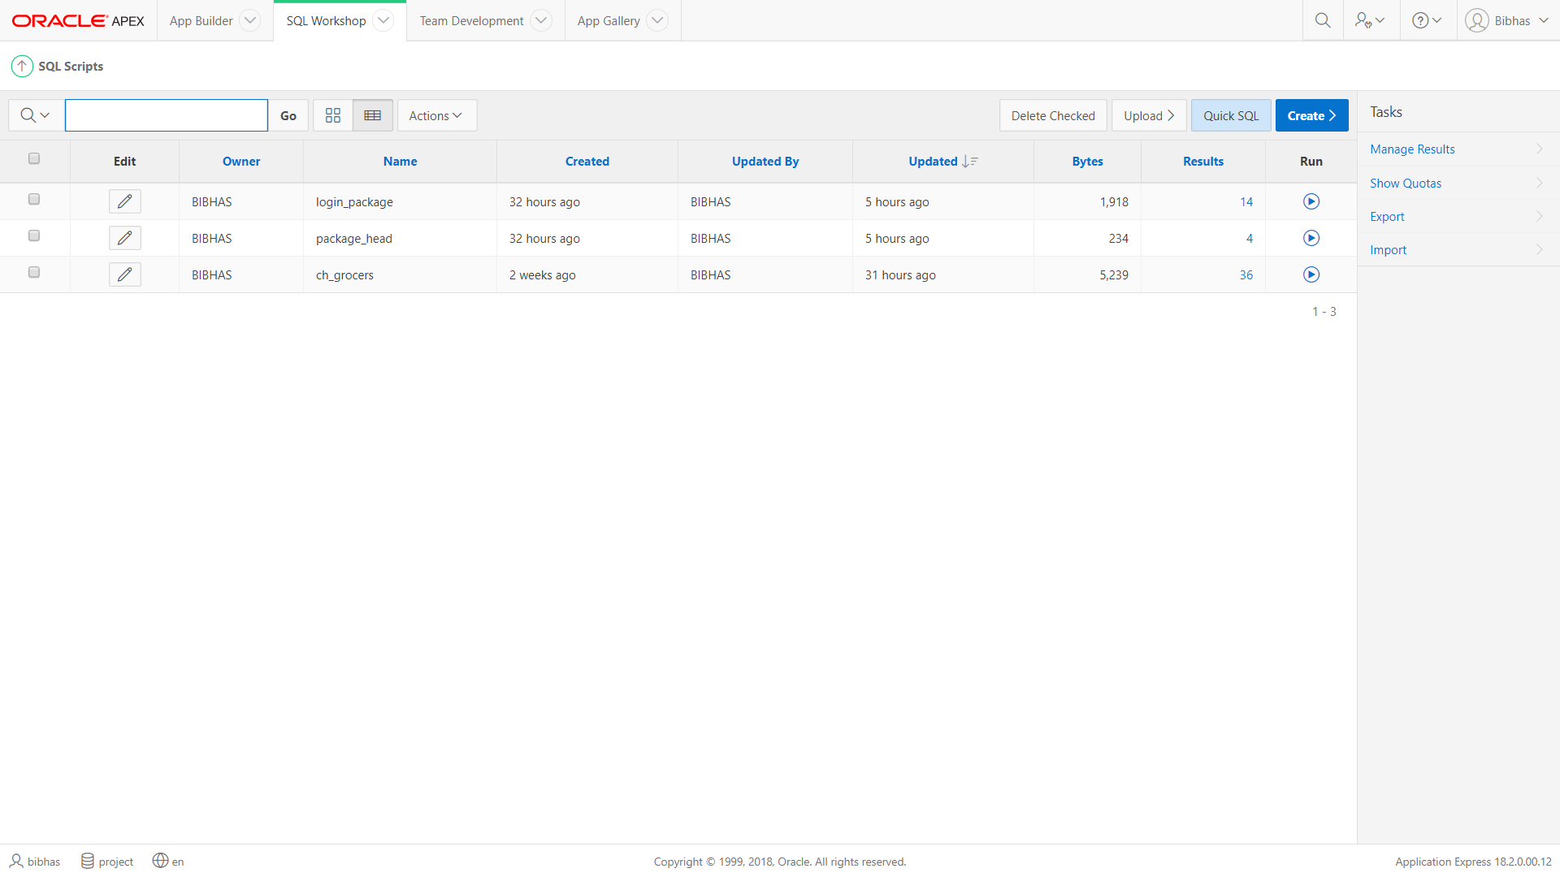

Click on upload to upload script

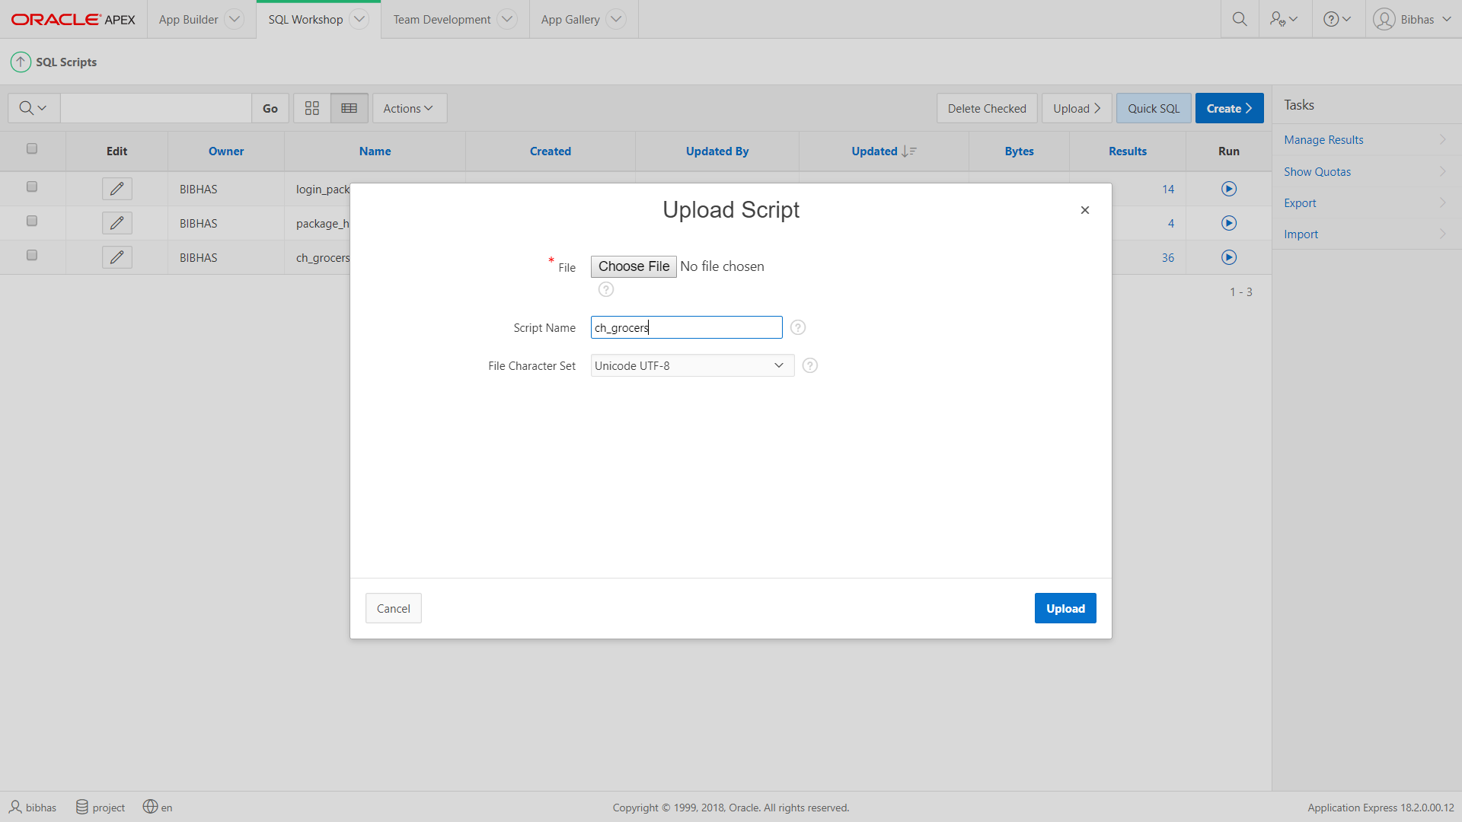

Click “Choose File” and upload ch_grocers.sql file.

Additional Setup

On the Apache section, click on Config and select PHP (php.ini) from the dropdown menu.

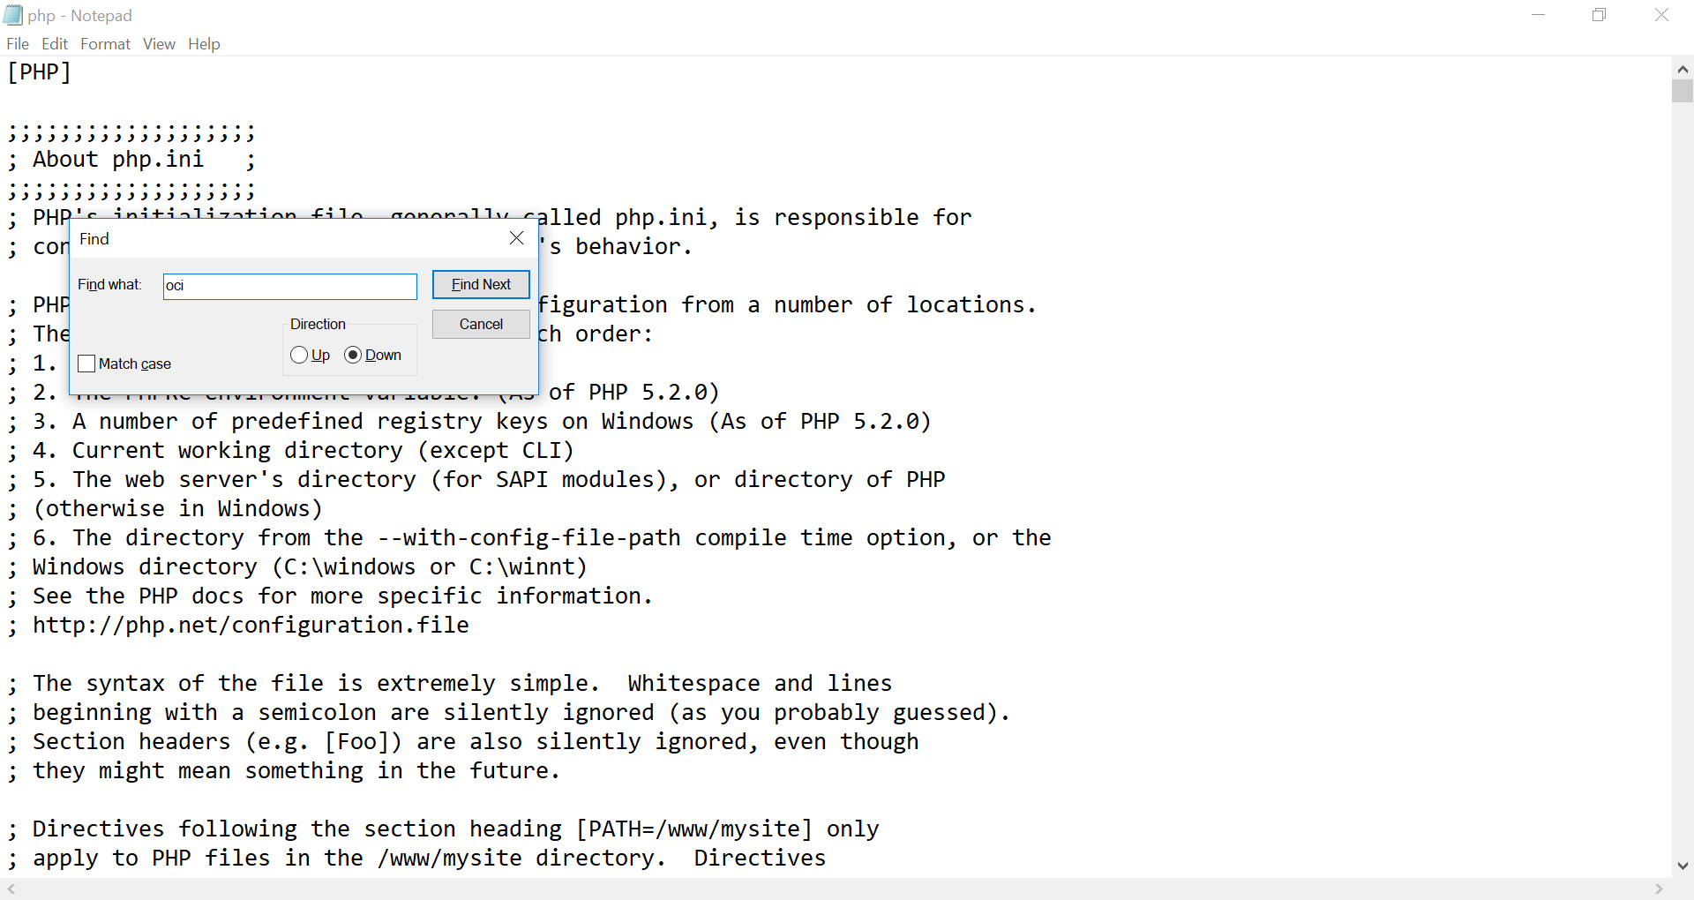

Hold Ctrl + F button and find for “oci” keyword.

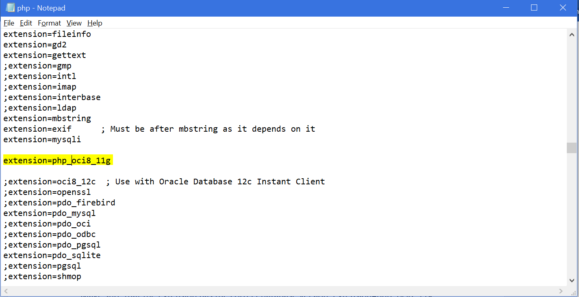

Make sure that the extension has the correct database version: extension=php_oci8_11g

Save the file and open XAMPP, again and open any browser and type the following link:localhost/mainproject/ now the website files will open.



